**Sri Lanka Institute of Information Technology**

**B.Sc. (Hons) Information Technology-**

**Cyber security**



**Year 02 Semester 01**

**SNP Assignment**

**IT Number – IT23554504**

**Student Name – J. A. C. P. Jayasooriya**

**Introduction**

This assignment for the course *IE2012 – Systems and Network Programming* focuses on providing practical, hands-on experience in Linux system administration within a virtualized environment. It covers key areas including basic Linux command-line operations, system services configuration (DHCP, DNS, and NTP), security administration (SSH, iptables, and ACLs), server setup (web and email servers), shell scripting automation, and debugging using GDB.

The tasks were completed in a virtual machine running a Linux distribution (Ubuntu/CentOS), where real-world administrative scenarios were simulated and configured. Through this assignment, I have gained a deeper understanding of the Linux operating system’s structure, command-line utilities, network services, scripting capabilities, and system-level debugging. All configurations, scripts, outputs, and analysis steps have been documented in detail with appropriate screenshots and explanations to demonstrate successful implementation.

**Declaration**

I’m, J.A.C.P. Jayasooriya , with registration number IT23554504,hereby declare that this report is my own work and has been completed in accordance with the guidelines were provided.

**Table of content**

#### **1. Basics of Linux Environment**

**1.1 Virtual Machine Setup  
1.2 Command Line Introduction**

* **1.2.1 Basic Navigation Commands (ls, cd, pwd, mkdir, rmdir)**
* **1.2.2 File Manipulation Commands (touch, cp, mv, rm, nano, cat, echo)**
* **1.2.3 System Information Commands (uname, hostname, uptime, lscpu, free, df)**
* **1.2.4 User Management Commands (whoami, id, useradd, passwd)**
* **1.2.5 15 Essential Linux Commands (ifconfig, grep, sudo, history, chmod, etc.)**

#### **2. DHCP, DNS, and NTP Services Configuration**

**2.1 DHCP Configuration**

* **2.1.1 Server Setup (Installation, Subnet Configuration, Lease Settings)**
* **2.1.2 Client Configuration (NetPlan, IP Assignment)**
* **2.1.3 Verification (ping, ip route, dhclient)**

**2.2 DNS Configuration**

* **2.2.1 BIND9 Installation & Forwarders Setup**
* **2.2.2 Client Configuration (/etc/netplan, nslookup, dig)**
* **2.2.3 Reverse DNS Lookup Test**

**2.3 NTP Configuration**

* **2.3.1 Chrony Server Setup (Pool Servers, Firewall Rules)**
* **2.3.2 Client Synchronization**
* **2.3.3 Verification (chronyc sources, timedatectl)**

#### **3. Security and Server Setup**

**3.1 Shell Scripting**

* **3.1.1 Log Cleanup Script (Cron Job, Retention Policy)**
* **3.1.2 System Monitoring Script (Metrics Collection, Scheduling)**

**3.2 SSH Configuration**

* **3.2.1 OpenSSH Server Setup**
* **3.2.2 Remote Access from Windows Client**

**3.3 iptables & ACLs**

* **3.3.1 Rule Implementation (SSH/HTTPS Allow, HTTP Block)**
* **3.3.2 Social Media Site Blocking**
* **3.3.3 Persistent Rule Saving**

**3.4 Web Server (Apache)**

* **3.4.1 Installation & Default Page Setup**
* **3.4.2 Firewall Configuration (ufw allow Apache)**

**3.5 Email Server (Postfix)**

* **3.5.1 Basic Configuration (main.cf)**
* **3.5.2 Local Mail Testing & Relay Setup (Gmail)**

#### **4. GDB Debugging & File Analysis**

**4.1 GDB Workflow**

* **4.1.1 Executable Debugging (Breakpoints, Stepping)**
* **4.1.2 Memory/Register Inspection (info registers, x/xw)**

**4.2 File System Monitoring**

* **4.2.1 strace for System Calls**
* **4.2.2 Reverse Engineering data.txt (Hex, Strings, Entropy Checks)**

**1.Basics of Linux Environment**

**Virtual machine setup:**

### **VirtualBox Setup Guide**

#### **1. Download & Install VirtualBox**

1. **Download**:
   * Get the latest version for your OS (Windows/macOS/Linux) from [virtualbox.org](https://www.virtualbox.org/).
2. **Install**:
   * Run the installer and follow defaults (allow driver installations if prompted).

#### **2. Download Guest OS ISO**

* Example: [Ubuntu ISO](https://ubuntu.com/download/desktop) (e.g., Ubuntu 22.04 LTS).

### **3. Create a New Virtual Machine (VM)**

1. **Open VirtualBox** → Click **"New"**.
2. **Name**: Ubuntu 22.04 (or any name).
3. **Type**: **Linux** → **Version**: *Ubuntu (64-bit)*.
4. **Memory (RAM)**: **4096 MB** (4GB recommended).
5. **Hard Disk**:
   * Select **"Create a virtual hard disk now"**.
   * Choose **VDI** (VirtualBox Disk Image) → **Dynamically allocated**.
   * Size: **25GB** (min. for Ubuntu).

### **4. Configure VM Settings**

1. Select the VM → Click **"Settings"** (gear icon).
2. **System → Processor**:
   * Assign **2+ CPUs** (improves performance).
3. **Display → Video Memory**: **128MB** (enable **3D Acceleration** if needed).
4. **Storage → Optical Drive**:
   * Click the **CD icon** → **Choose a disk file** → Select the Ubuntu ISO.
5. **Network**:
   * **Adapter 1**: **NAT** (default for internet access).

**UBUNTU SETUP**

### **1. Download Required Files**

* **Ubuntu ISO: Download the latest LTS version from**[**Ubuntu Official Site**](https://ubuntu.com/download/desktop)**(e.g., Ubuntu 22.04 LTS).**
* **VirtualBox: Download and install**[**Oracle VirtualBox**](https://www.virtualbox.org/)**.**

### **2. Create a New Virtual Machine (VM)**

1. **Open VirtualBox → Click "New".**
2. **Name: Ubuntu 22.04 (or your preferred name).**
3. **Type: Linux.**
4. **Version: Ubuntu (64-bit).**
5. **Click Next.**

### **3. Allocate Resources**

* **RAM: 4GB (4096 MB) recommended for smooth performance.**
* **Hard Disk:**
  + **Select "Create a virtual hard disk now" → VDI (VirtualBox Disk Image).**
  + **Dynamically allocated (saves space).**
  + **Size: 25GB (minimum for Ubuntu).**

### **4. Configure VM Settings**

1. **Select the VM → Click "Settings".**
2. **System → Processor:**
   * **Assign 2 CPUs (or more if your host PC allows).**
3. **Display → Video Memory: 128MB (enable 3D acceleration if needed).**
4. **Storage → Controller: IDE:**
   * **Click the CD icon → Choose a disk file → Select the Ubuntu ISO.**
5. **Network:**
   * **Adapter 1: NAT (default for internet access).**

### **5. Install Ubuntu**

1. **Start the VM → Ubuntu installer will boot.**
2. **Language: Select your preference → Install Ubuntu.**
3. **Keyboard Layout: Choose your layout.**
4. **Updates & Software:**
   * **Select "Normal Installation" + "Download updates while installing".**
5. **Installation Type:**
   * **Erase disk and install Ubuntu (safe for virtual machines).**
6. **Timezone & User Details:**
   * **Set your location.**
   * **Enter username and password.**
7. **Wait for installation to complete → Restart when prompted.**

### **6. Install VirtualBox Guest Additions**

**Why? Enables features like shared folders, clipboard, screen resizing.**

1. **After booting Ubuntu, go to VirtualBox menu:**
   * **Devices → Insert Guest Additions CD Image.**
2. **Open Terminal (Ctrl+Alt+T) and run:**

**sudo apt update**

**sudo apt install build-essential dkms linux-headers-$(uname -r)**

1. **Mount the CD:**

**sudo mount /dev/cdrom /mnt**

**cd /mnt**

**sudo ./VBoxLinuxAdditions.run**

1. **Reboot the VM:**

**sudo reboot**

### **7. Post-Installation Setup**

#### **A. Enable Shared Clipboard & Drag-Drop**

* **Go to VirtualBox:**
  + **Devices → Shared Clipboard → Bidirectional.**
  + **Devices → Drag’n’Drop → Bidirectional.**

#### **B. Set Up Shared Folders (Optional)**

1. **VirtualBox:**
   * **Settings → Shared Folders → Add a folder (e.g., Ubuntu_Share).**
2. **In Ubuntu Terminal:**

**sudo usermod -aG vboxsf $(whoami)**

**reboot**

* + **Access shared folders at /media/sf_Ubuntu_Share.**

#### **C. Update & Upgrade**

**bash**

**Copy**

**Download**

**sudo apt update && sudo apt upgrade -y**

### **8. Troubleshooting**

* **Screen Resolution Issues:**
  + **Install Guest Additions properly (Step 6).**
* **No Internet:**
  + **Check VM Network Settings (use NAT or Bridged Adapter).**
* **Keyboard/Mouse Not Working:**
  + **Reinstall Guest Additions.**

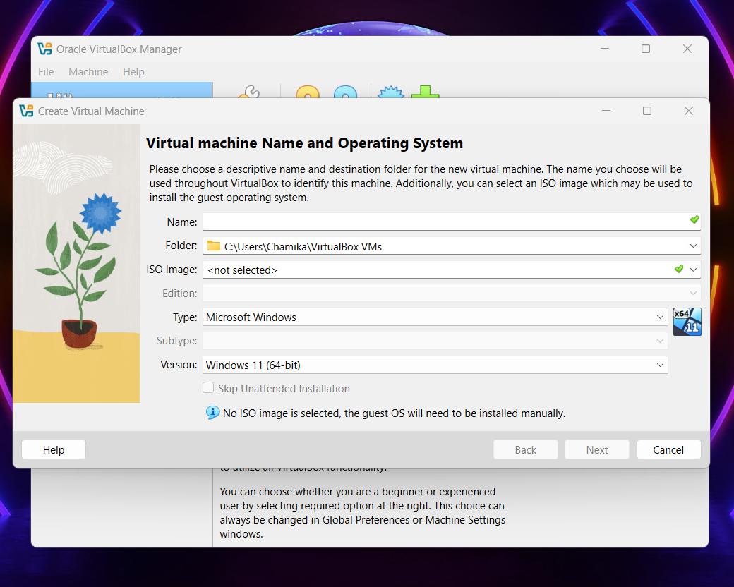

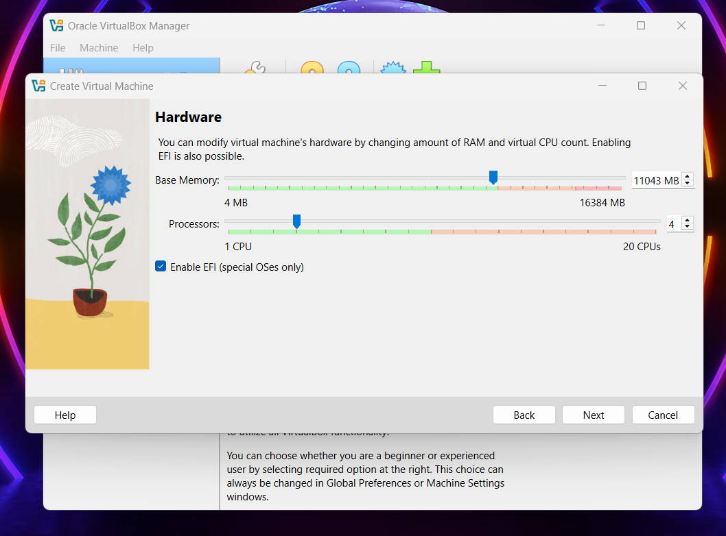

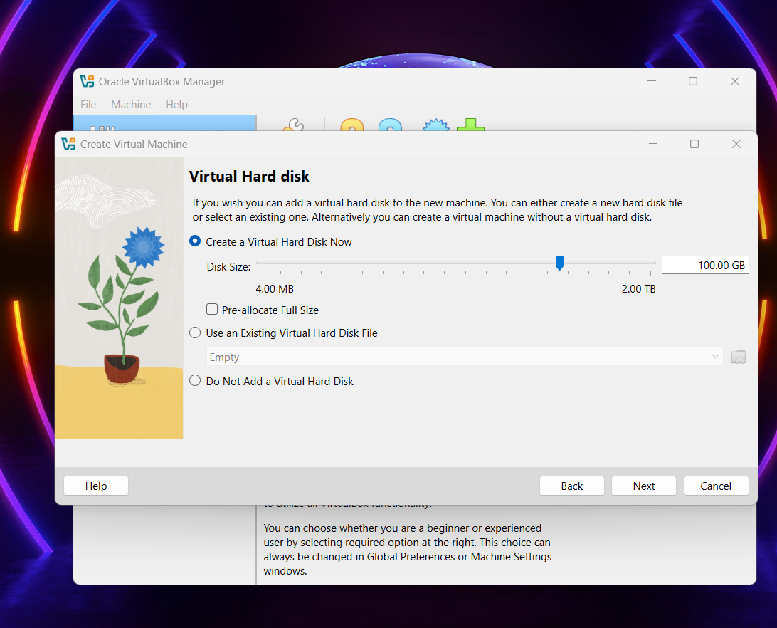

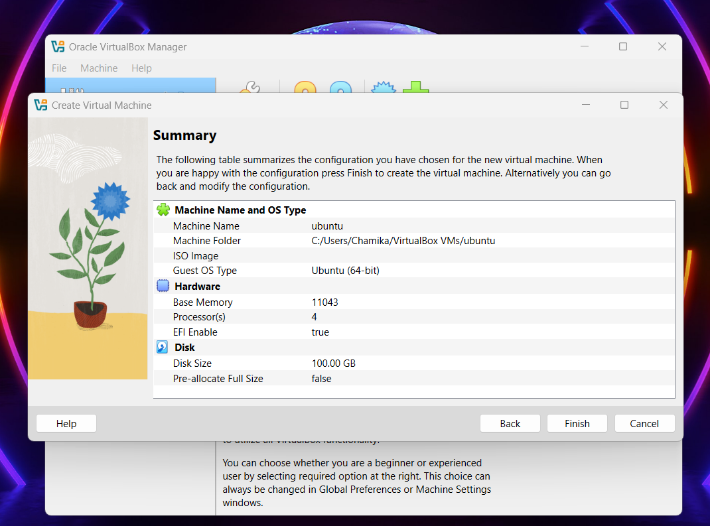

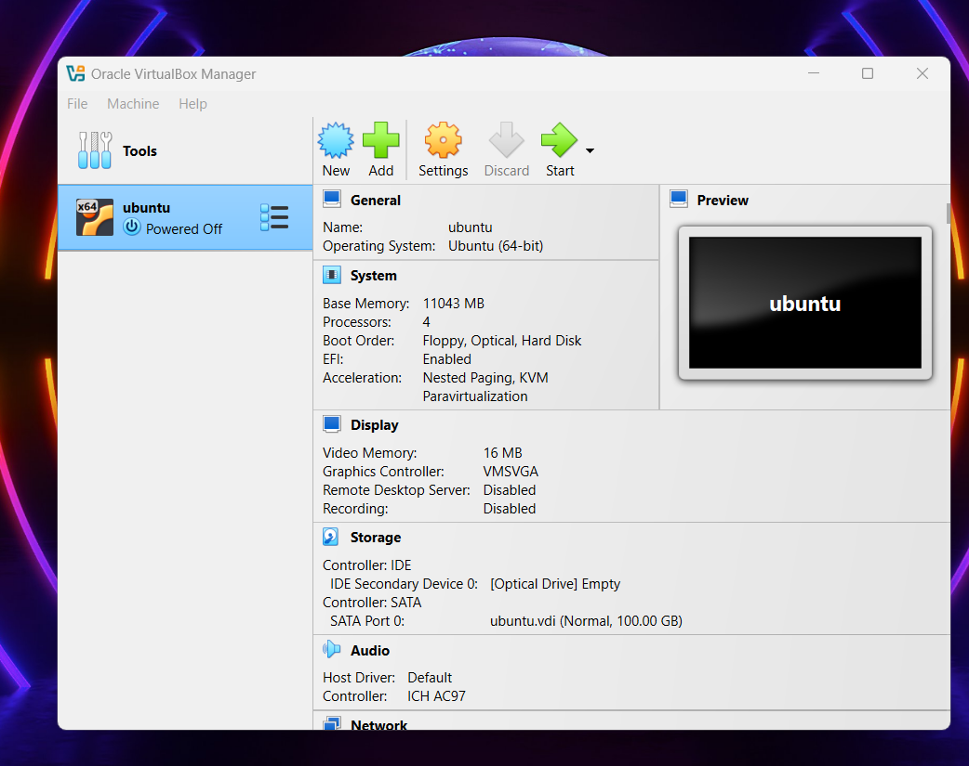

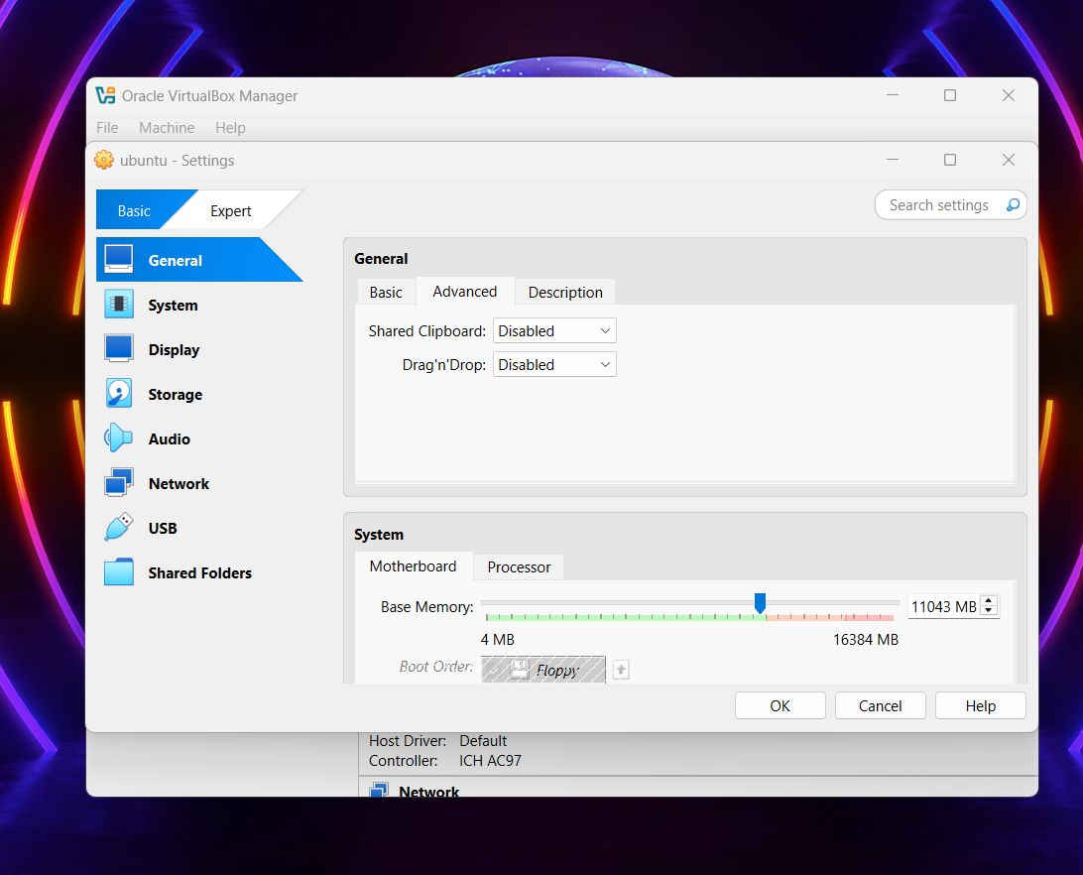

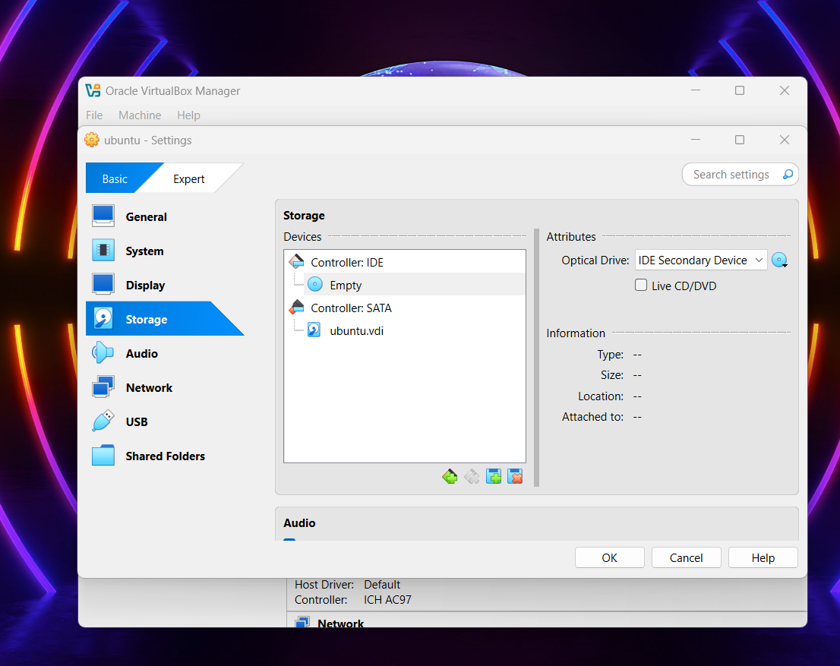

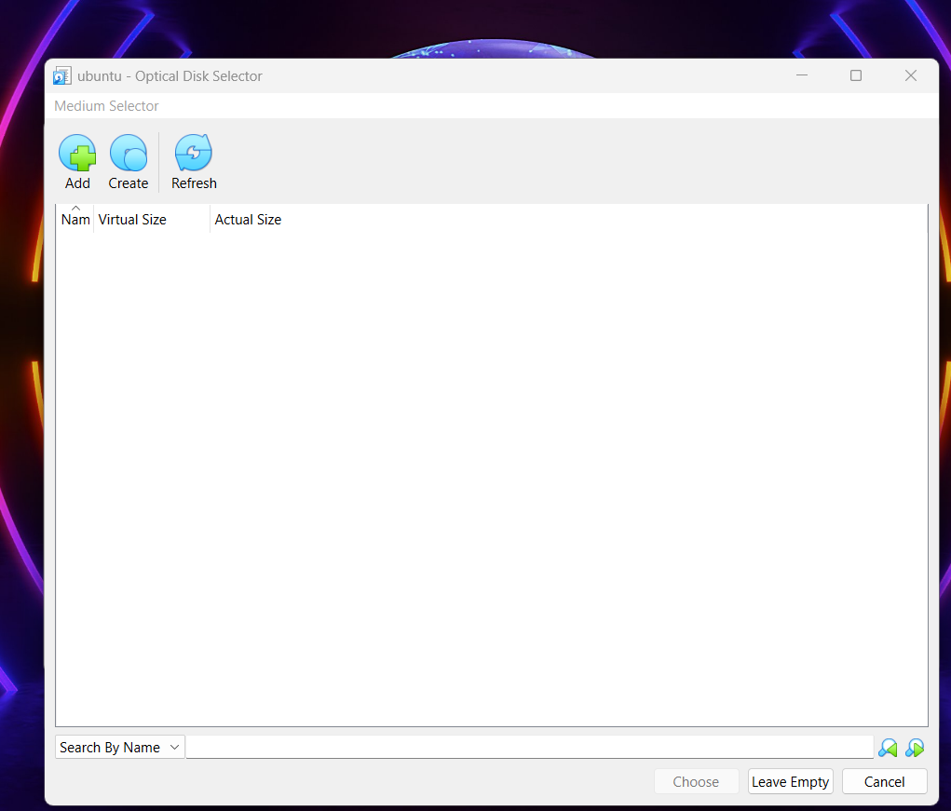

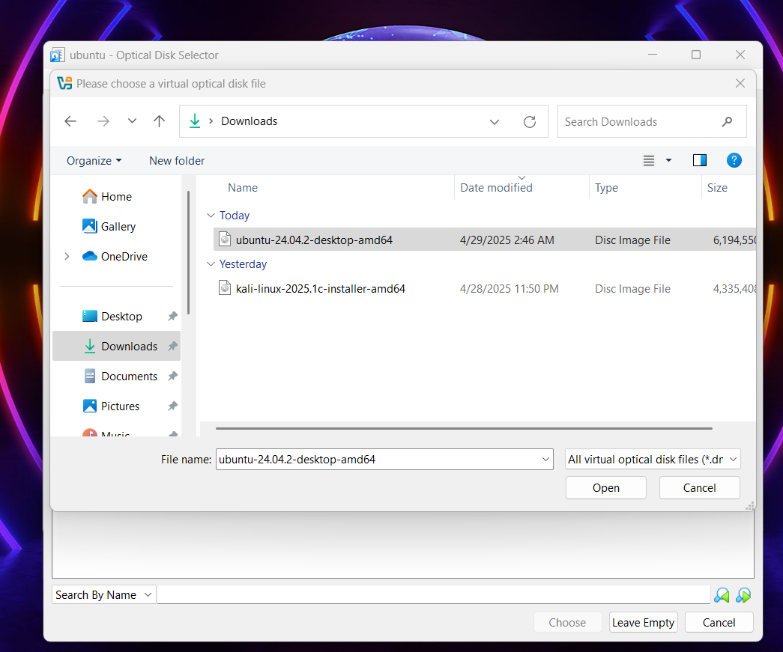

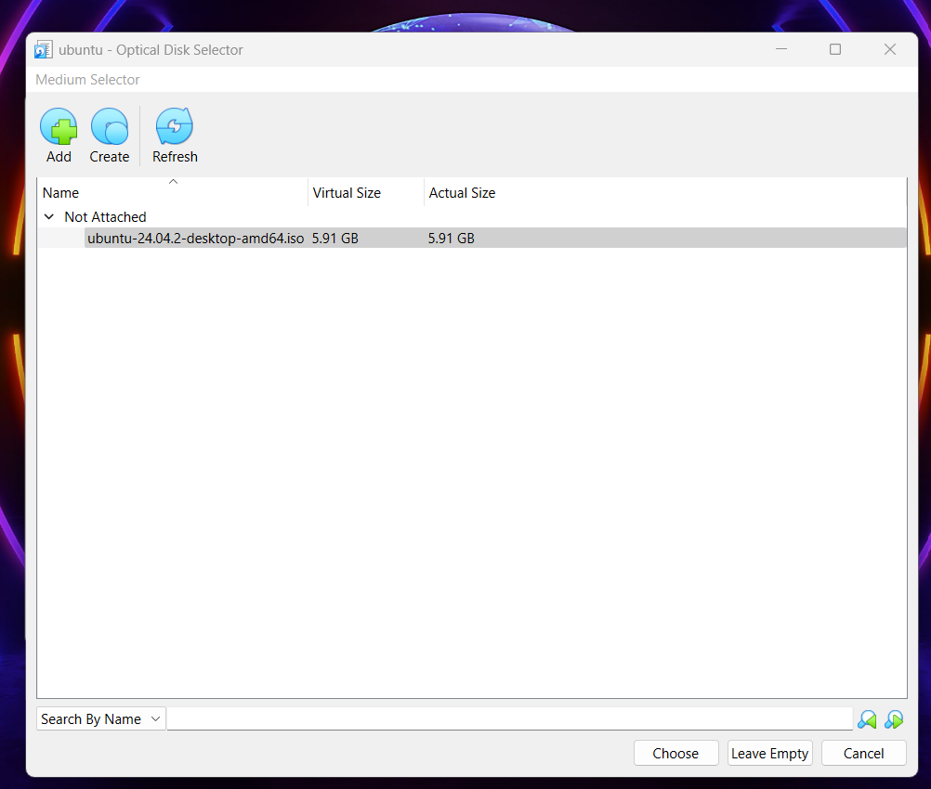

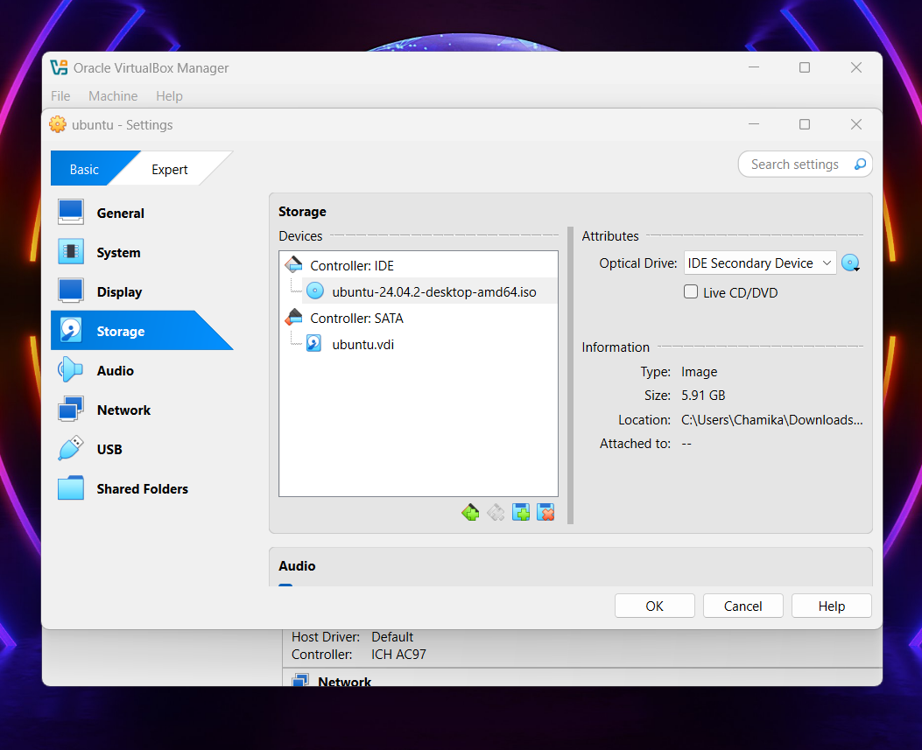

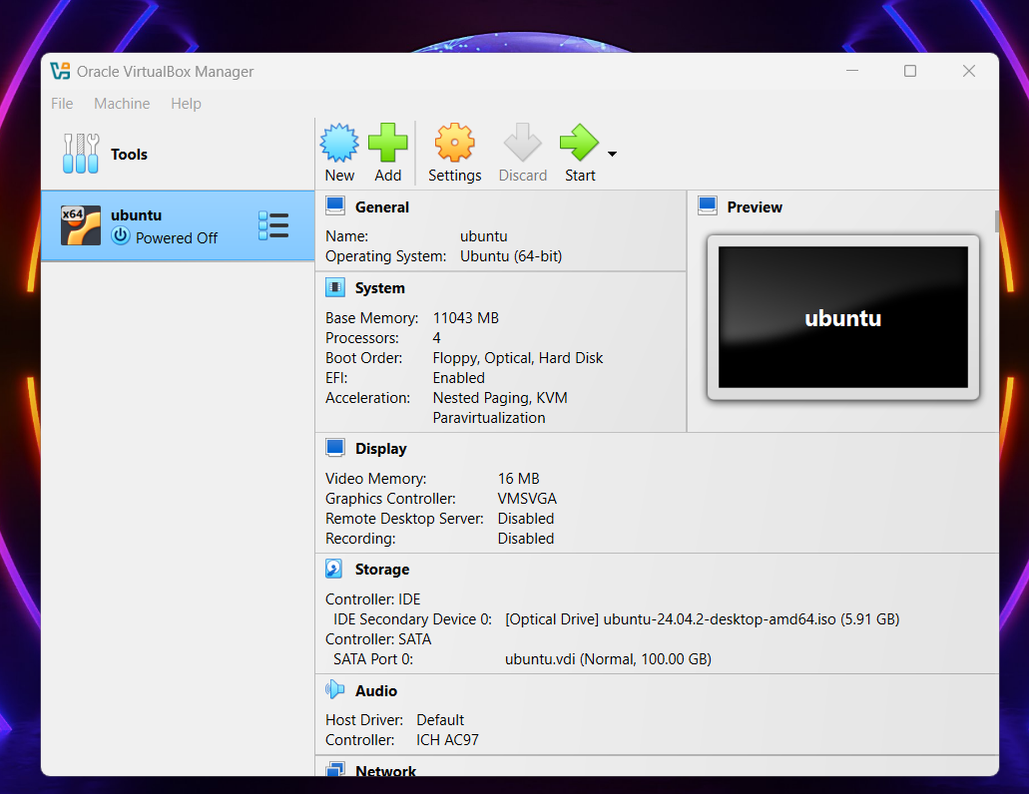

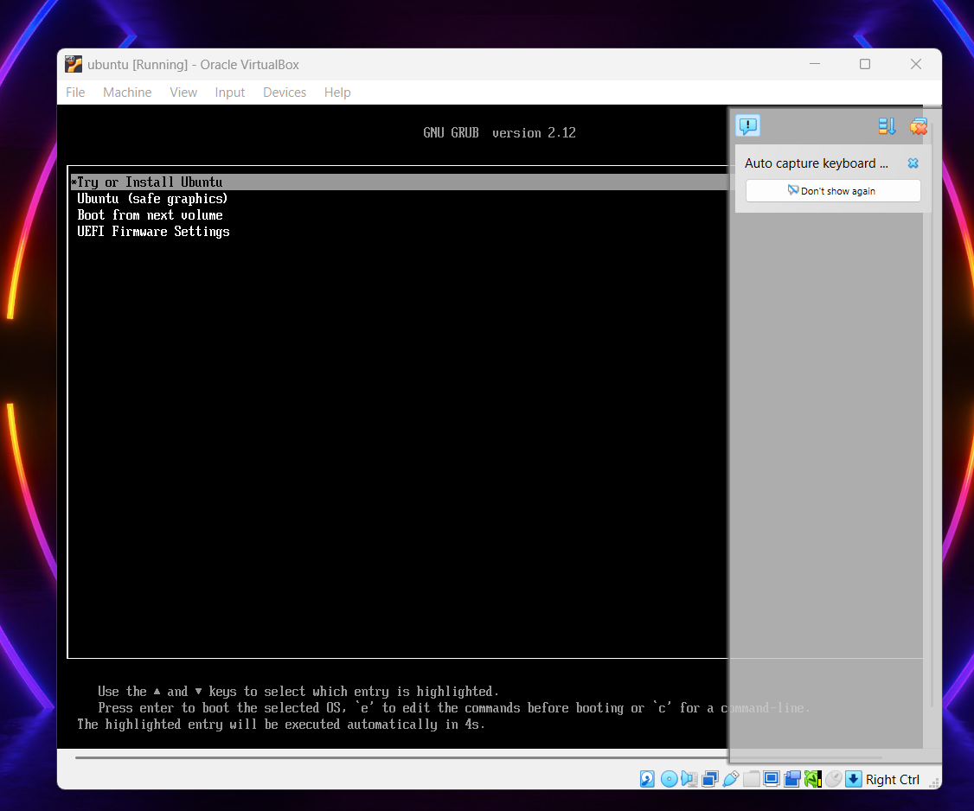

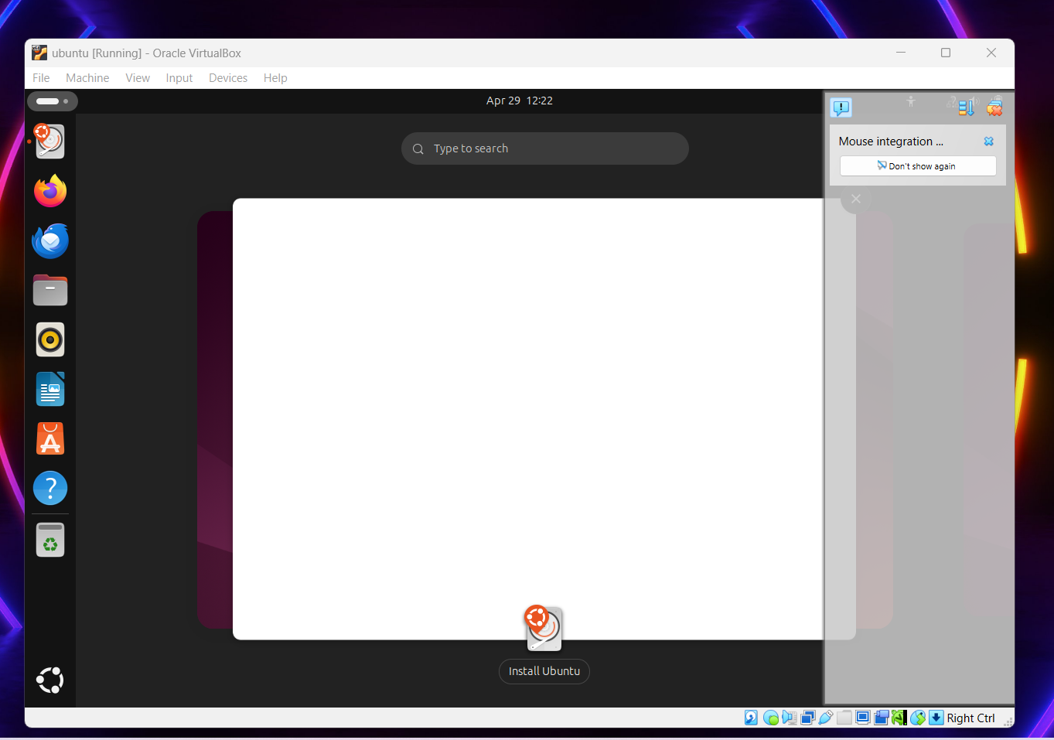

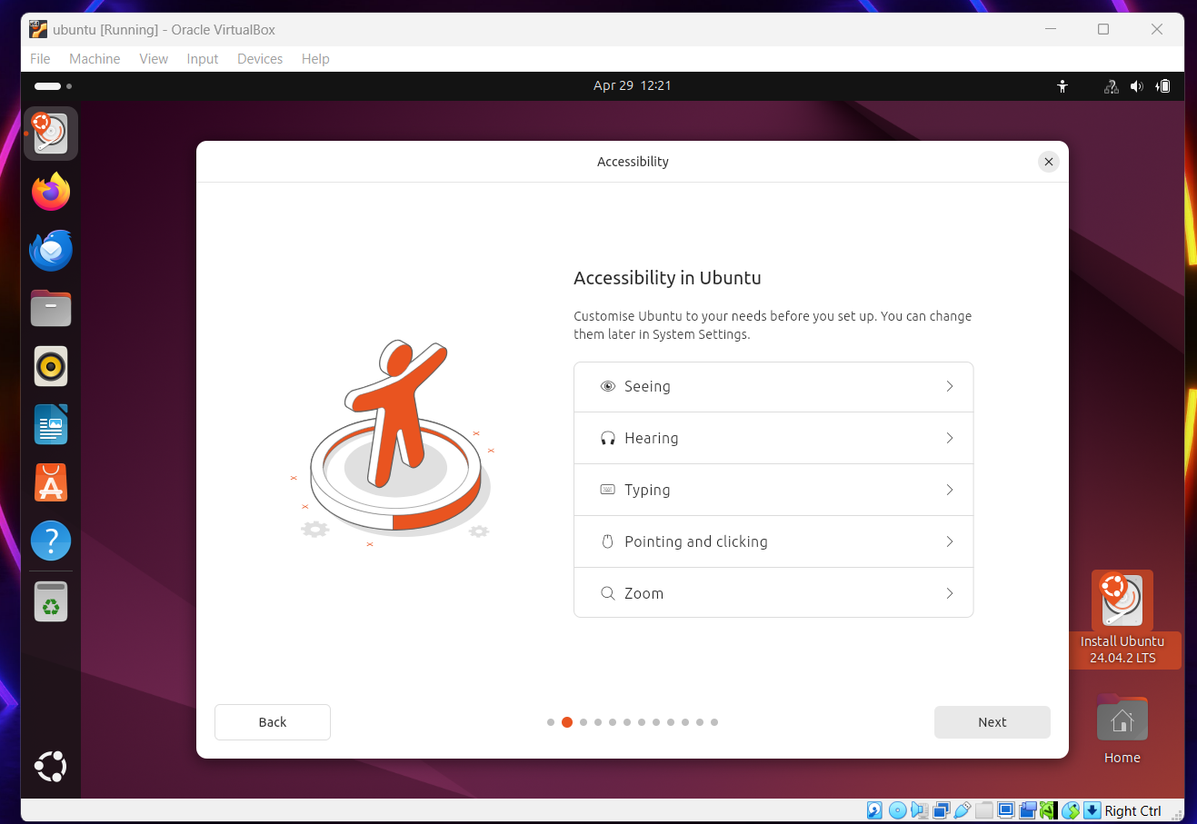

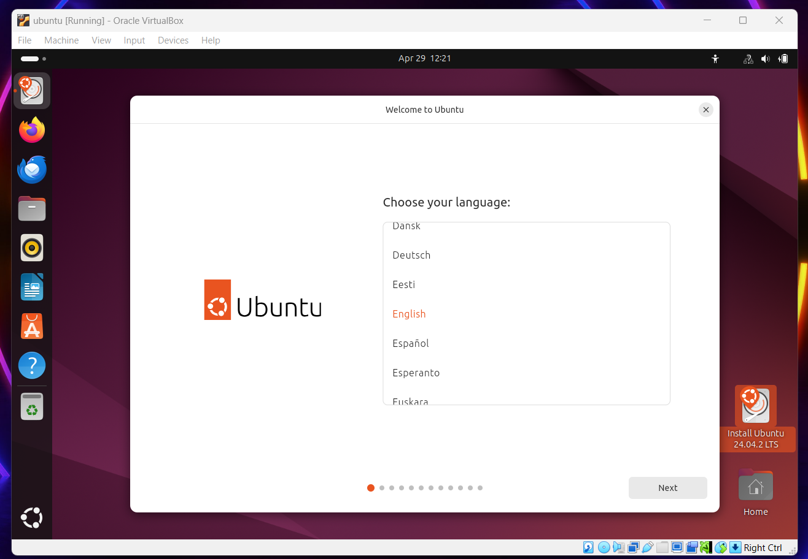

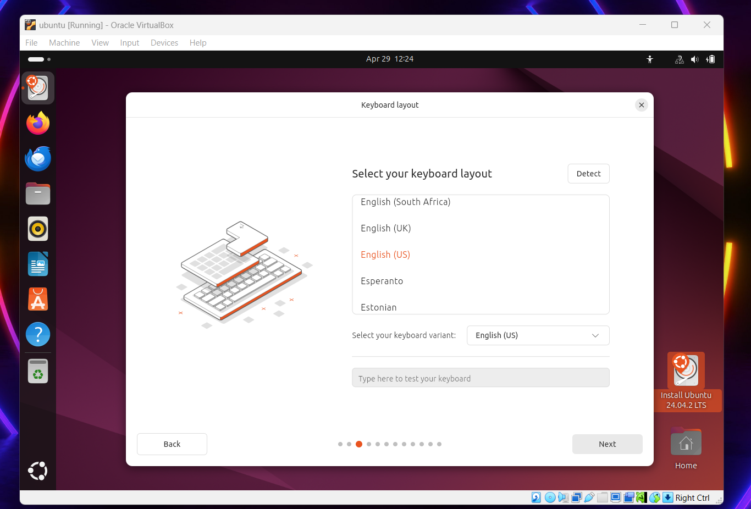

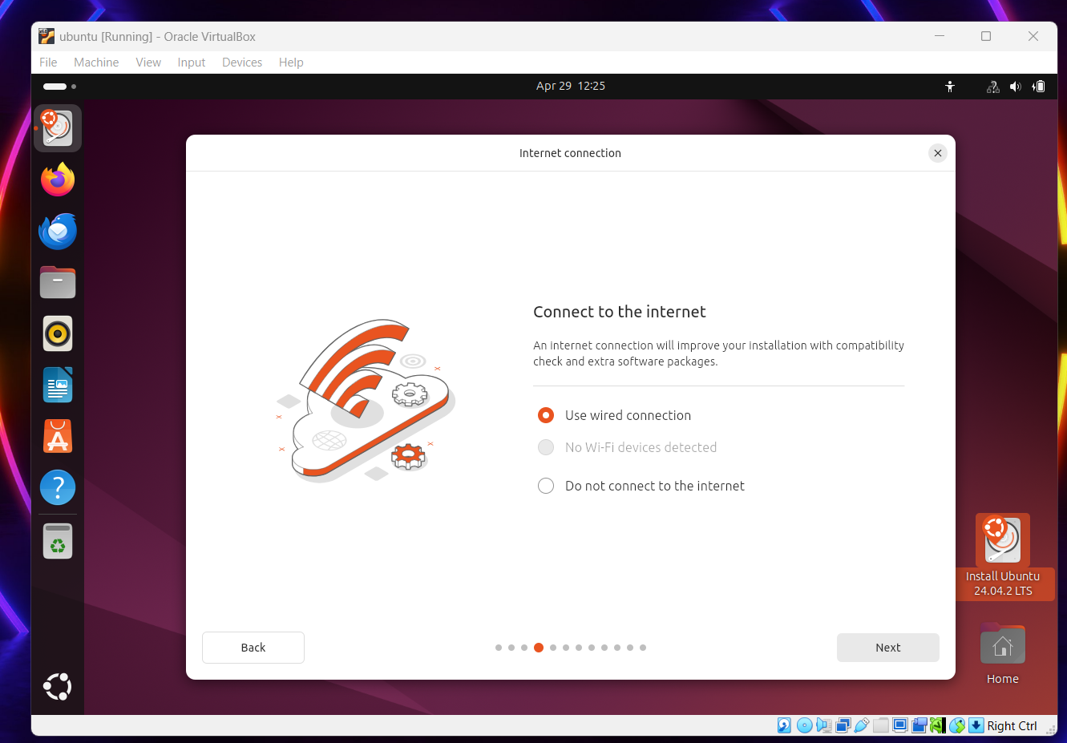

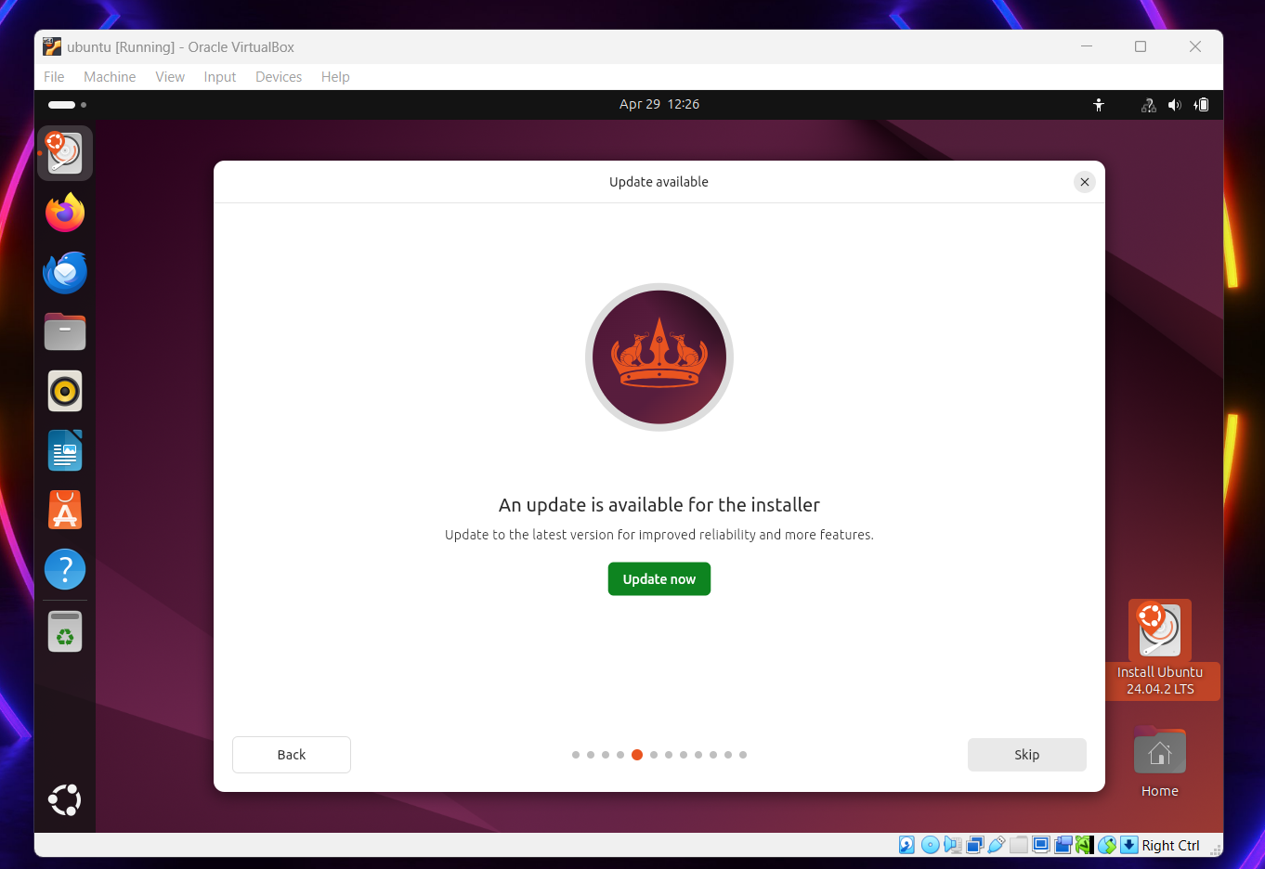

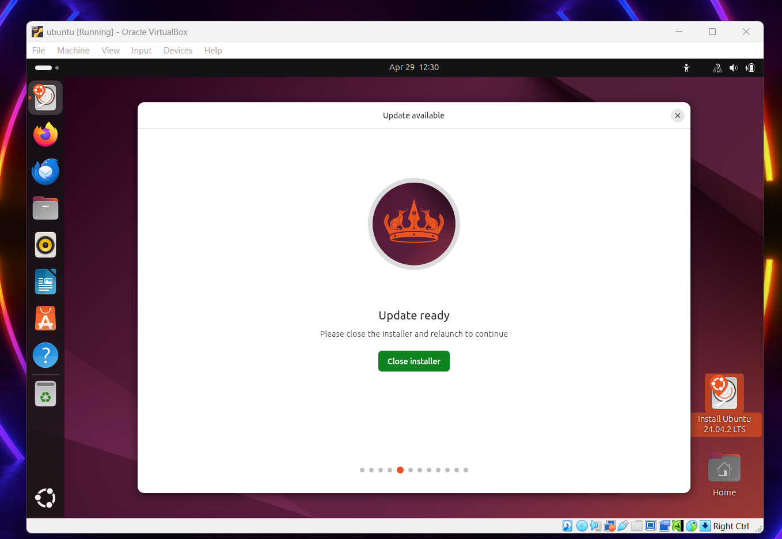

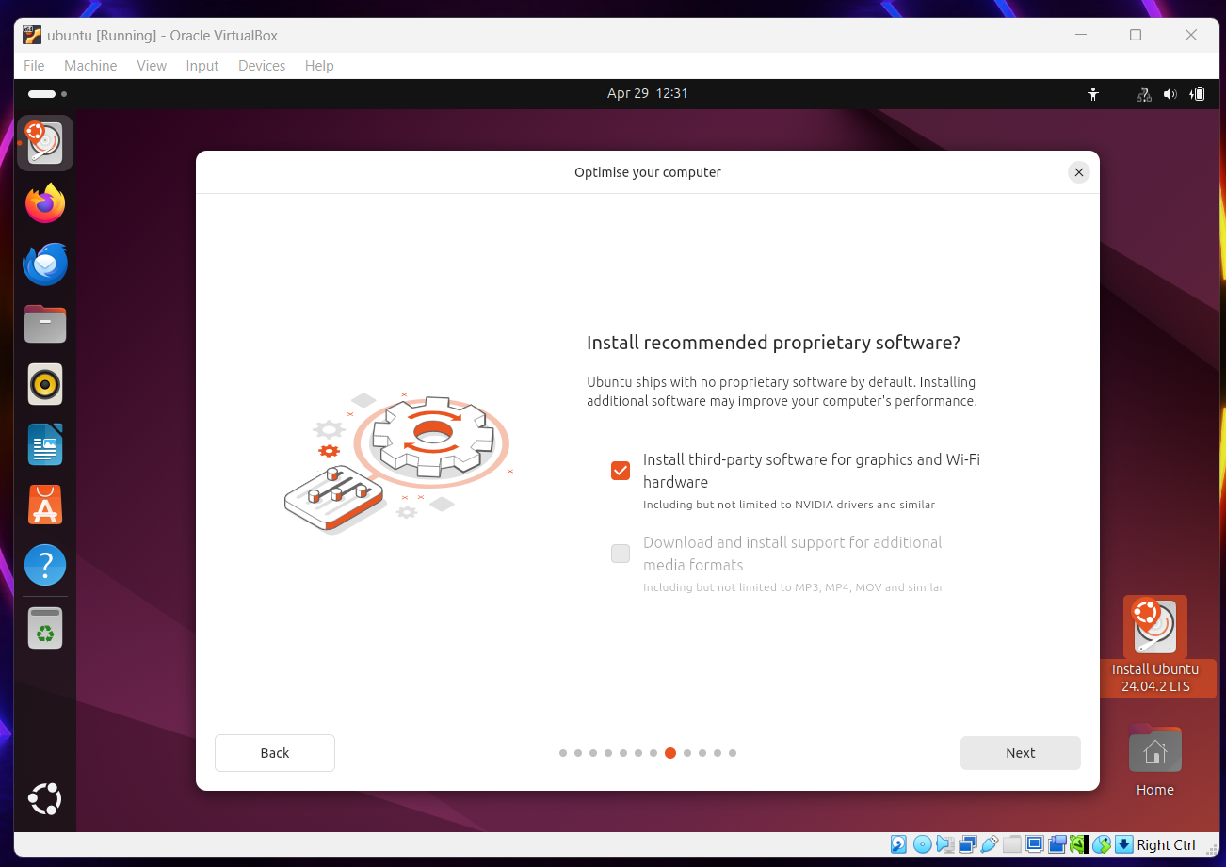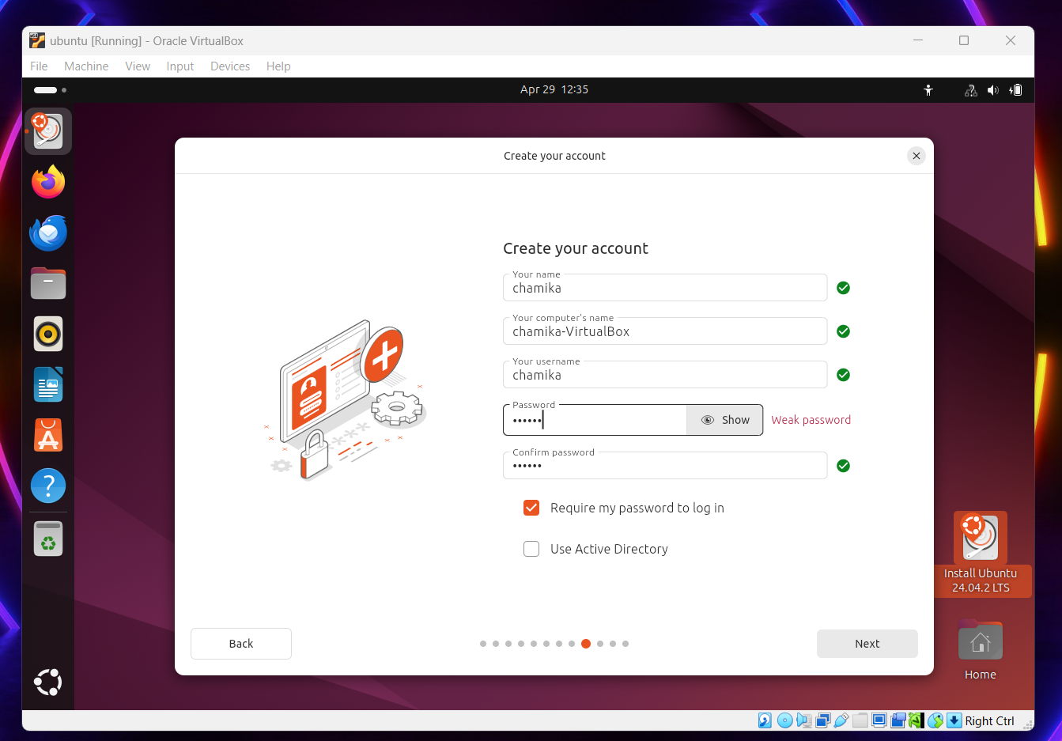

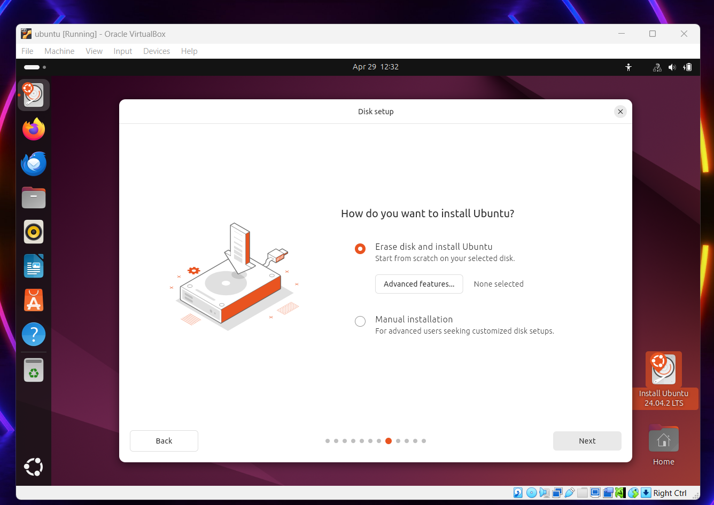

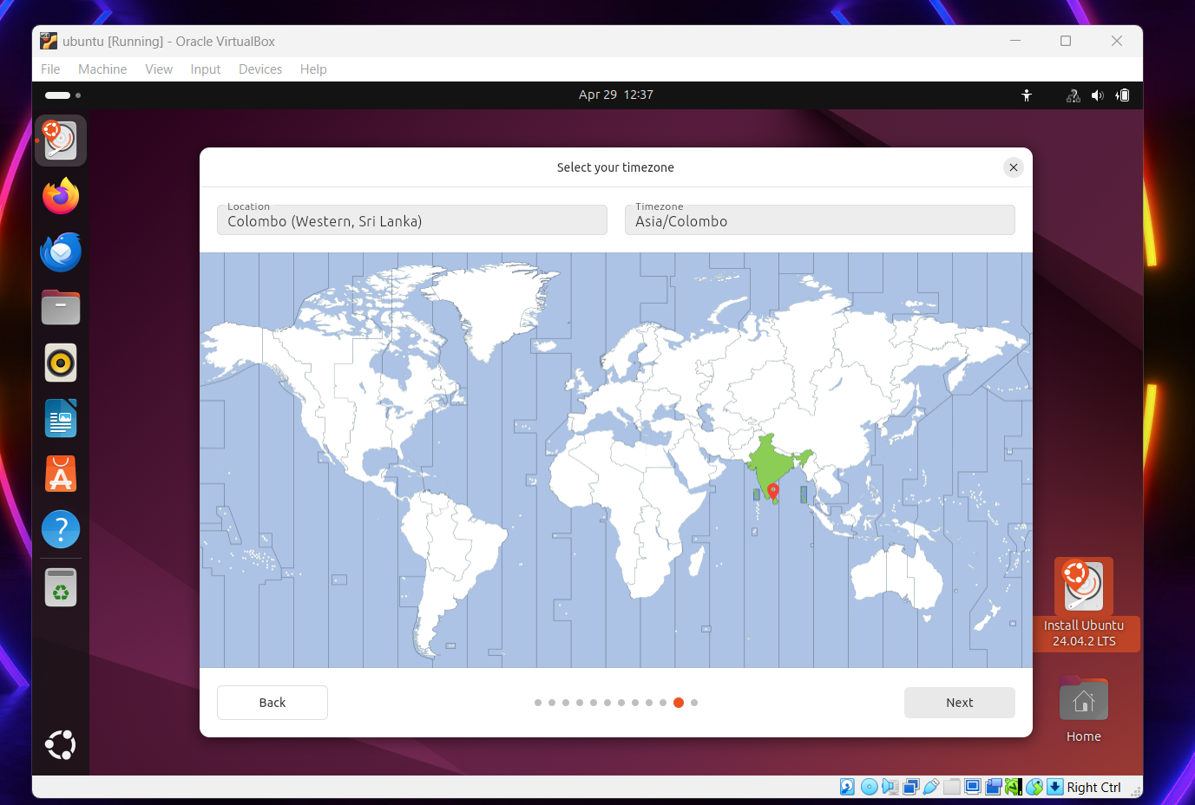

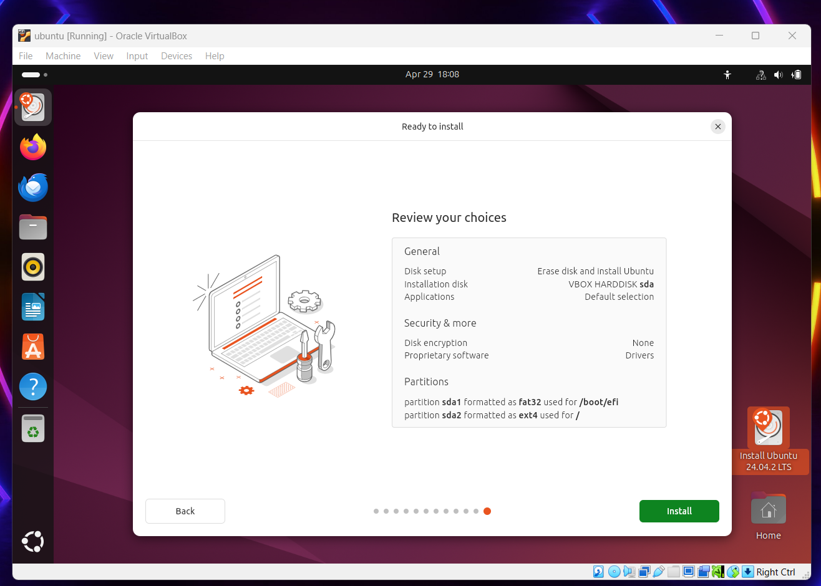

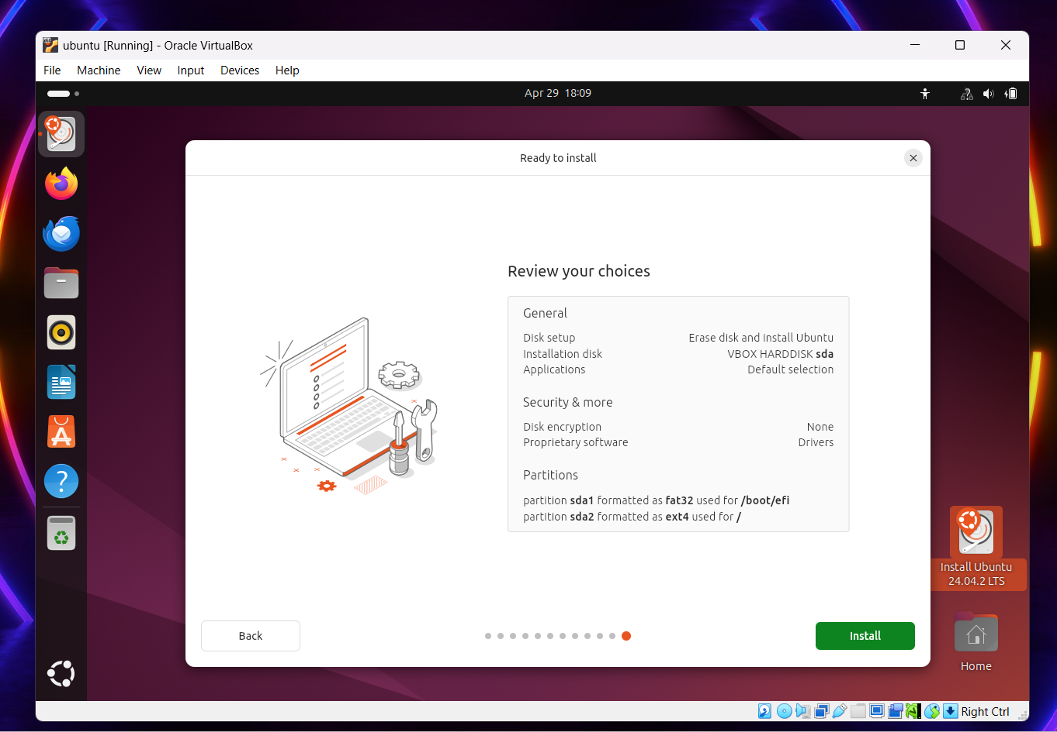

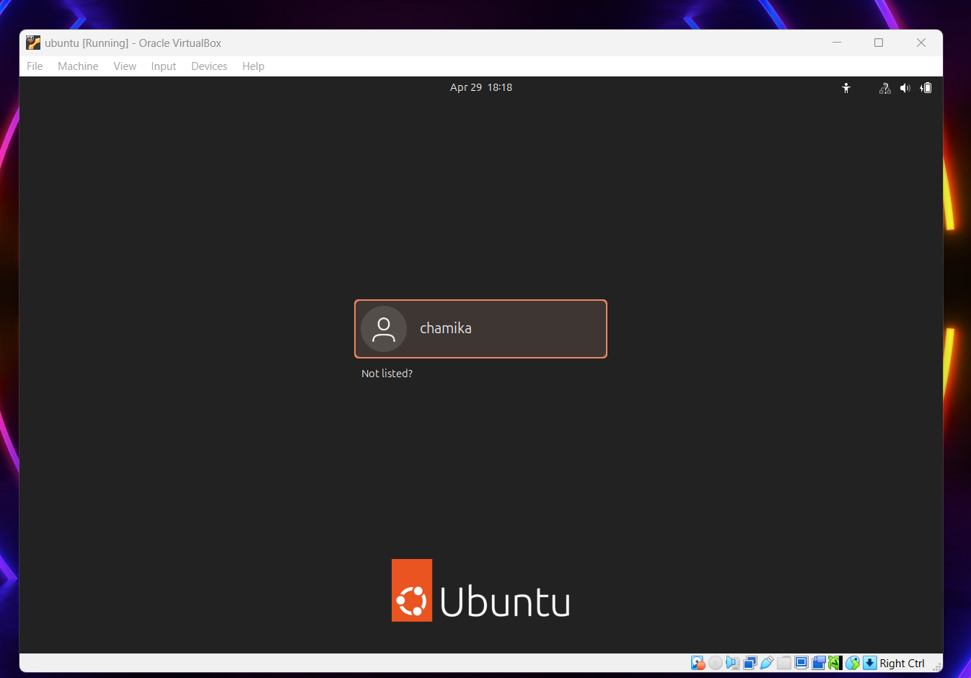

**Command Line Introduction**

**Basic navigation commands**

1.ls:

Lists the files and directories in the current working directory.

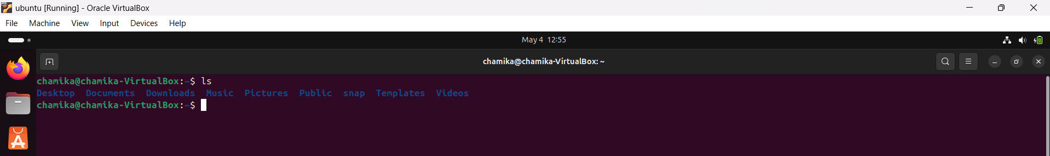

2.cd:

Changes the current directory to a specified one.

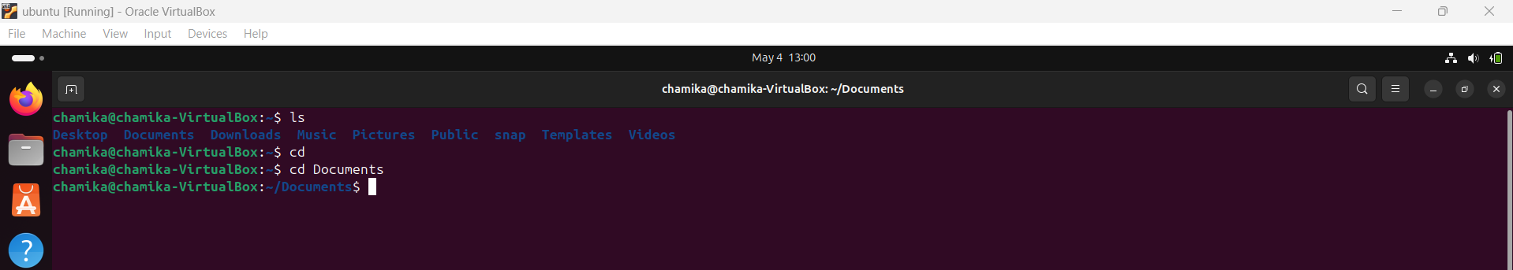

3.Pwd:

Displays the full path of the current working directory.

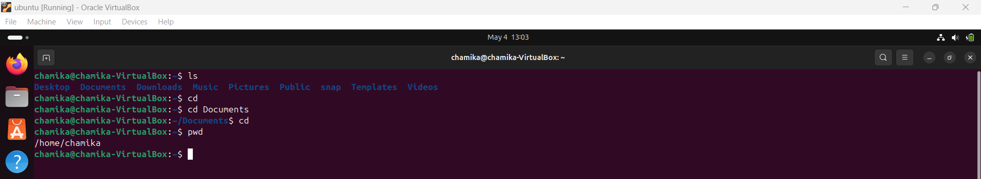

4.mkdir:

Creates a new directory with the given name.

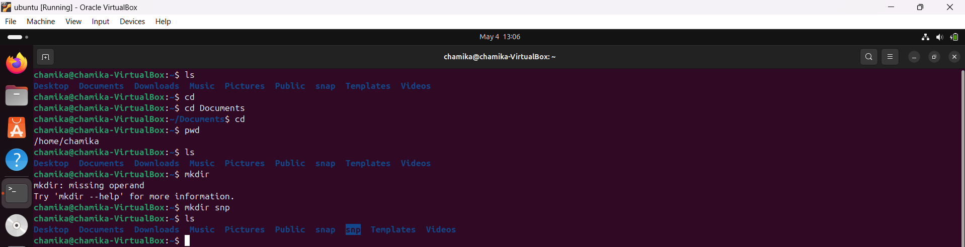

4.rmdir

Deletes an empty directory.

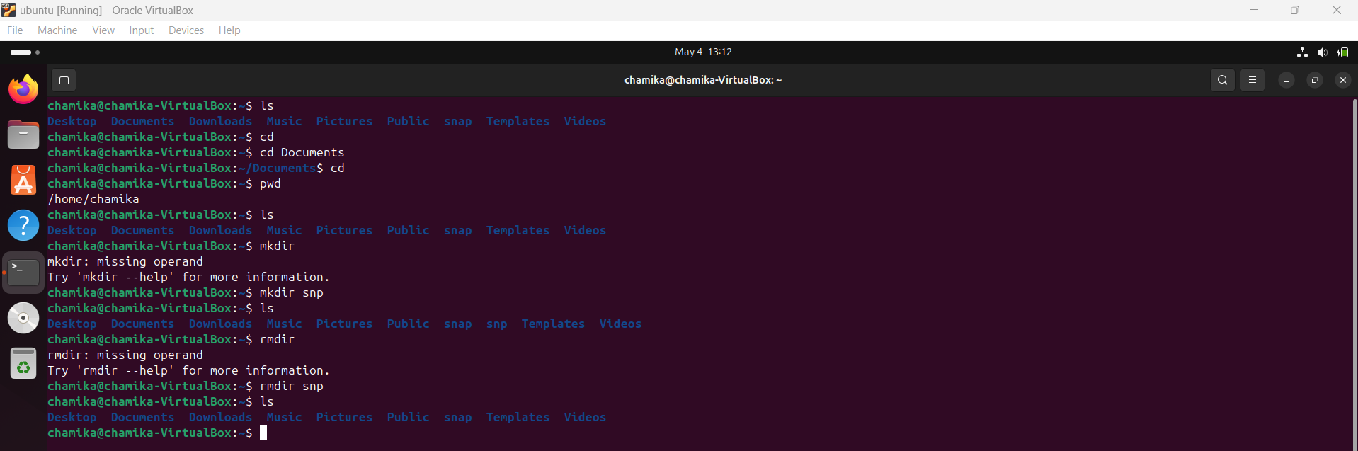

**File manipulation commands**

1.The **touch** command is used to create an empty file in the current directory or update the timestamp of an existing file

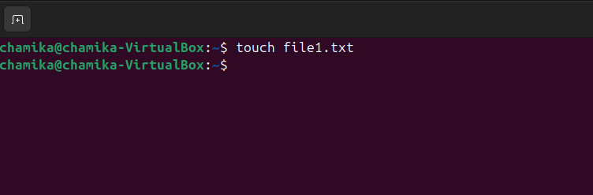

2.The **ls** command is used to list the files and directories in the current directory.

This command displays a list of files and directories in my current working directory. After running the **touch file1.txt** command, using ls will show **file1.txt** as part of the list of files.

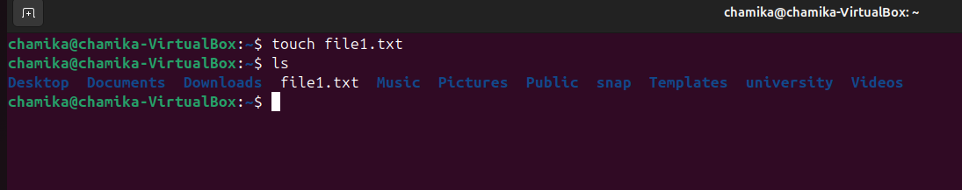

**3. Write text to a file (overwrite):**

The echo command is used to print text to the terminal or write text into a file.

This command writes the text **"Hello, Linux!"** into **file1.txt**. If the file already contains text, it will be replaced with this new text.

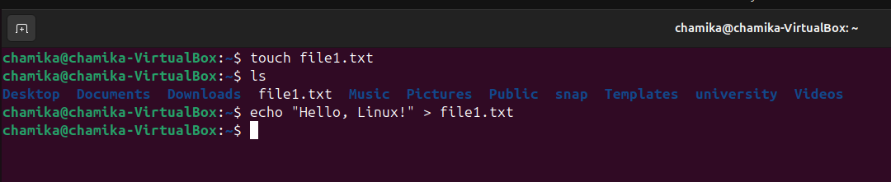

**4.Append text to a file (without overwriting):**

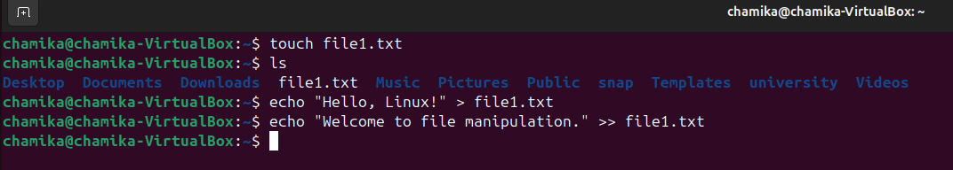This command appends the text **"Welcome to file manipulation."** to the end of **file1.txt**, preserving the existing content. The **>>** operator ensures that the new text is added at the end, instead of replacing the current content.

5.To view the contents of **file1.txt**, use the **cat** command:

This command displays the content of **file1.txt** in the terminal. After using **echo**, running **cat** will show the text inside the file, confirming the changes made by the **echo** commands.

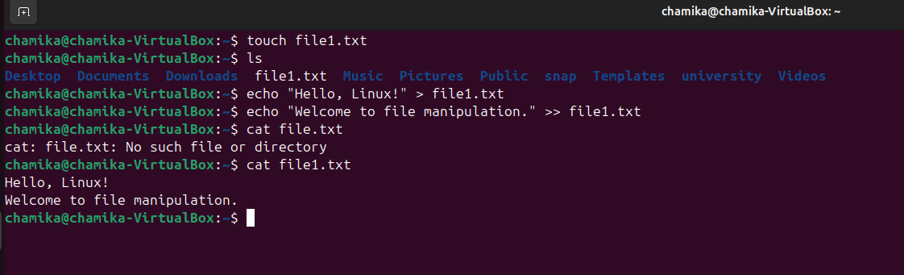

6.The **cp** command is used to create a duplicate of a file or directory.

This command makes a copy of **file1.txt** and saves it **as file2.txt** in the same directory. The original file **(file1.txt)** remains unchanged.

To verify that the copy was successful, use the **ls** command:

This will list all files in the current directory. You should now see both **file1.txt** and **file2.txt**, confirming that the copy was created successfully.

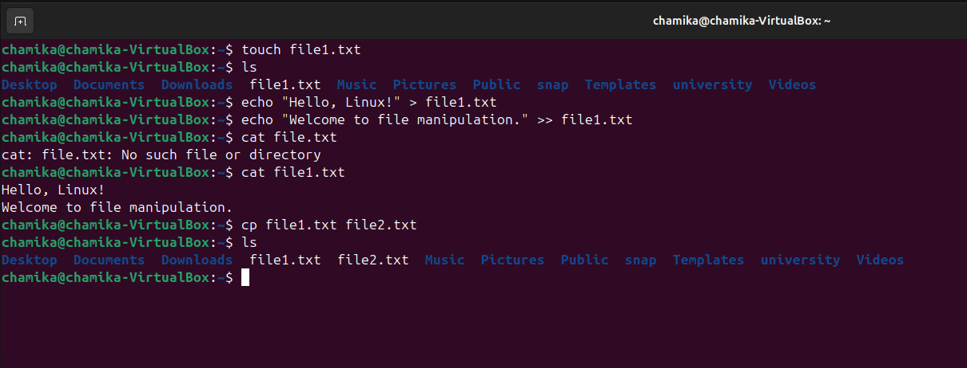

7.The **mv** command is used to move files from one location to another or to rename files.

This command renames **file2.txt** to **renamed_file.**txt in the same directory. The original file name is replaced with the new one.

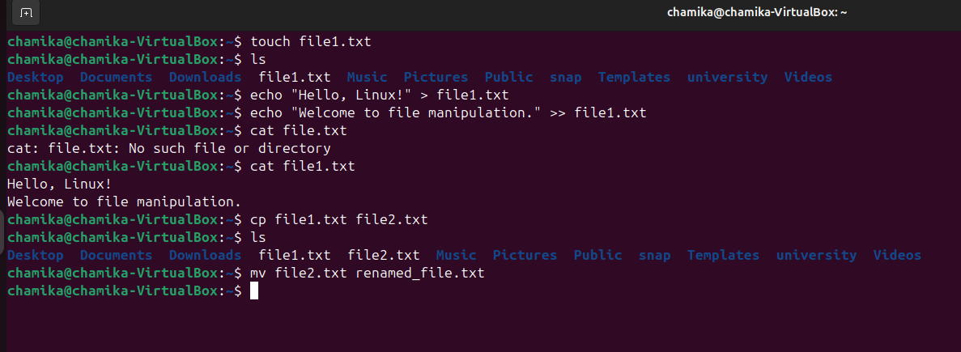

8.This command creates a new directory named **my_folder** in the current location.

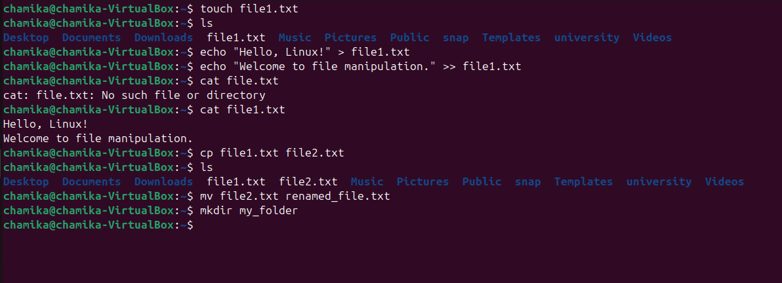

9.This command moves the file **renamed_file.txt** into the **my_folder** directory.

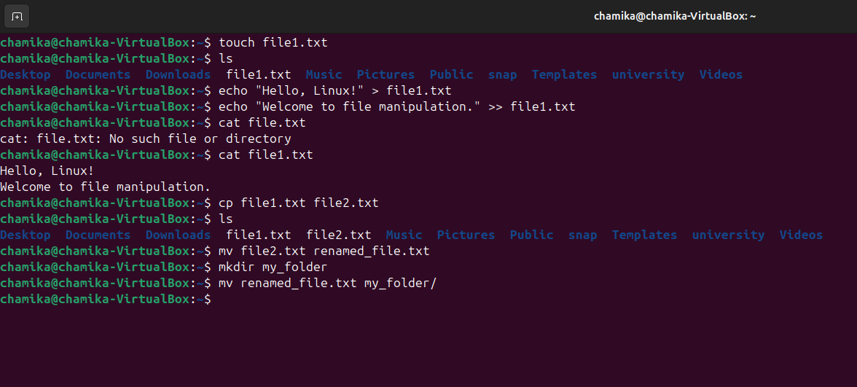

10.This command lists the contents of the **my_folder** directory. I can see **renamed_file.txt** inside it, confirming the move was successful.

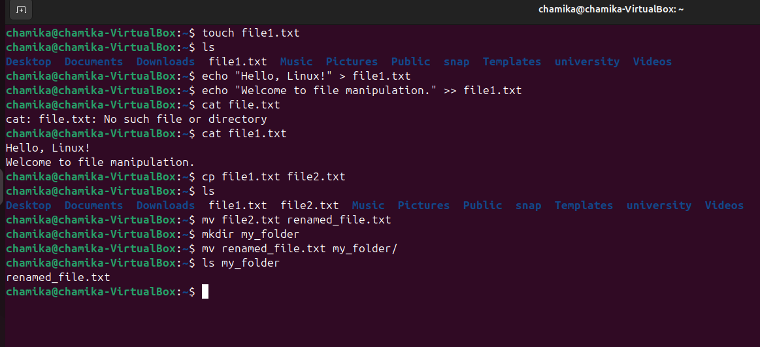

1. The **nano** command opens a simple text editor directly inside the terminal. It's user-friendly and ideal for quickly editing text files.

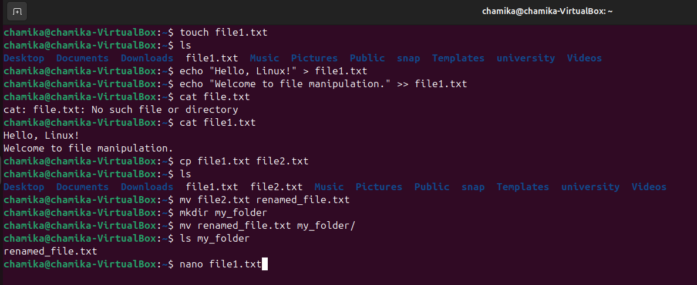This command opens **file1.txt** in the **nano editor**. If the file doesn't exist, it will create a new one with that name.

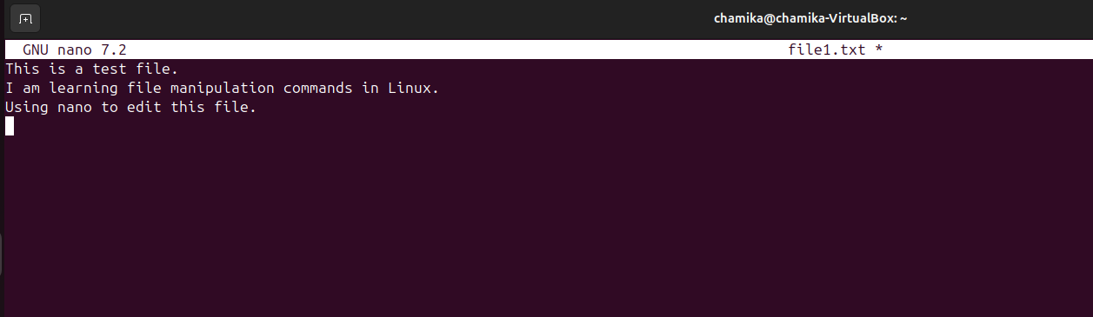

After typing this:

1. Press **Ctrl + O t**o save.
2. Press **Enter** to confirm the filename.
3. Press **Ctrl + X** to exit.

Then you i use **cat file1.txt** to view what i wrote.

* 1. This command displays the updated content of file1.txt in the terminal, allowing you to confirm your changes.

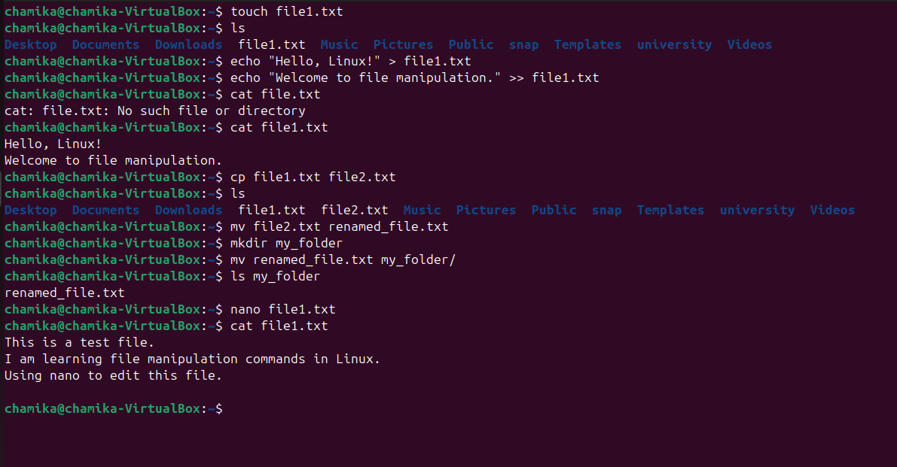

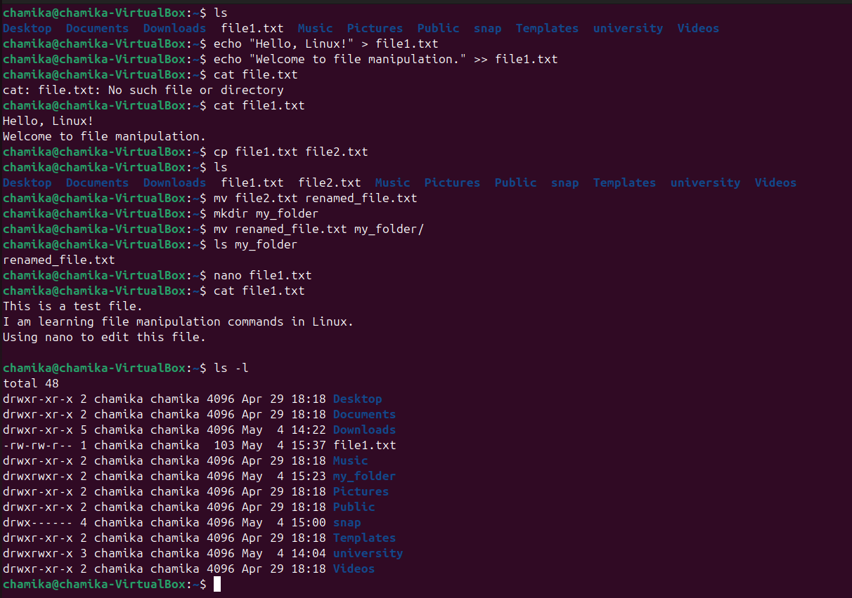**12** To see more detailed information about files, such as **file size, permissions, owner, and last modified time**, use:

**13** The **rm** command is used to **remove (delete) files** permanently from your system

This command deletes the file named file1.txt from the current directory. **Once deleted, it cannot be recovered**.

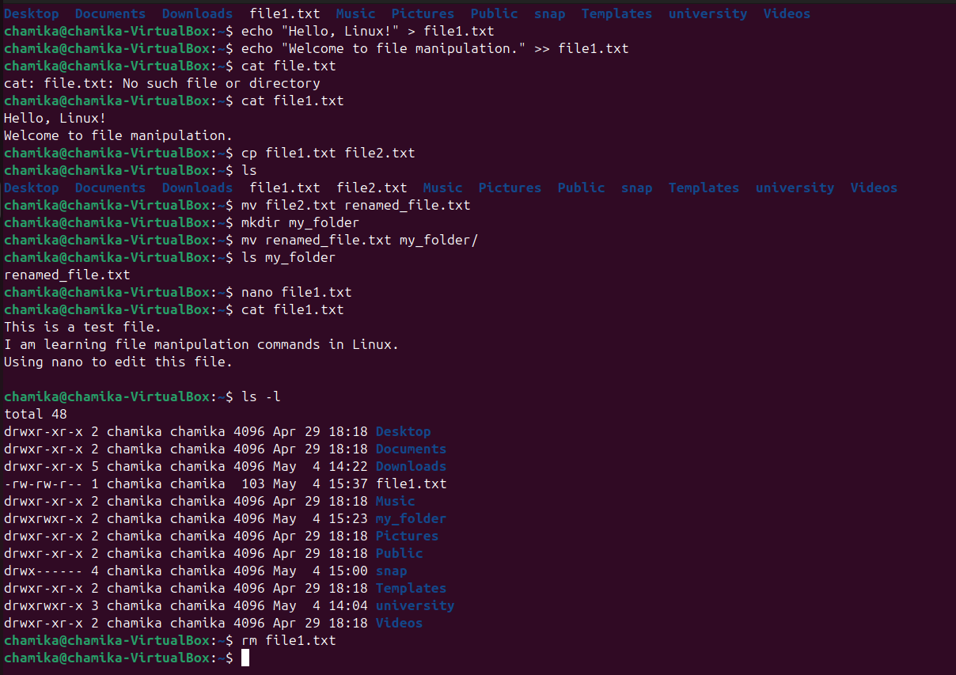

**14.** This will list the current files in the directory. **If file1**.txt was successfully removed, it will no longer appear in the list.

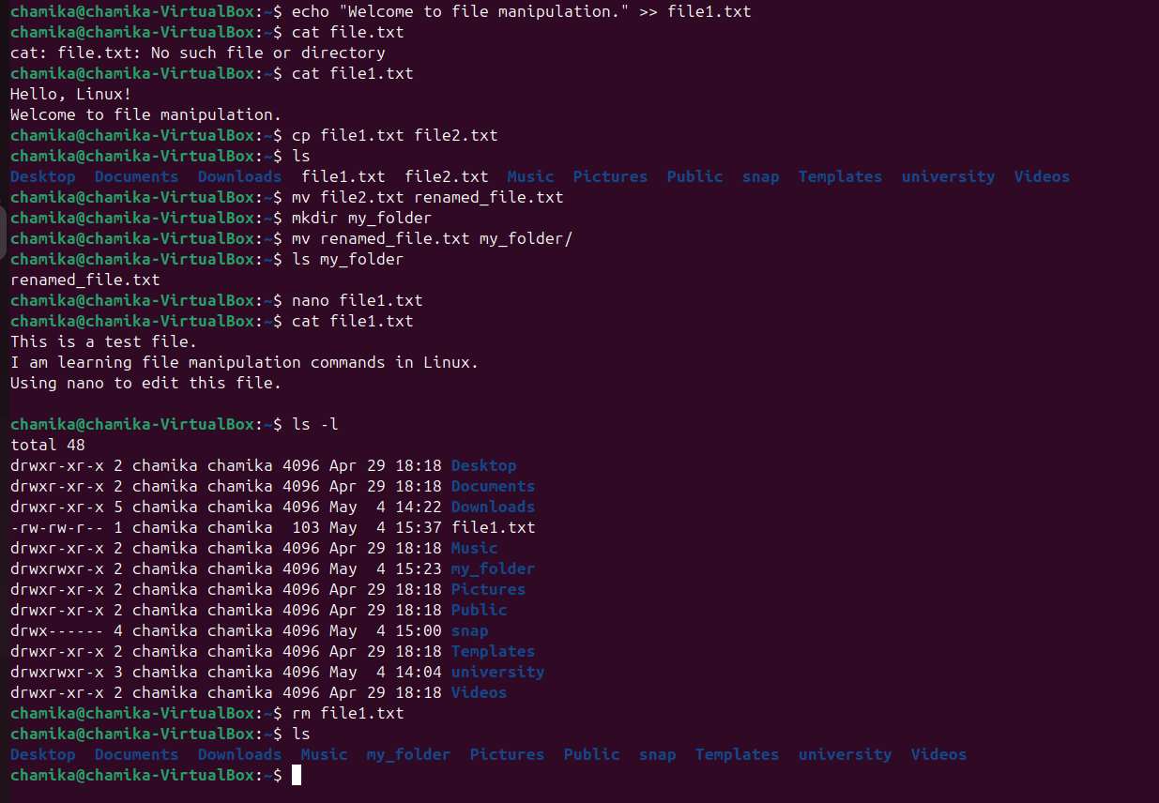

14. more commands can see what are the things in file1.txt

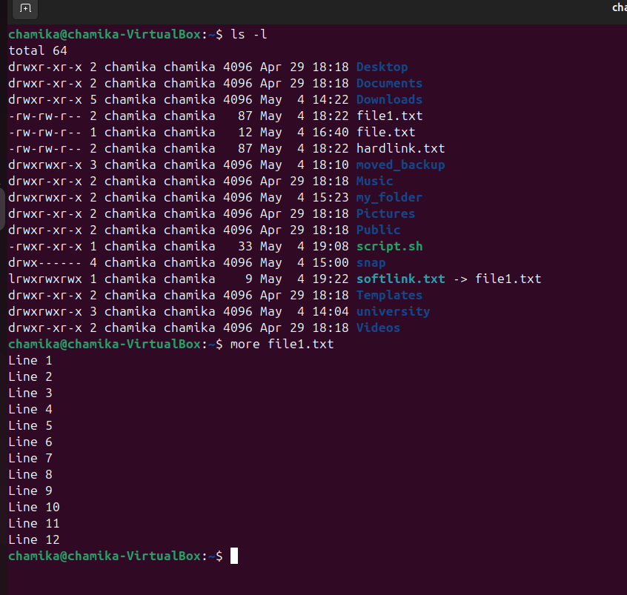

**System Information and User Management**

**system information commands**

|  |
| --- |
| **1.uname -a** |

|  |
| --- |
| Displays kernel name, version, and system architecture. |

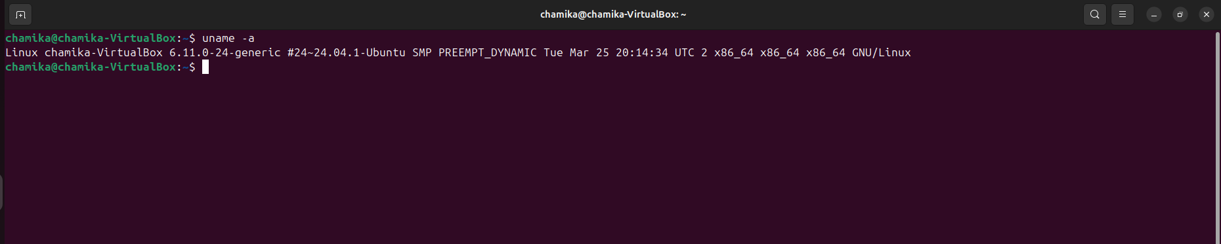

|  |
| --- |
| **2.hostname** |

|  |
| --- |
| Shows the system's hostname. |
| |  | | --- | | **3.uptime** |  |  | | --- | | Tells how long the system has been running. | |

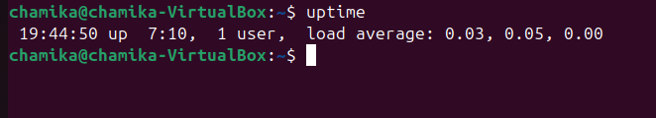

|  |
| --- |
| **4.cat /etc/os-release** |

|  |
| --- |
| Displays operating system name and version. |

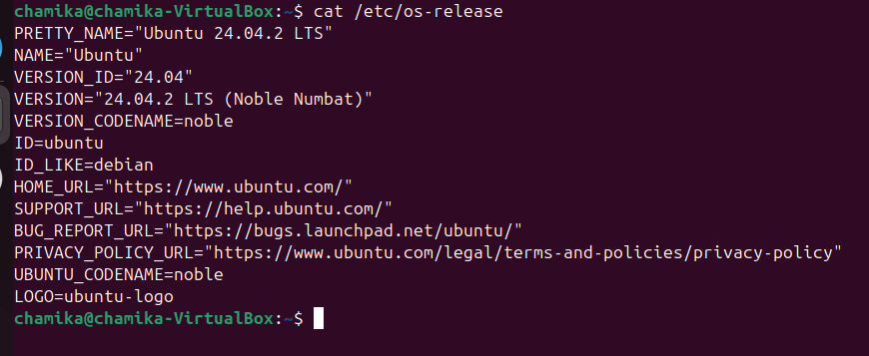

|  |
| --- |
| **5.lscpu** |

|  |
| --- |
| Lists CPU architecture and specifications. |
|  |
| |  | | --- | | **6.free -h** |  |  | | --- | | Shows used and available memory. | |

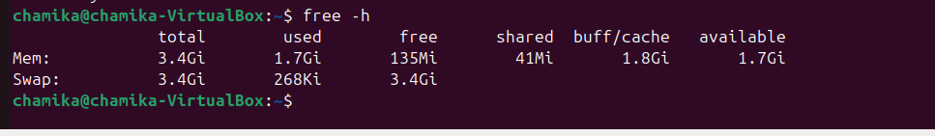

|  |
| --- |
| **7.df -h** |

|  |
| --- |
| Displays disk space usage of file systems. |
|  |
| |  | | --- | | **8.lsblk** |  |  | | --- | | Lists all block devices (drives and partitions). | | |  | | --- | | **9.top / htop** |  |  | | --- | | Monitors real-time processes and system performance. | | |

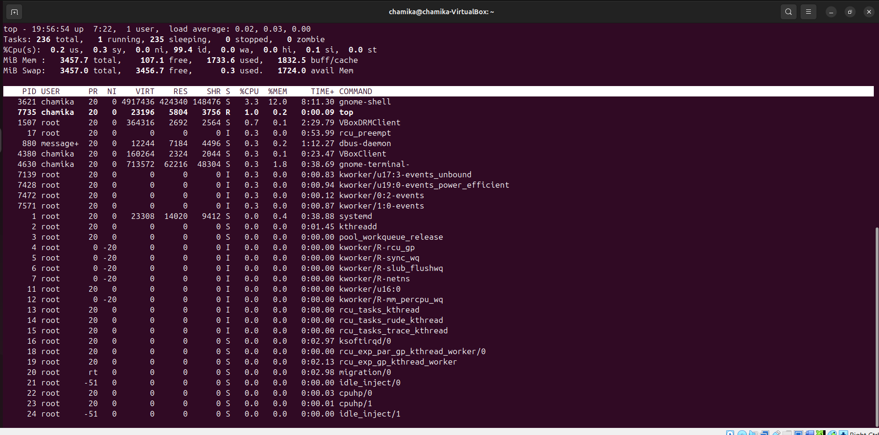

|  |
| --- |
| **10.vmstat** |

|  |
| --- |
| Reports memory, CPU, and I/O statistics. |

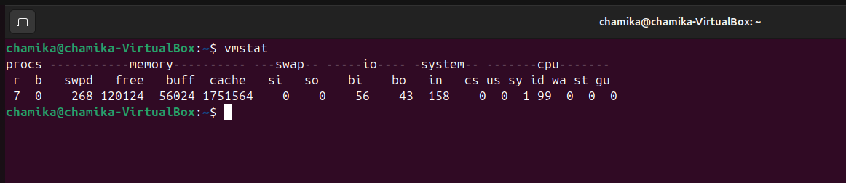

|  |
| --- |
| **11.cat /proc/version** |

|  |
| --- |
| Shows detailed kernel version and compiler info. |

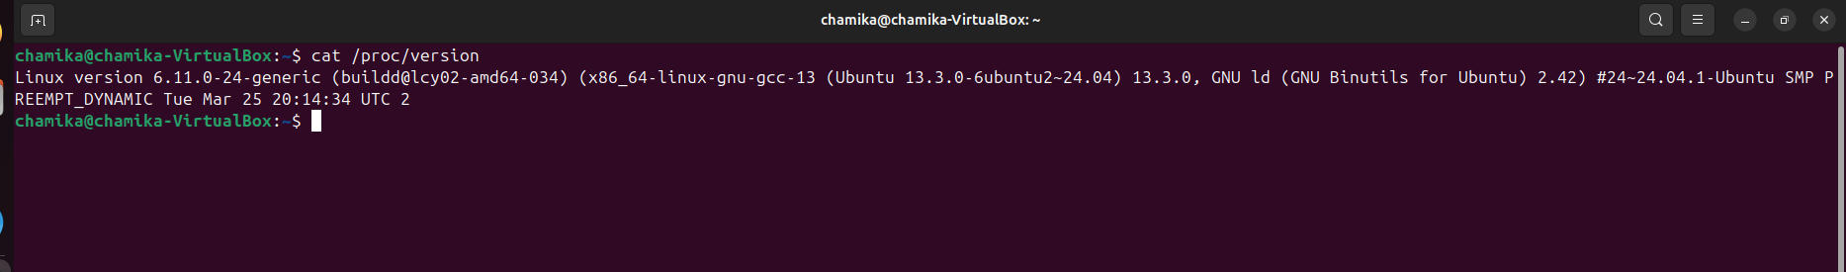

|  |
| --- |
| **12.free -m** |

|  |  |
| --- | --- |
| Shows memory usage in MB | |
| **User Management Commands** | |
| **1.whoami** |

|  |
| --- |
| Displays the currently logged-in user. |
| |  | | --- | | **2.id** |  |  | | --- | | Shows UID (User ID), GID (Group ID), and groups of the user. |  |  | | --- | | **3.who** |  |  | | --- | | Lists all users currently logged in. |      |  | | --- | | **4.users** |  |  | | --- | | Shows a list of users currently logged into the system. |      |  | | --- | | **5.cat /etc/passwd** |  |  | | --- | | Lists all user accounts with their user details. | |  |  |  | | --- | | **6.cat /etc/group** |  |  | | --- | | Displays all groups and their members. |     **7.passwd**  using this command we can change the password of currently logged in account.    **8. useradd**  using this command crate new user account for virtual machine Basic syntax with default settings is like useradd [option] username.    **15 basic linux commands** |
|  |

### **1. ifconfig**

* **Description**: Displays information about all network interfaces (IP, MAC address, status).

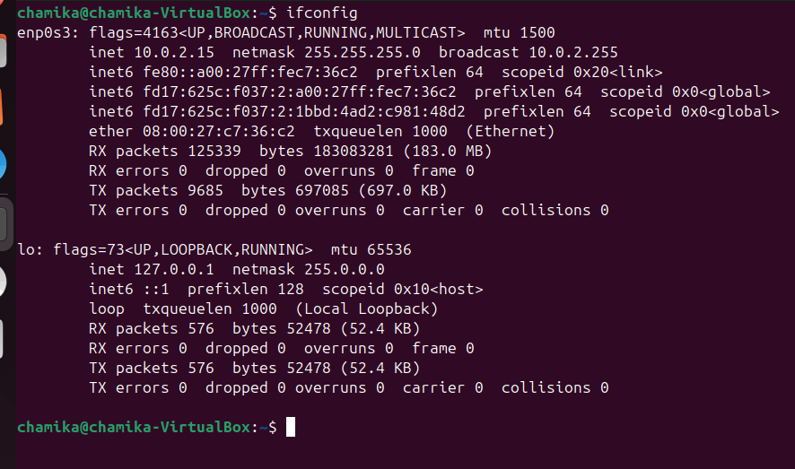

### **2. ip a or ip addr**

* **Description**: Shows IP addresses and details of network interfaces; similar to ifconfig.

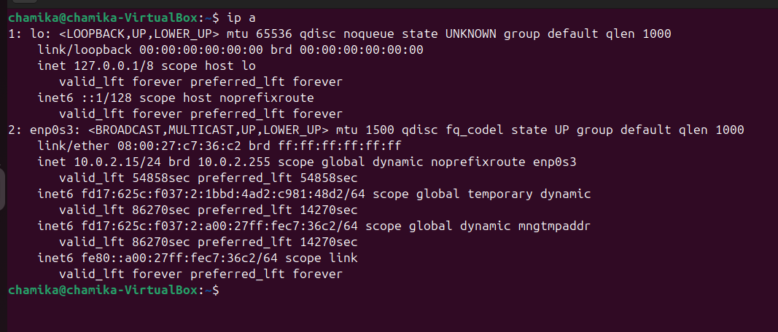

### **3. grep**

* **Description**: Searches for specific text or patterns within file

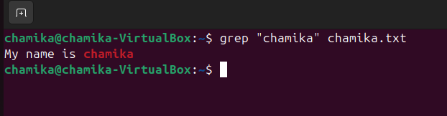

### **4. uptime**

* **Description**: Displays how long the system has been running, including load averages.

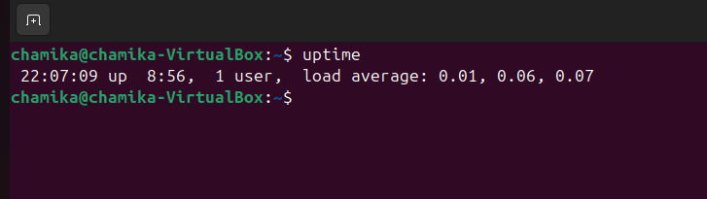

### **5. man**

* **Description**: Opens the manual page of any command for detailed information.

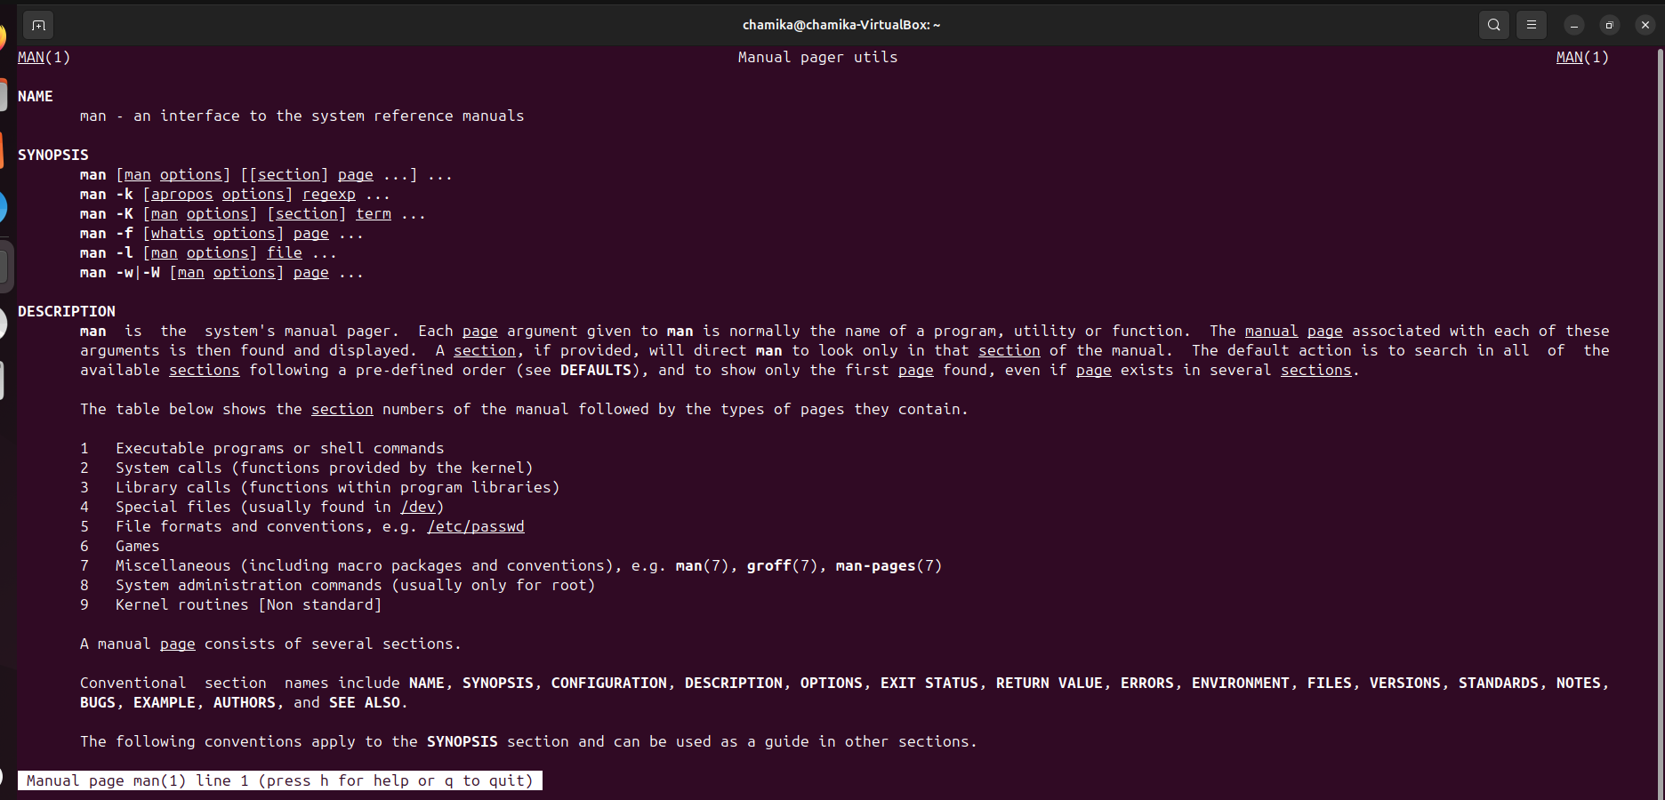

### **6. sudo su**

* **Description**: Switches the current user to the superuser (root) with administrative privileges.

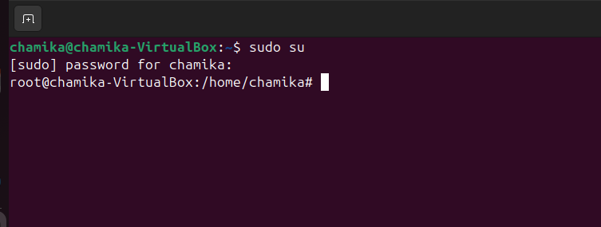

### **7. history**

* **Description**: Displays the list of previously used commands in the terminal.

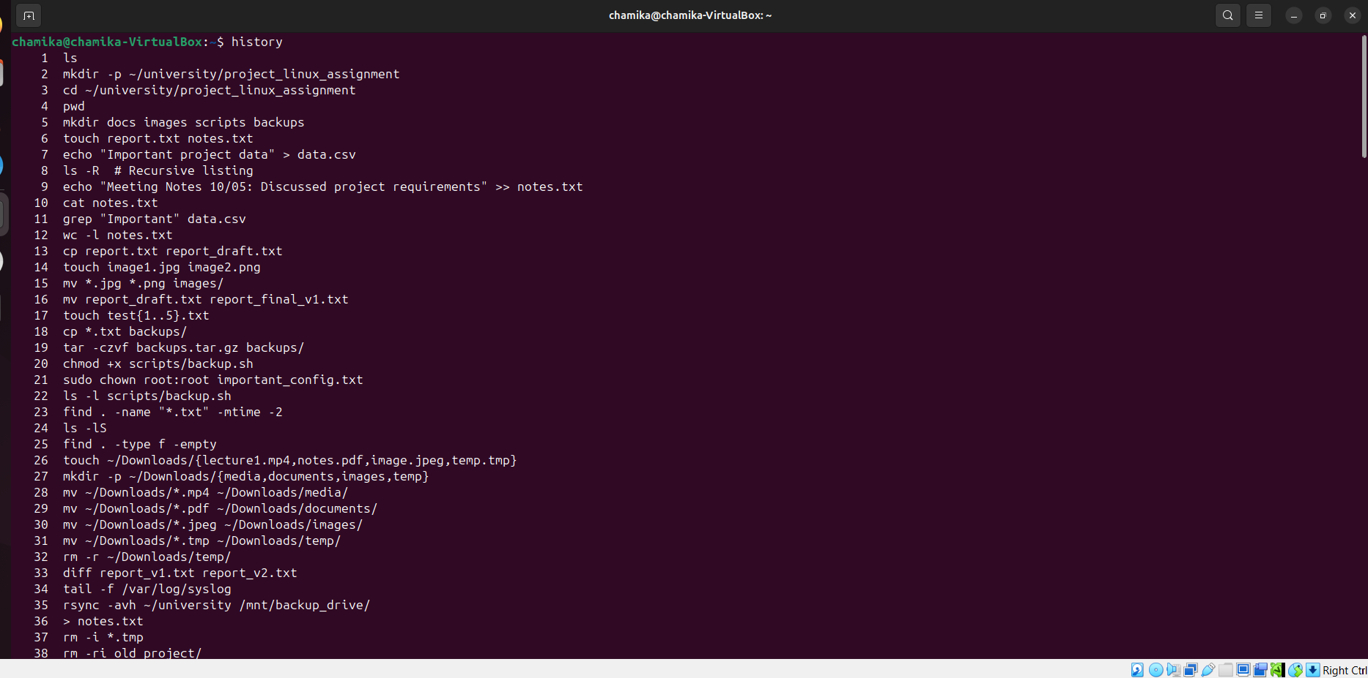

### **8. touch**

* **Description**: Creates a new, empty file.

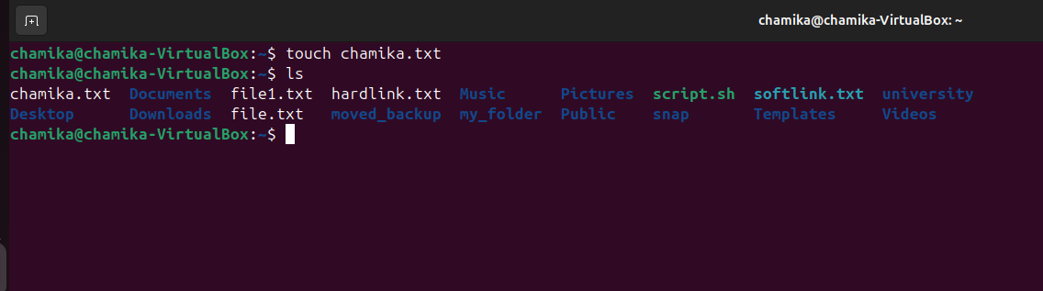

### **9. rm**

* **Description**: Removes files or directories (permanently deletes them).

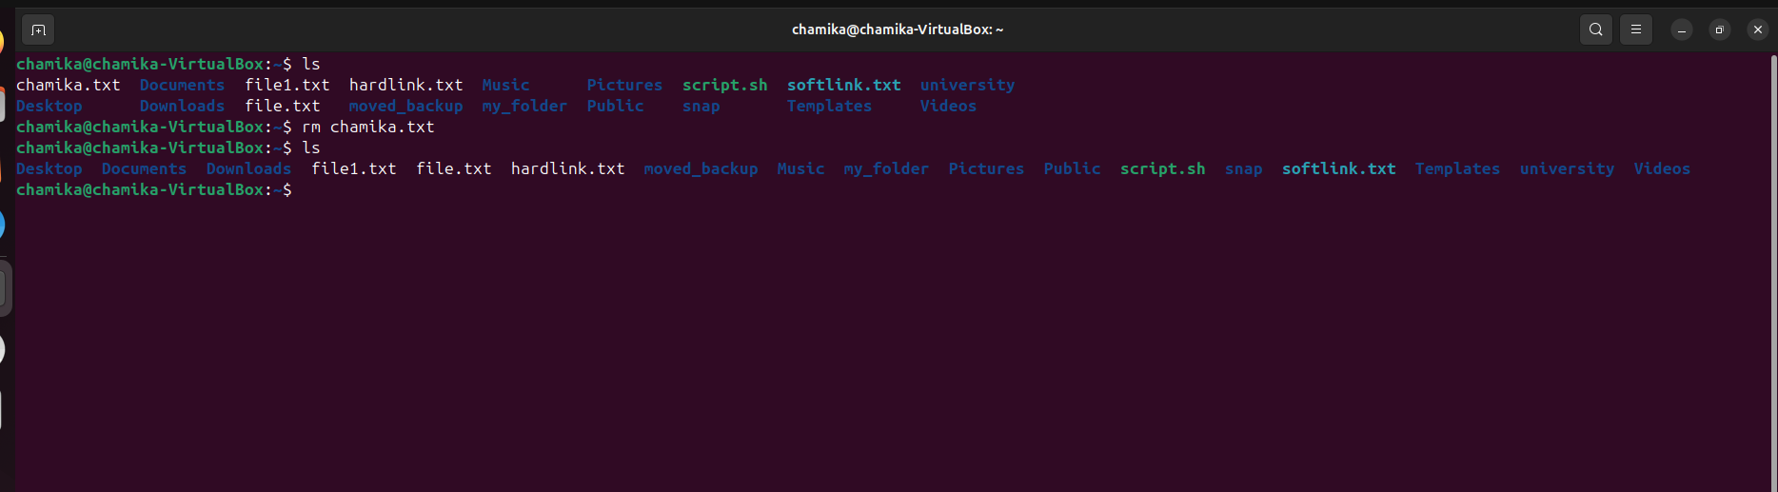

### **10. who**

* **Description**: Displays currently logged-in users on the system.

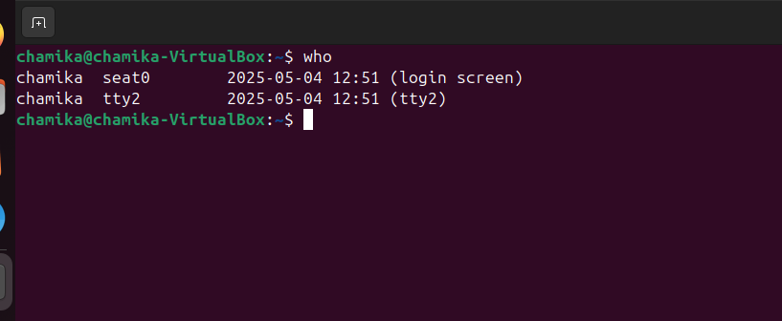

### **11. last**

* **Description**: Shows login history of users, including login time and IP address.

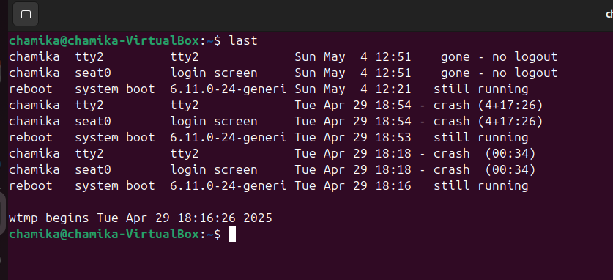

### **12. head**

* **Description**: Displays the first 10 lines of a file by default (top to bottom).

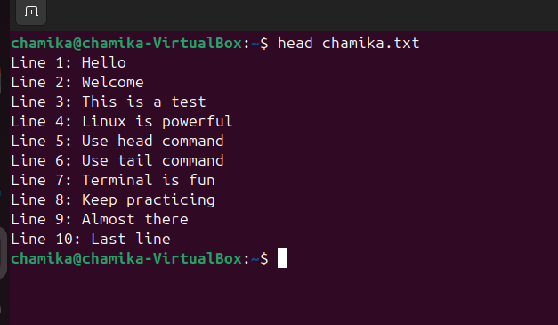

### **13. tail**

* **Description**: Displays the last 10 lines of a file by default (bottom to top).

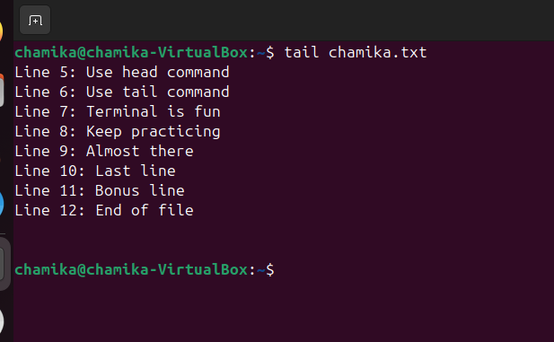

### **14. chmod**

* 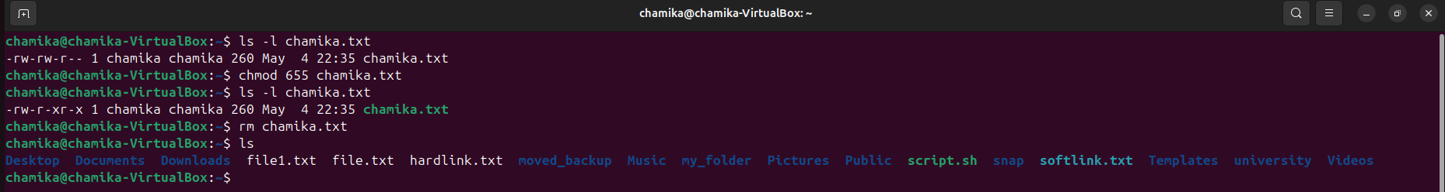**Description**: Changes permissions (read/write/execute) of a file or directory.

### **15. env**

* **Description**: Displays all current environment variables and system configuration data.

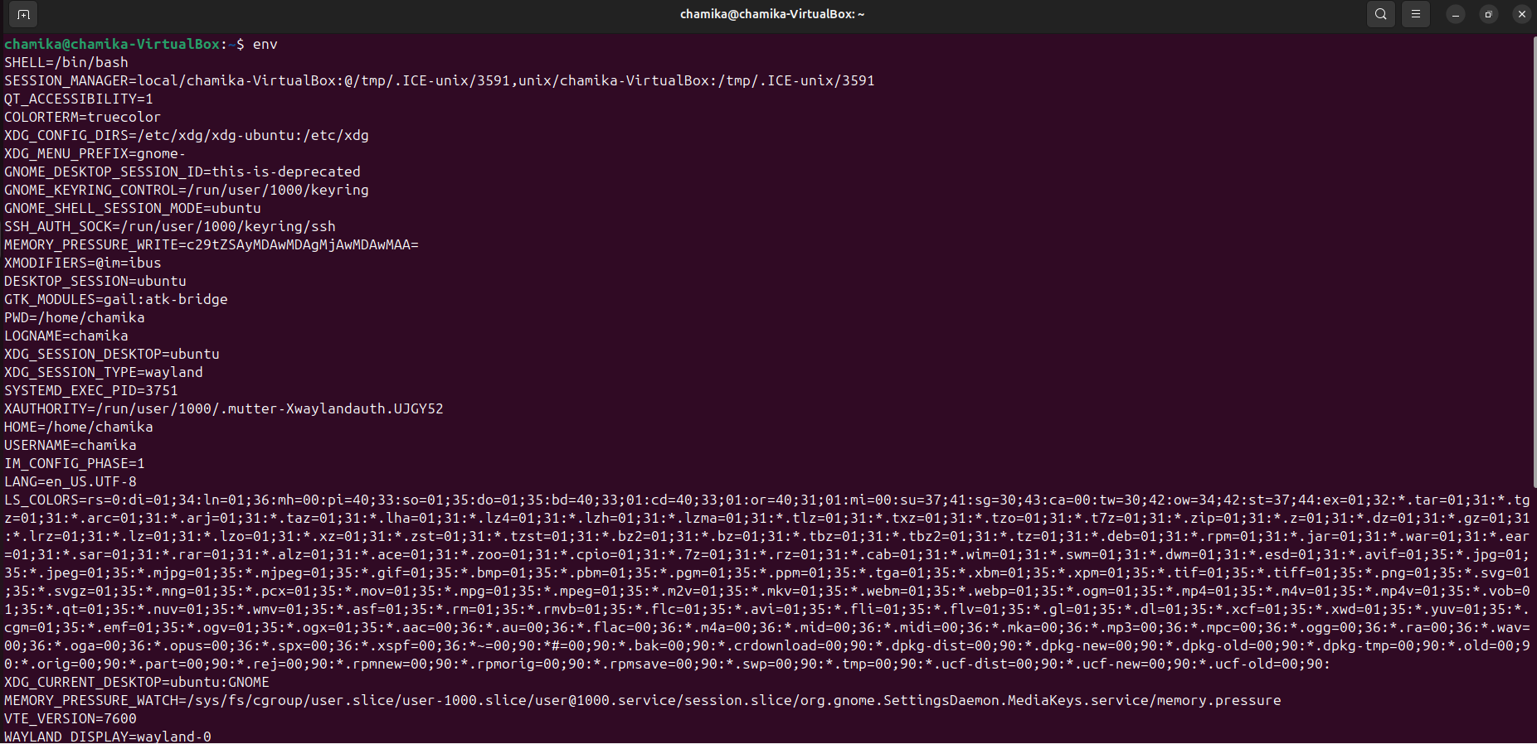

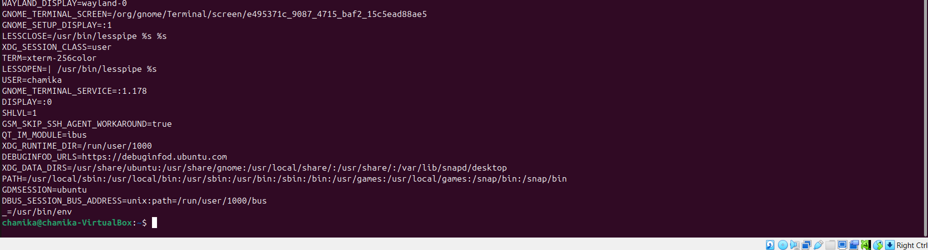

I USED VMWERE WORKSTATION TO DO ALL PARTS

BELOW

**2. DHCP, DNS and NTP Services configuration**

**2.1DHCP(Dynamic Host Configuration Protocol) Error! Bookmark not defined**.

For this DHCP configuration I used two ubuntu instances, one as server and other one as client.

**DHCP Installation and configuration**

**→DHCP server configuration**

1.Update the system.

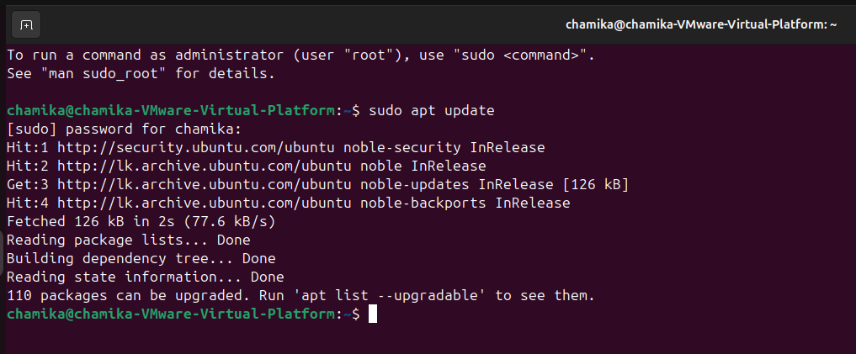

2. Install the DHCP server using

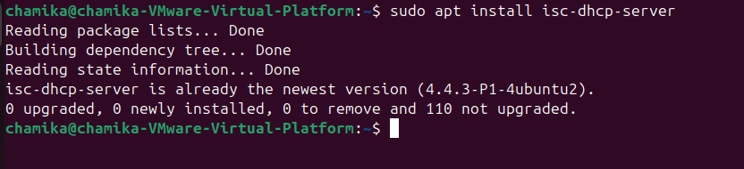Use →**sudo apt install isc-dhcp-server**

before opening dhcp configuration file we should know information about network interfaces

3.View all network interfaces to note down NIC (In this case ifconfig is not pre-installed in ubuntu machine so I needed to install it using **sudo apt install net-tools)**

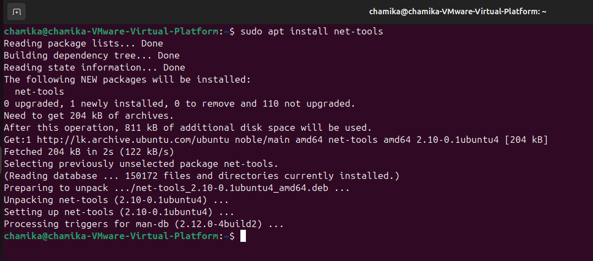

After net-tools installation type **ifconfig** and it shows network interface information.in this case my NIC is **ens33**

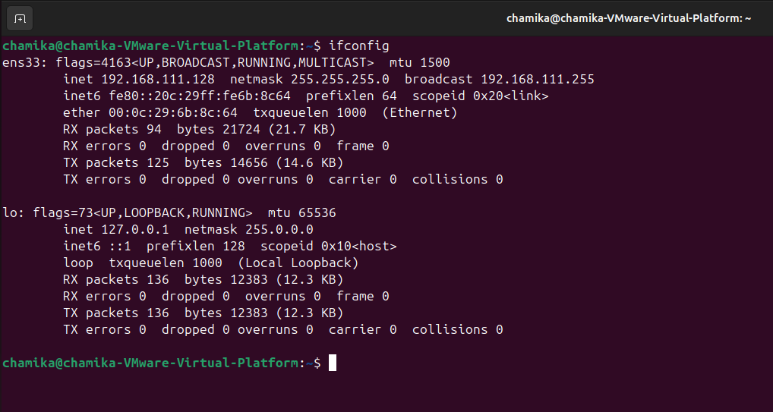

4.Open the configuration file using **nano** text editor

Use→**sudo nano /etc/default/isc-dhcp-server.**

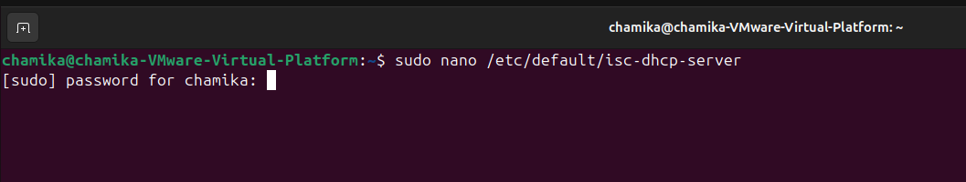

5. Modify the details about INTERFACESv4 inside this configuration file.

In here we should specify in which network interface the DHCP server will listen.

• Set INTERFACESv4= “ens33” →server listen to DHCP request on the ens33

• Keep INTERFACESv6= “ ” empty → server will not handle IPv6 DHCP requests

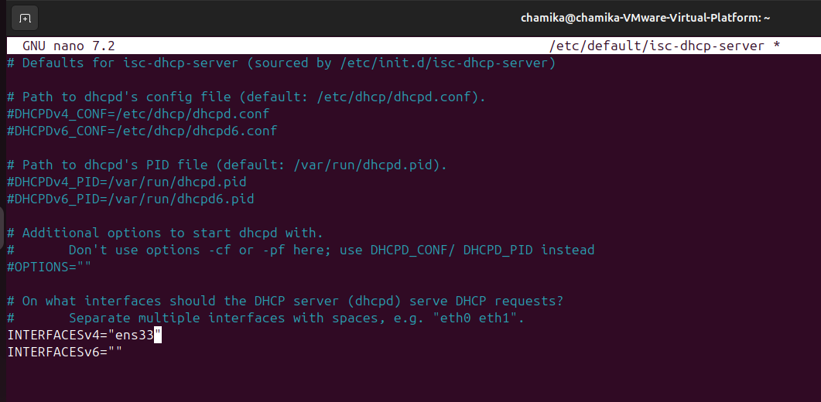

To save changes simply press ctrl+o → enter → ctrl+x

6. Now to open main configuration file for make changes according to newly enabled network interface.

First DHCP directory by cd /etc/dhcp. To find the main files exact name list down content in the directory by ls there you can fing .conf file to open it

Use**→ sudo nano /etc/dhcp/dhcp.conf**

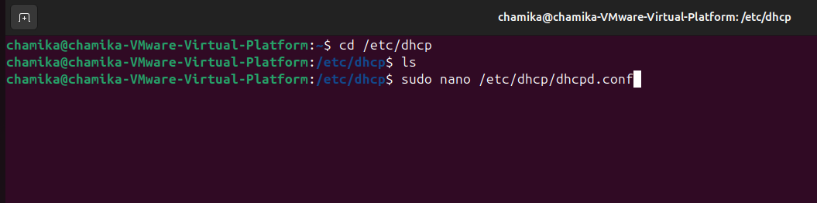

7.Modify the content in the main file gathered information by ifconfig

# A slightly different configuration for an internal subnet.

subnet 192.168.111.0 netmask 255.255.255.0

{

range 192.168.111.100 192.168.111.200;

option subnet-mask 255.255.255.0;

option routers 192.168.111.1;

option broadcast-address 192.168.111.255;

default-lease-time 600;

max-lease-time 7200;

}

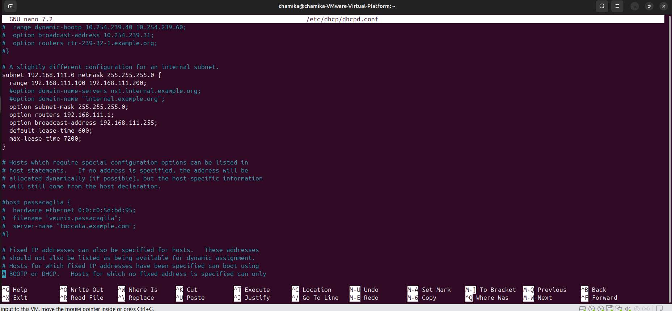

To save changes simply press **ctrl+o → enter → ctrl+x**

8.Then restart theconfiguration. Restart the DHCP sever to apply changes by

Use →**sudo systemctl restart isc-dhcp-server**

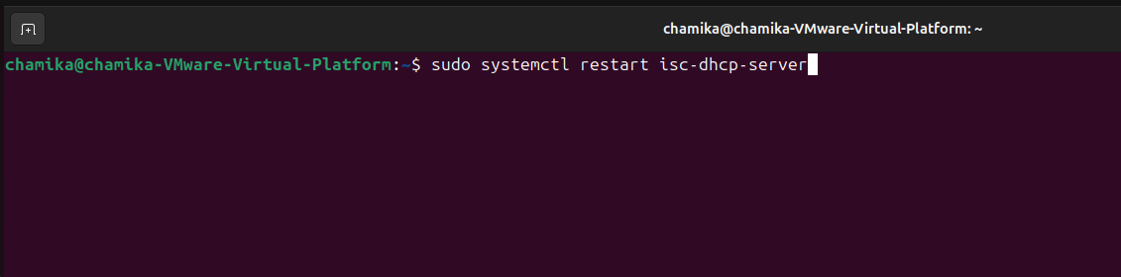

9.Then enable configuration to ensure that DHCP server starts automatically whenever the system is booted.

Use →**sudo systemctl enable isc-dhcp-server**

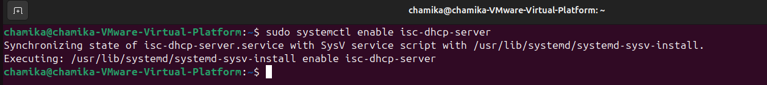

10.Then check the current status of the firewall to ensure that the server will be able to communicate with client without any restrictions.(In this case status should be Inactive)

Use → **sudo ufw status**

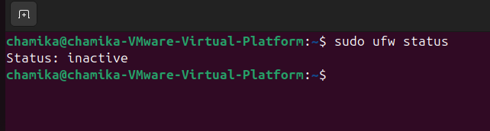

11.Check the status of the configuration to ensure that DHCP server is working correctly

Use→**sudo systemctl status isc-dhcp-server**

If it is successful status should be active.

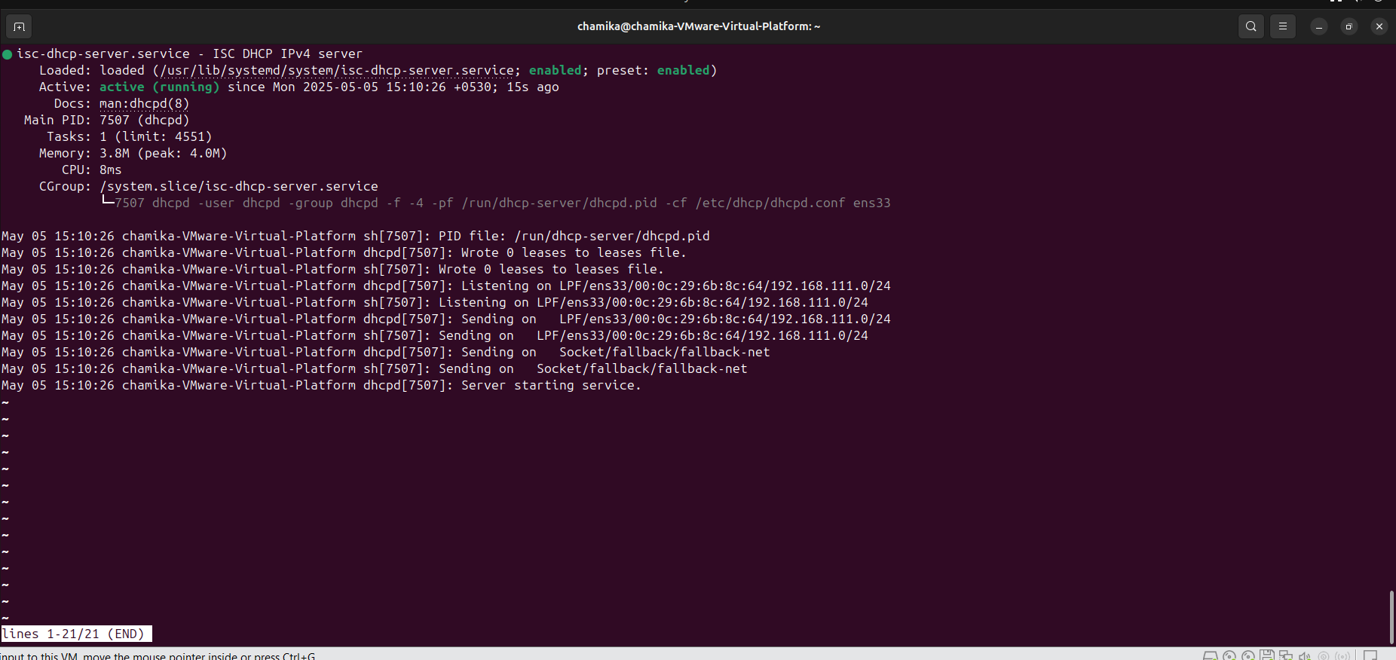

**→DHCP client configuration**

1.Install DHCP client another virtual machine(in this case I used my second ubuntu instance as client machine)

Use→**sudo apt install isc-dhcp-client**

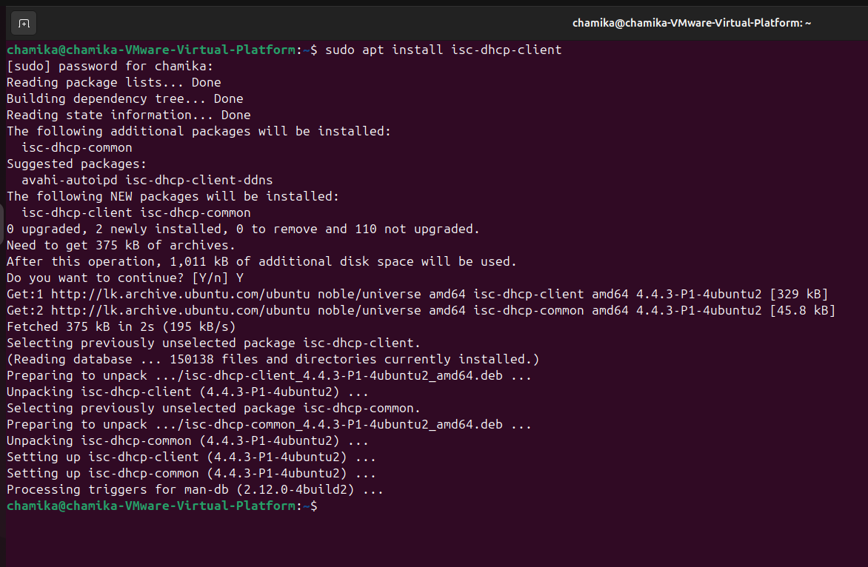

2.Configure the client to obtain an IP address from DHCP. To do that open client’s configuration file.

Use→ **sudo nano /etc/netplan/01-netcfg.yaml**



3.Modify the configuration file to apply changes

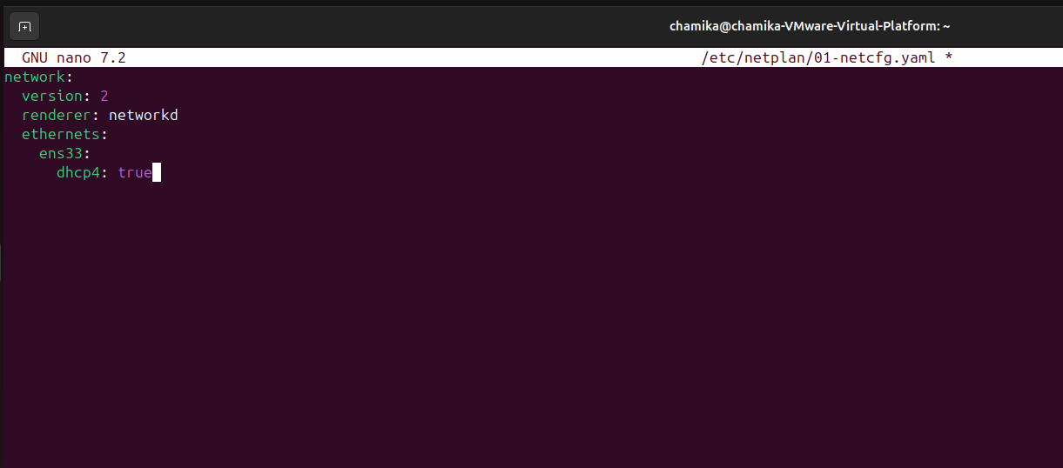

4.Apply the changes

Use→**sudo netplan apply**

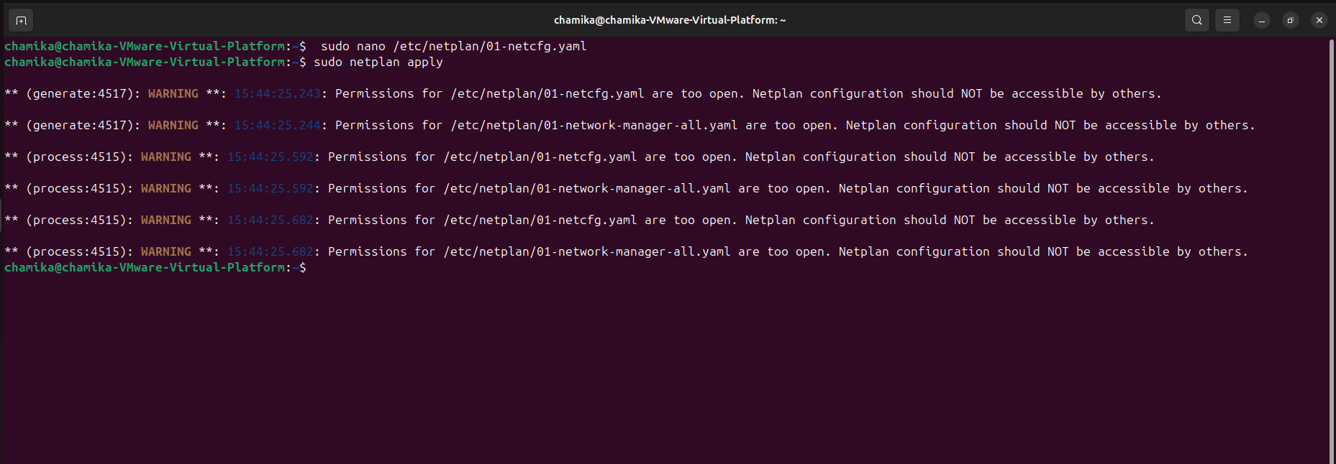

Int this case I want to give full permission to user file to do that

Use→**sudo chmod 600 /etc/netplan/01-netcfg.yaml**

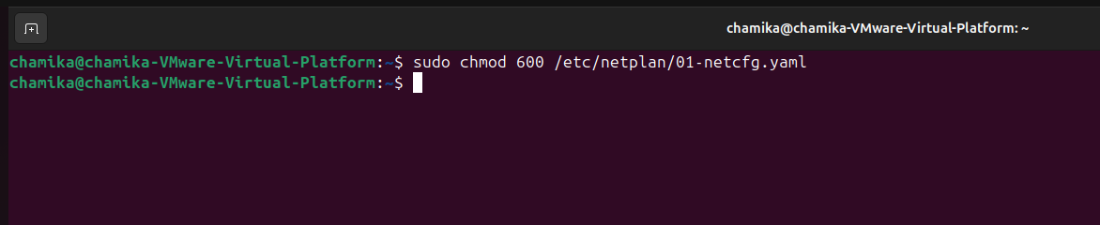

5.Restart service to apply changes

Use→**sudo systemctl restart systemd-networkd**

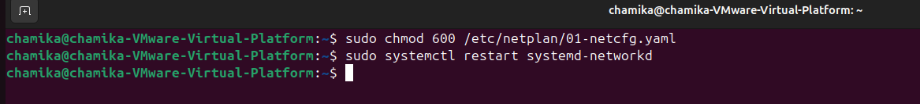

6.Enable it to ensure start boot time

Use→ **sudo systemctl enable systemd-networkd**

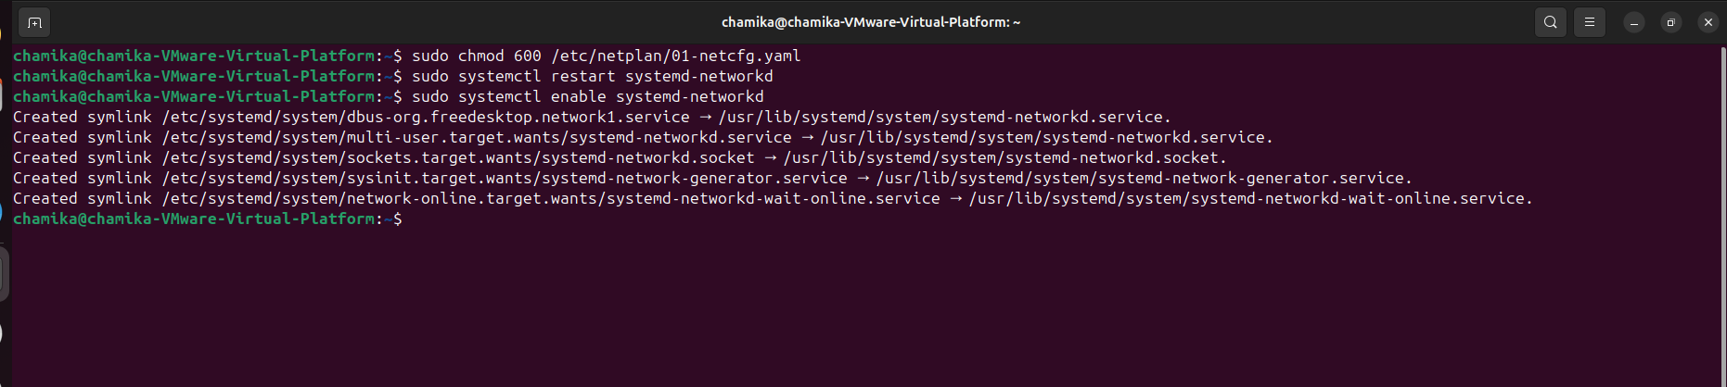

7.Then verify the configuration by checking the status.(if it is success status should be active)

Use→**sudo systemctl status system-networkd**

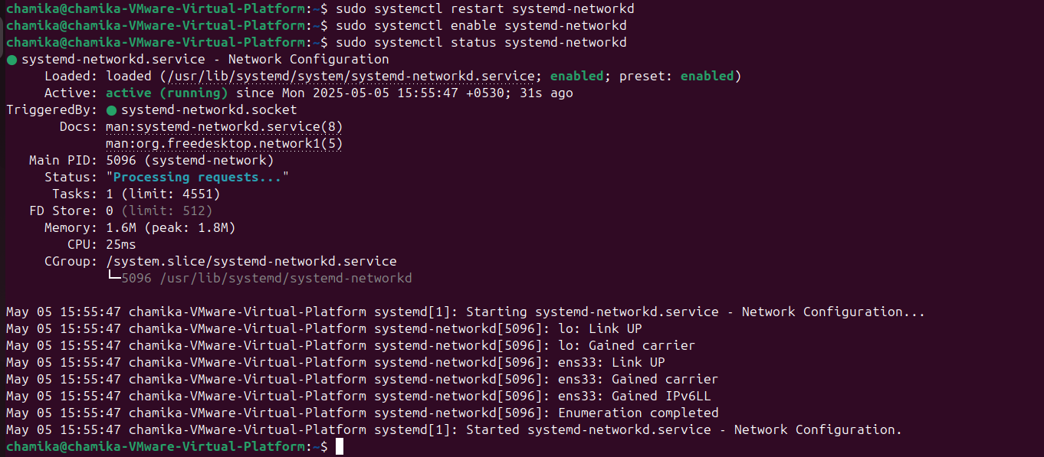

→Verification

1.Check network connectivity

Try to check internet or network connectivity by pinging an external website or gateway provided by DHCP server.use ping command with some website domain name in this case I used google.com use→**ping google.com**

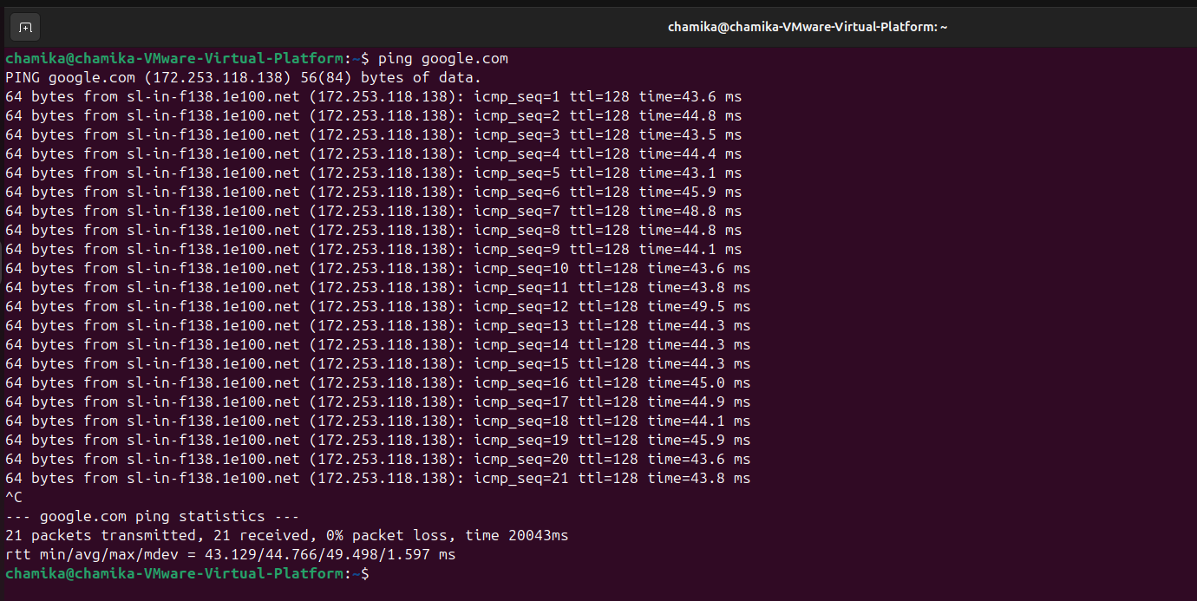

2.check the default gateway

Use→**ip route show**

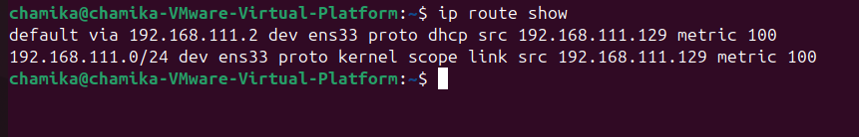

3.Check the status of your network interfaces and whether they have obtained IP addresses

Use→**ip addr show**

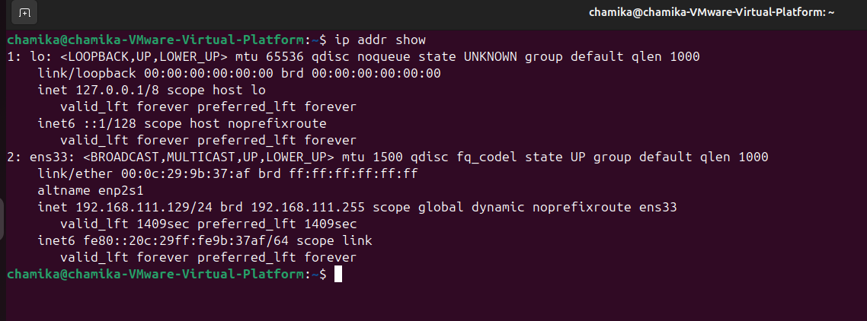

4.Check if the DHCP client obtained an IP address

Use→**sudo dhcpclient -v ens33**

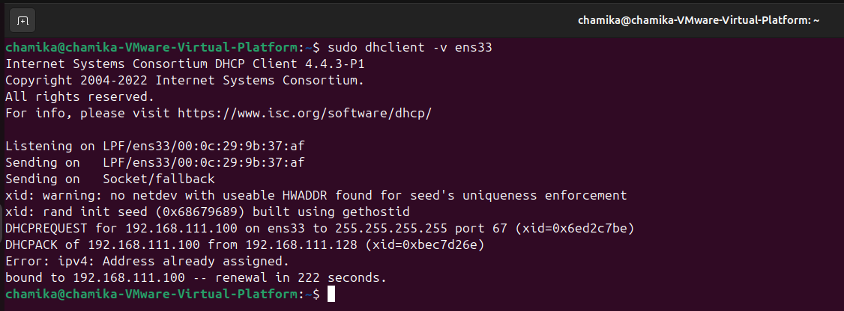

5.Verify the DHCP client



6.get the DHCP server ip address by using **ifconfig** in server instance and ping it in the DHCP client

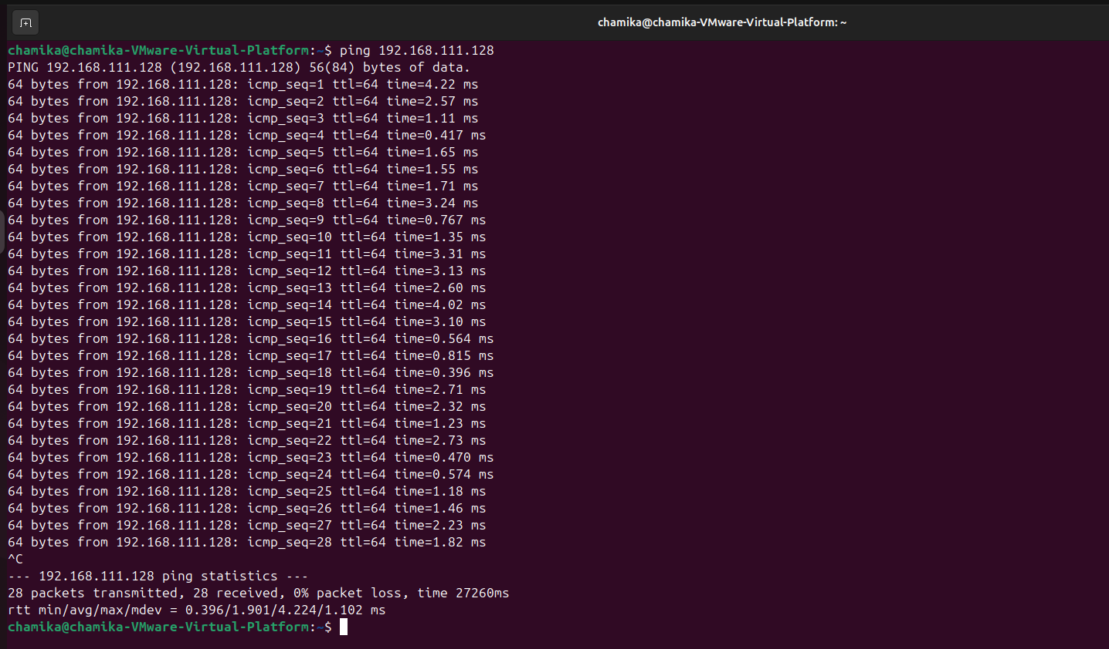

7. finally in the dhcp server (in my case ubuntu server instance) get a list of the clients that are connected to the DHCP server.

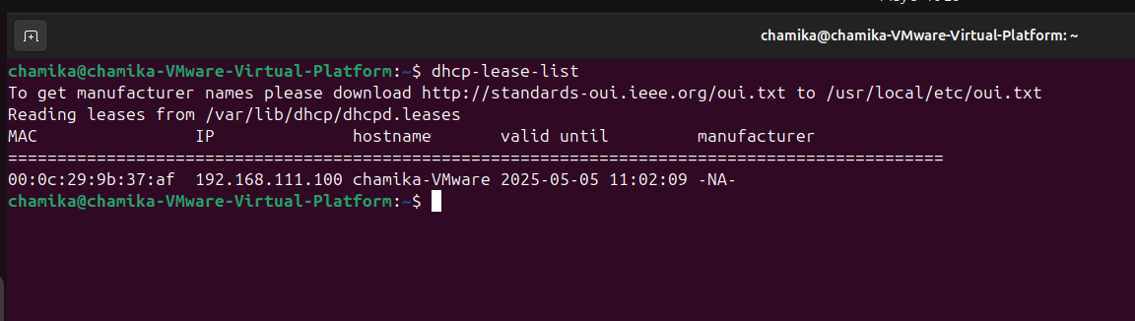

**2.2 DNS (Domain Name System)**

For this DNS configuration I used two ubuntu instances, one as server and other one as client.

**DNS Installation and Configuration**

→DNS server configuration

1.update the package list

Use→**sudo apt update**

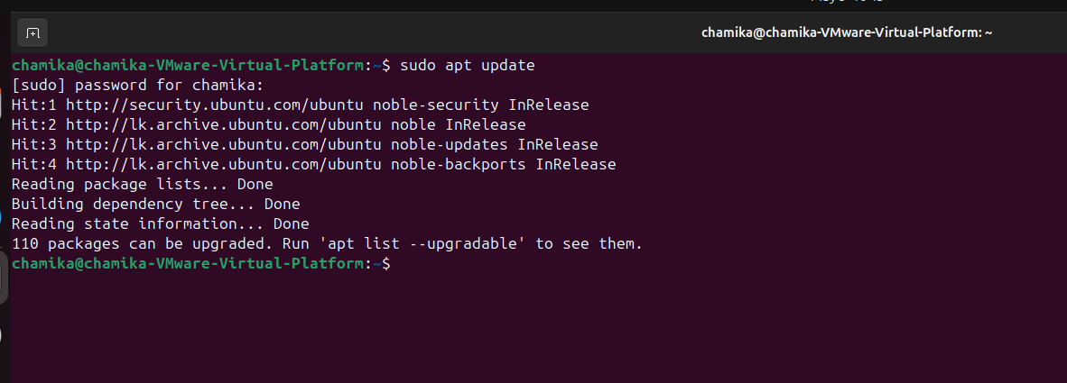

2.Install BIND9 (BIND9 DNS Server and related utilities on a Debian-based system like Ubuntu)

Use→ **sudo apt install bind9 bind9utils bind9-doc**

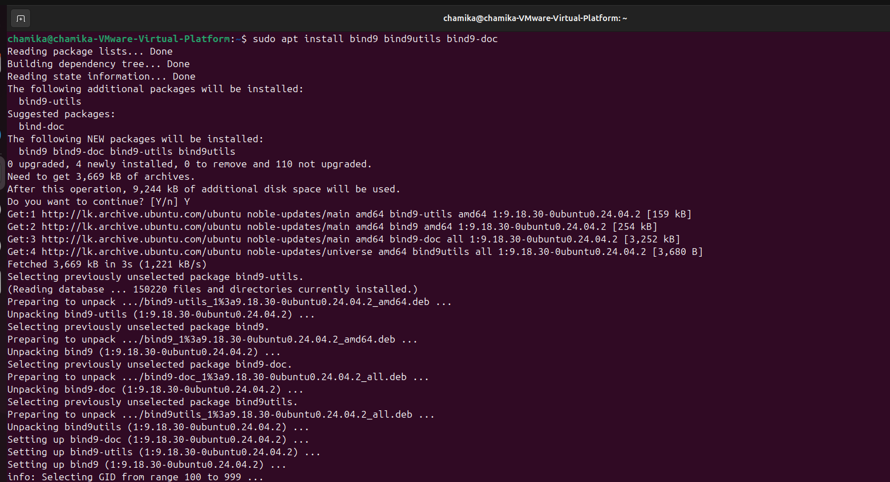

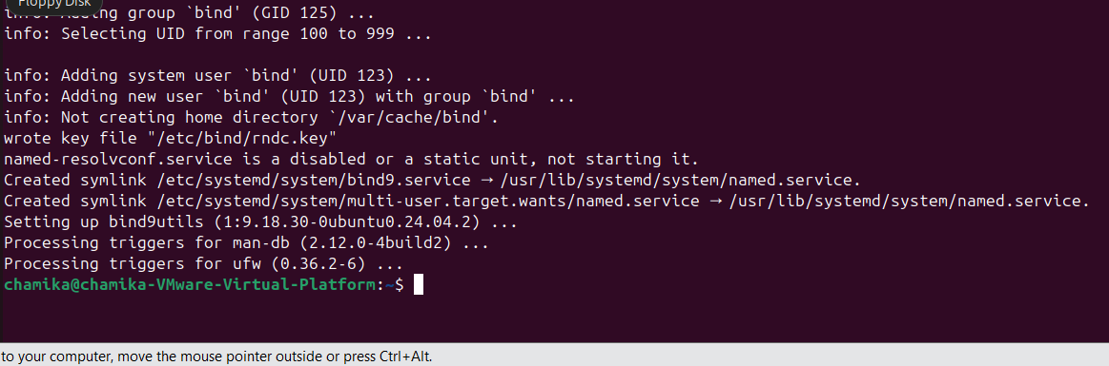

3.configure DNS forwarders

• From configuring DNS forwarders in a server allows it to resolve external domain queries by forwarding request to another DNS server.

• In this case I want to resolve external domain names so configuring DNS forwards is necessary.

a) →Open the BIND configuration file

First I need to find exact file so use **cd /etc/bind/** to go bind directory and list down files with detailed informations using **ls -lrt**

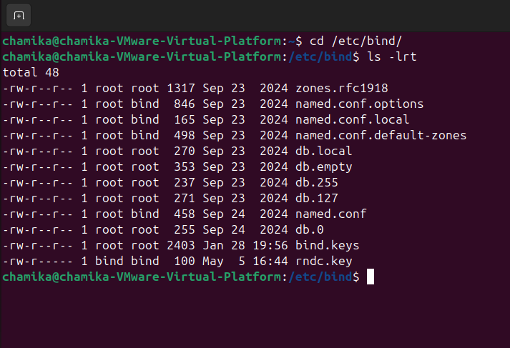

There I can find needed root bind file

Use→**sudo nano /etc/bind/named.conf.options**



b) Modify the forwards section by adding

forwarders {

8.8.8.8;

8.8.4.4;

};

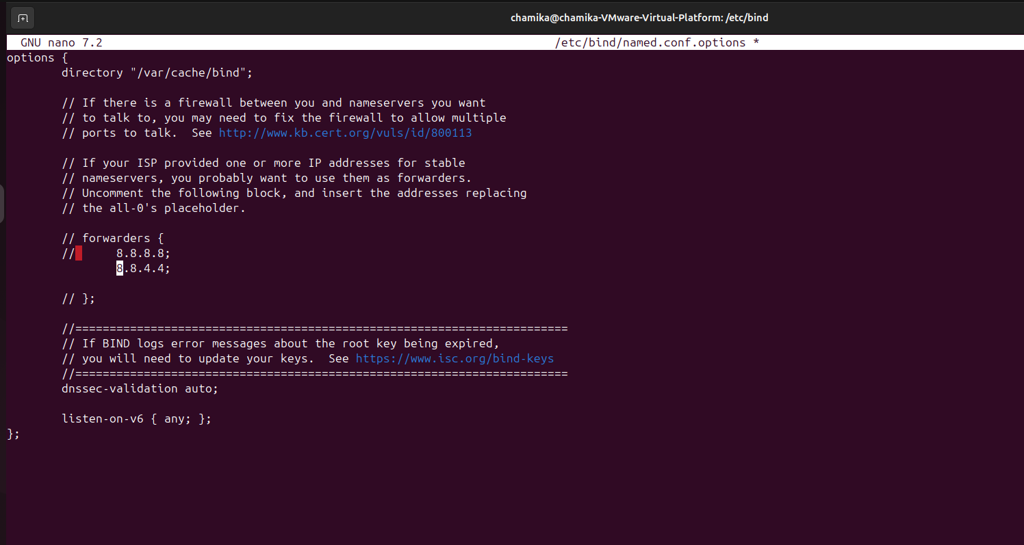

c) save **ctrl+o→enter→ctrl+x**

d)check if changes applied correctly for further clarification

use→**sudo cat /etc/bind/named.conf.options**

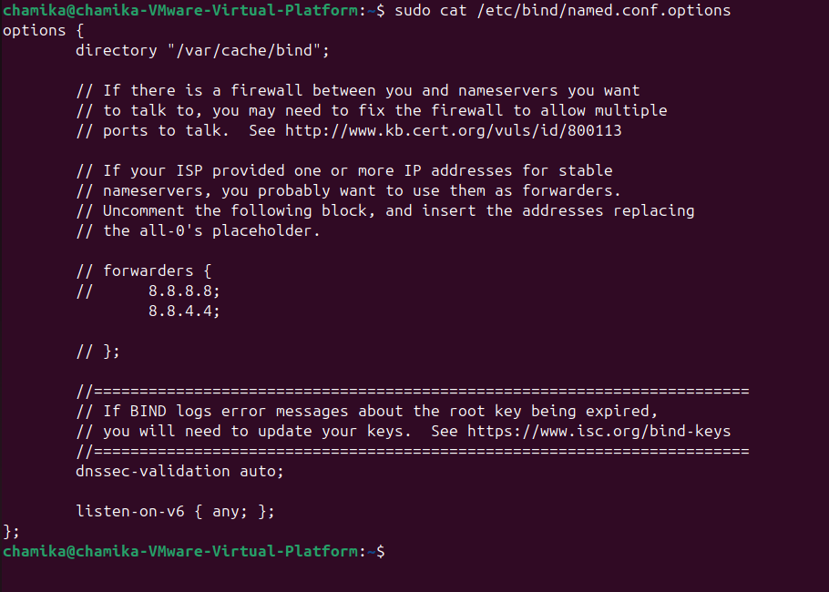

1. Restart the service to apply changes

Use→**sudo systemctl restart bind9**



5.check the status find if it working correctly, in this case it should be active

Use→**sudo systemctl status bind9**

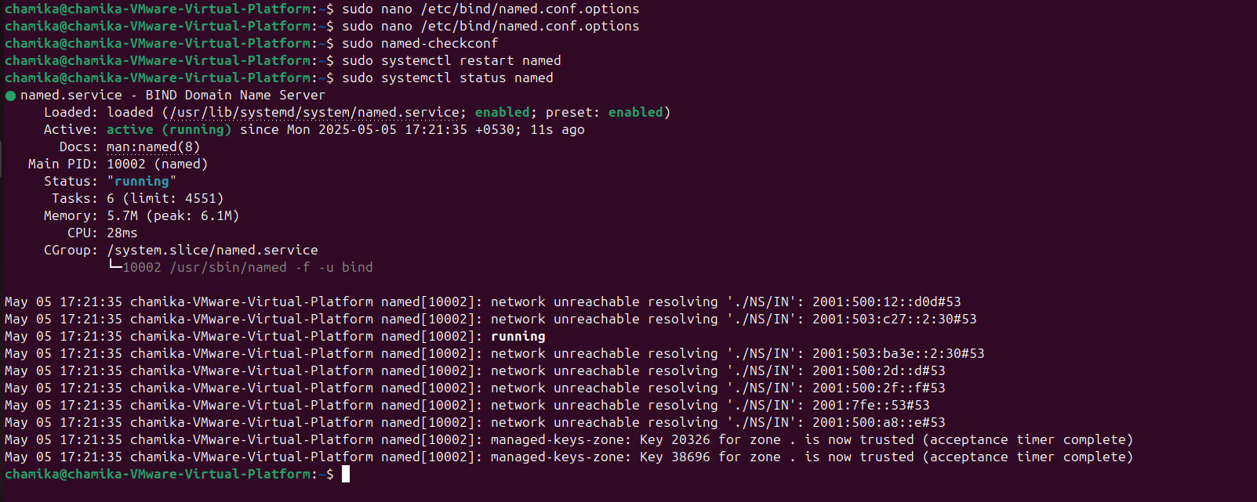

Verification of Forwarders

• Using dig tool test external domain name resolution from both DNS server and client machines Use→**dig google.com**

• If it returns ip address of google.com, the forwarders are working correctly.

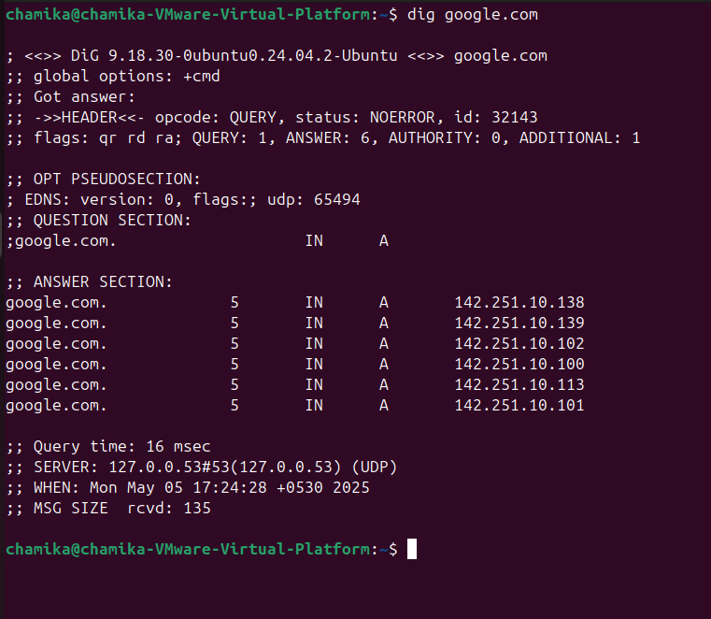

→DNS client configuration

1.open the Netplan Configuration file

Use→**sudo nano /etc/netplan/00-installer-config.yaml**

network:

ethernets:

ens33:

dhcp4: true nameservers:

addresses: -192.168.1.1

version: 2

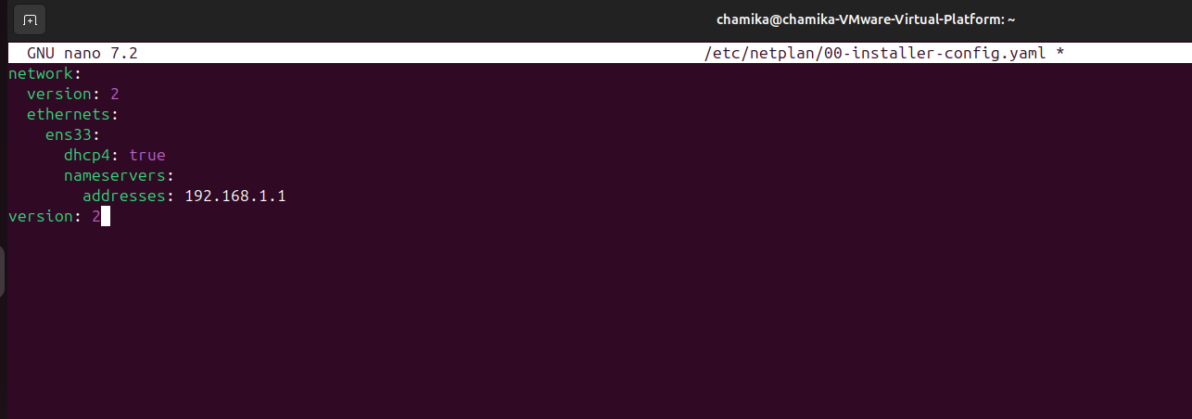

before adding nameserver ip I need to know my server ip address, to do that simply type **ifconfig** in server and capture the ip address, in my case ip is **192.168.1.1**

2.check if it changed correctly

Use→**sudo cat /etc/netplan/00-installer-config.yaml**

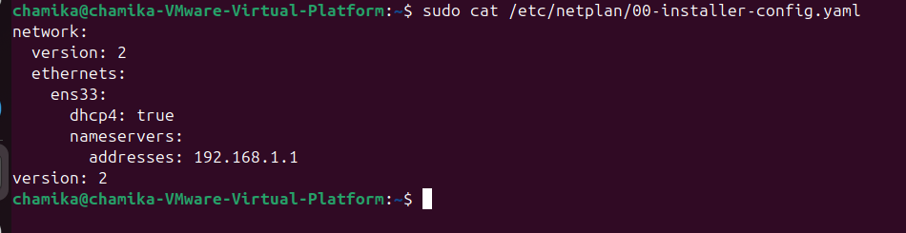

3.apply changes

Use→**sudo netplan apply**

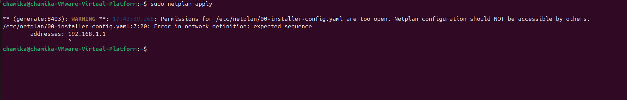

4.in this case I need to give permission to user.

Use→**sudo chmod 600 /etc/netplan/00-installer-config.yaml**



Verification

5.Test DNS resolution To test DNS resolution , can use tools like **nslookup,dig,ping**

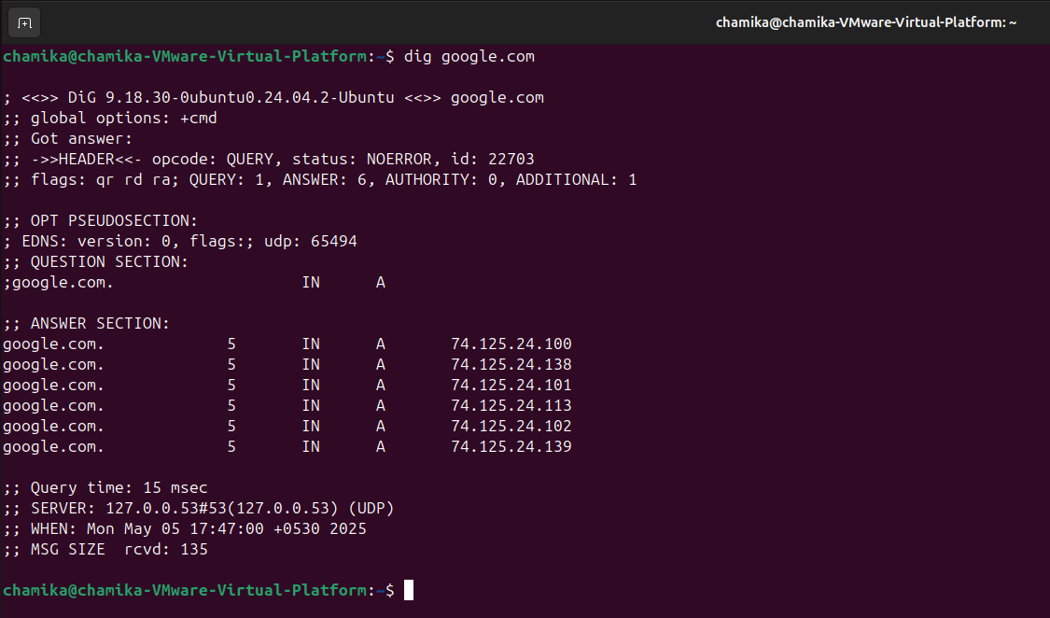

ANSWER SECTION : This shows the resolved IP addresses for the domain

SERVER : this shows which DNS server used for the query

• **nslookup**

Use→**nslookup google.com**

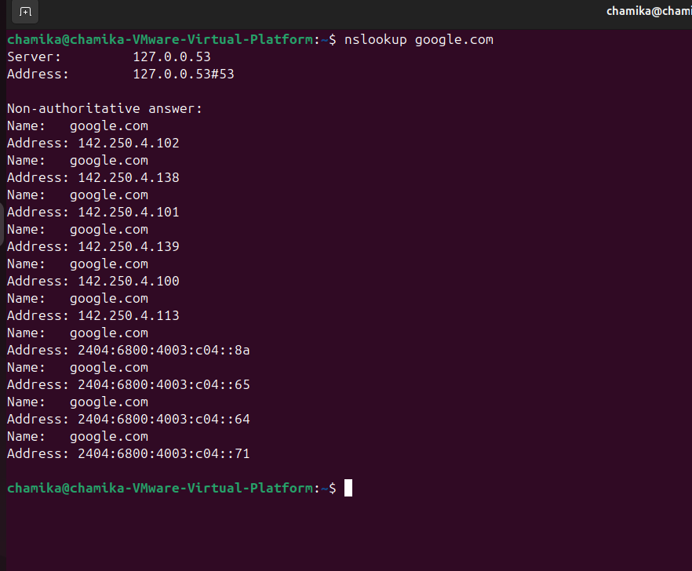

→**address :** shows the resolved IP address for the domain

→**Server :** Indicates which DNS server was used for the query

In this case I wanted to check if I can reverse DNS lookup.

**• Test Reverse DNS lookup**

In this case I used ip address gain by **nslookup google.com**

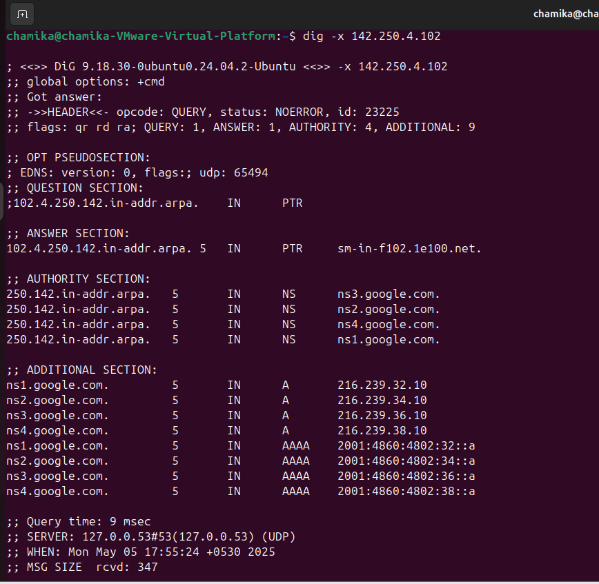

The reverse DNS lookup check weather an ip address can be resolve.

**NTP (Network time protocol)**

**NTP Installation and Configuration**

For this NTP configuration I used two ubuntu instances, one as server and other one as client.

→NTP server configuration

1.update the package list

Use→**sudo apt update**

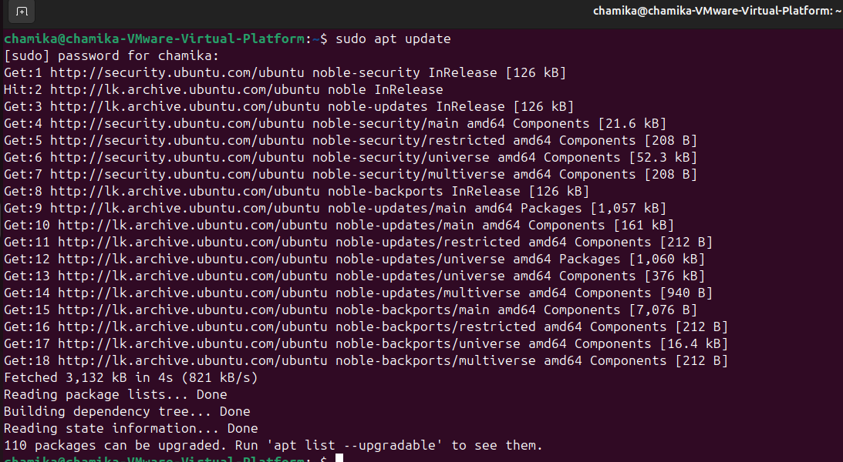

2.install chrony in the server machine

(in this case I used chrony over ntp because chrony offering better performance and it used to synchronize the system clock with NTP servers)

Use**→ sudo apt install chrony**

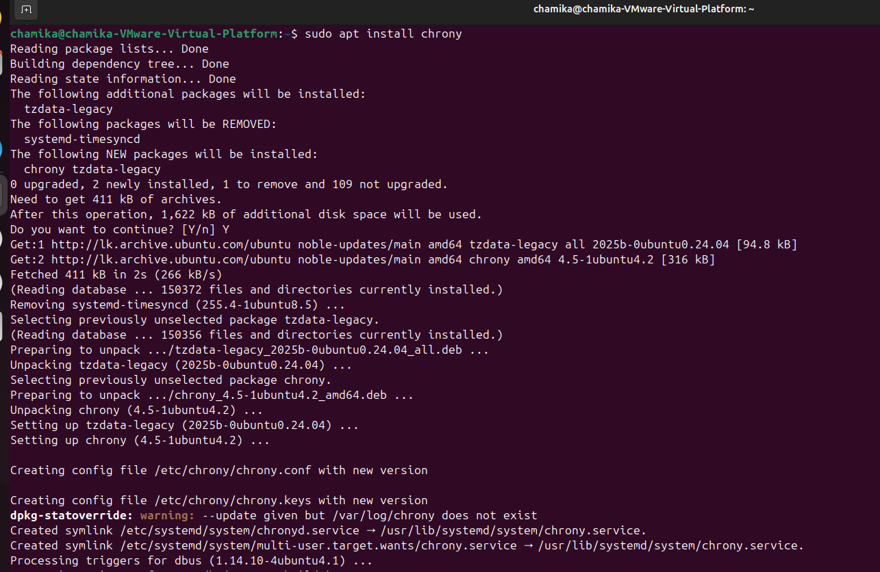

3.open the chrony configuration file using nano text editor.

Use**→ sudo nano /etc/chrony/chrony.conf**



4.commant out existing pool services and replace them with asia pool services To get pool services visit→ https://www.ntppool.org/zone/asia

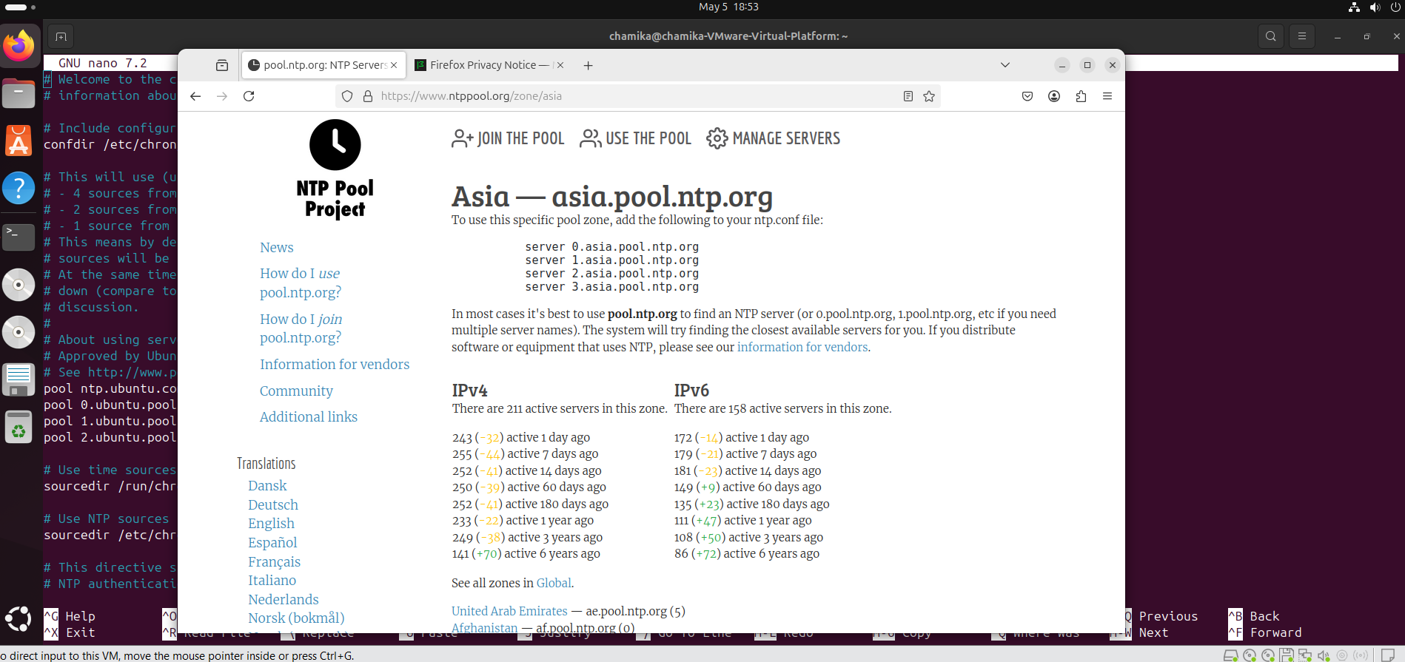

server 0.asia.pool.ntp.org

server 1.asia.pool.ntp.org

server 2.asia.pool.ntp.org

server 3.asia.pool.ntp.org

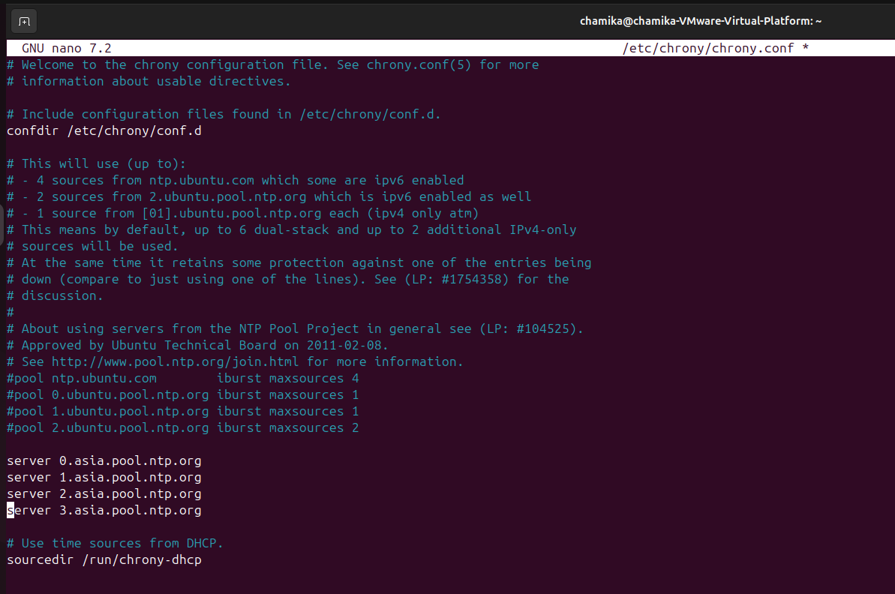

5.allow access to local network to synchronize with actual network address range.

To do that first I need to know my server ip address with range

Use**→ip addr show**

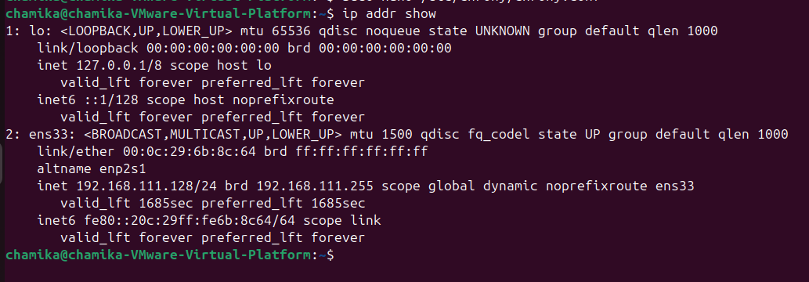

1. then copy that ip and in the end of the **/etc/chrony/chrony.conf** file make changes.
2. Use**→allow 192.168.170.128/24**

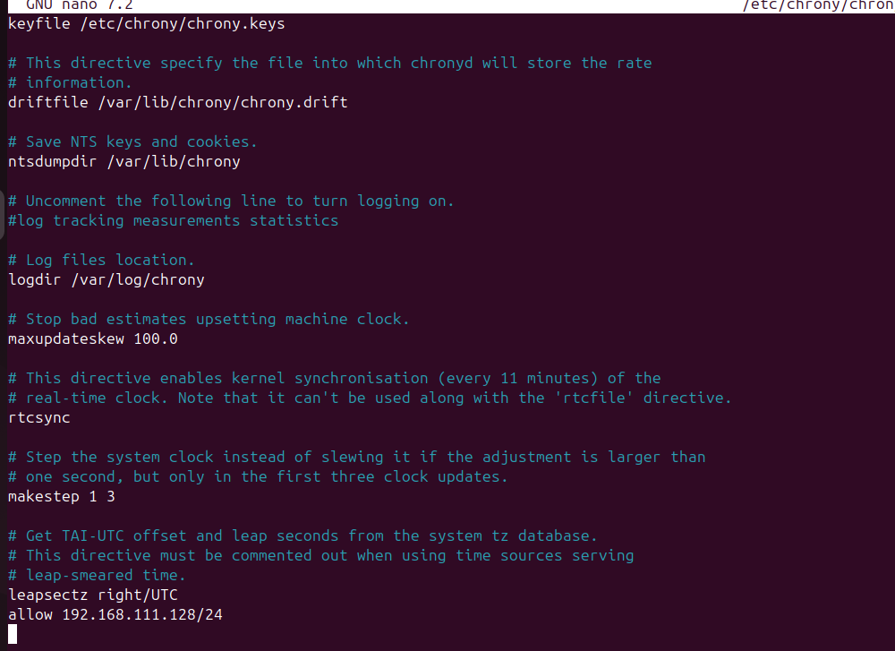

Save save ctrl+o→enter→ctrl+x

7.restart the chrony server

Use**→ sudo systemctl restart chrony**



8.Then enable configuration to ensure that NTP server starts automatically whenever the system is booted.

Use**→ sudo systemctl enable chrony**



9.check the status of the configuration if it is running correctly

In this case it should be active

Use→ **sudo systemctl status chrony**

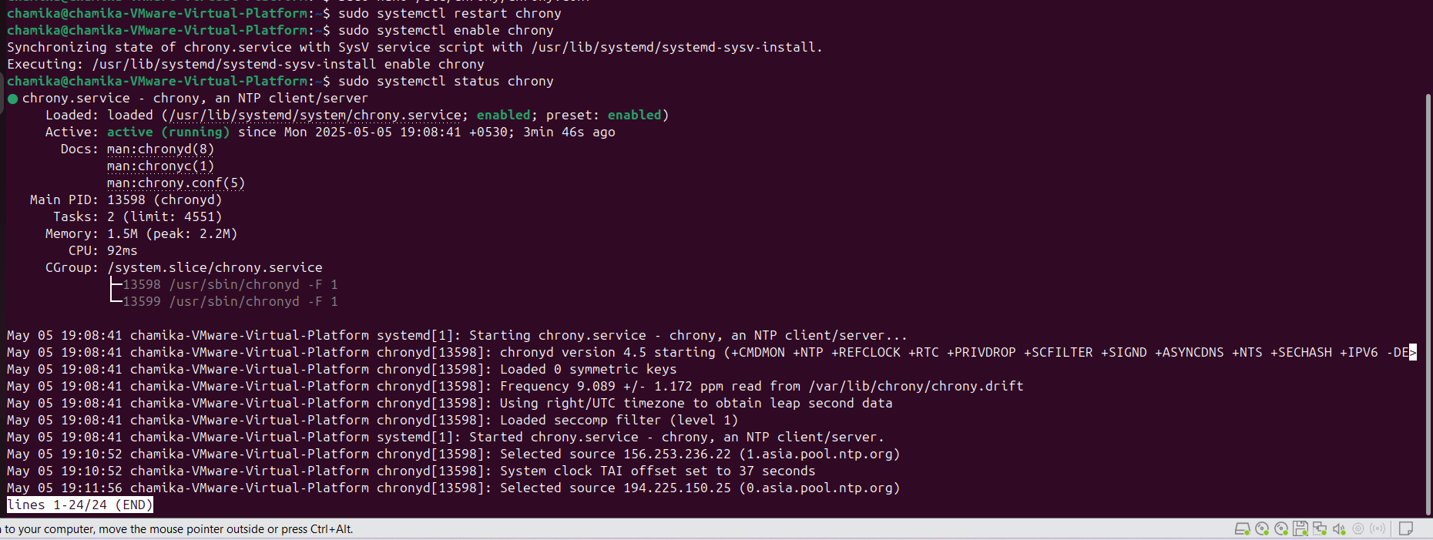

10.Allow NTP services through firewall. If a firewall is active, allow NTP service through it Use→**sudo ufw status**

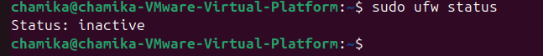

In this case status should be inactive

Then allow NTP through it.

Use→**sudo ufw allow 123/udp**



→NTP client configuration

1.update the package list

Use**→sudo apt update**

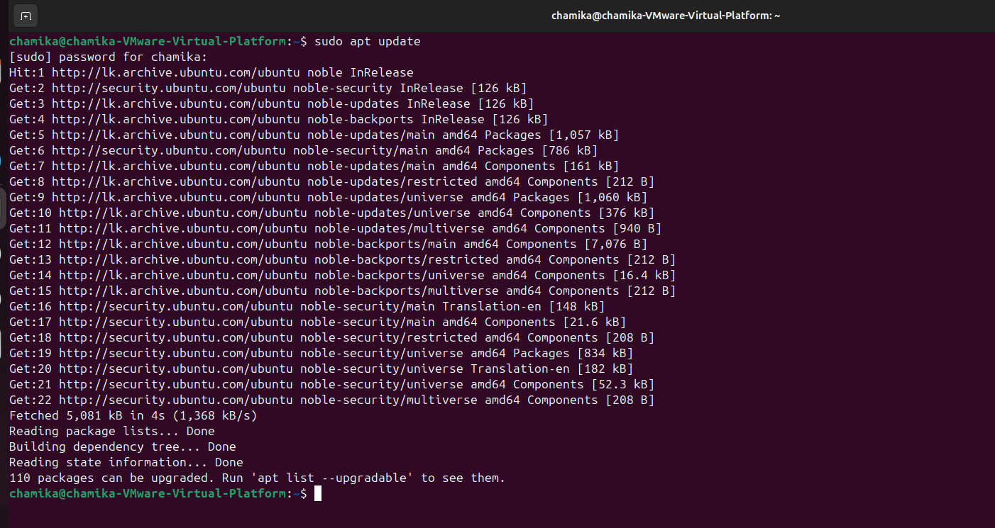

2. .install chrony in the client machine

Use**→sudo apt install chrony**

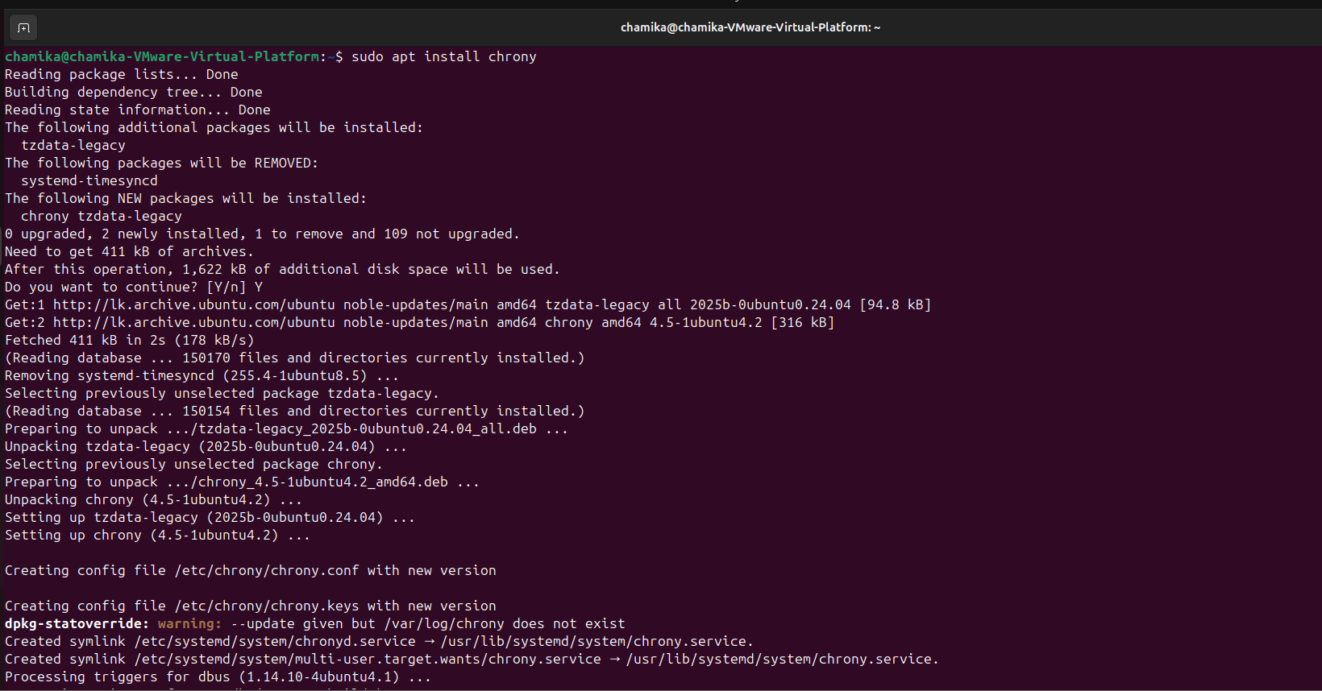

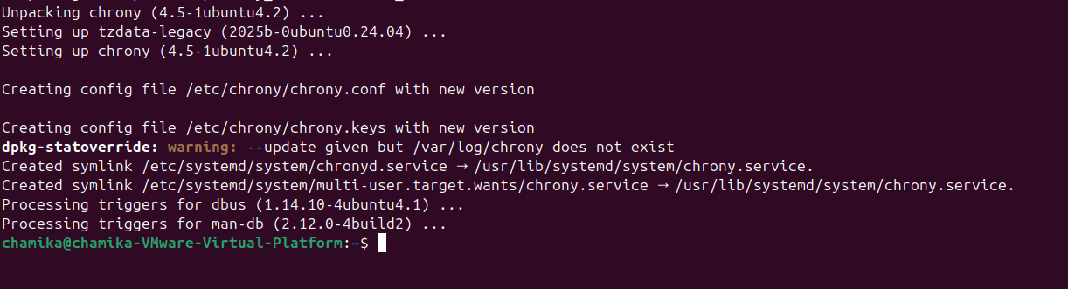

3.open the chrony configuration file and comment out existing server entries.

Use→**sudo nano /etc/chrony/chrony.conf**

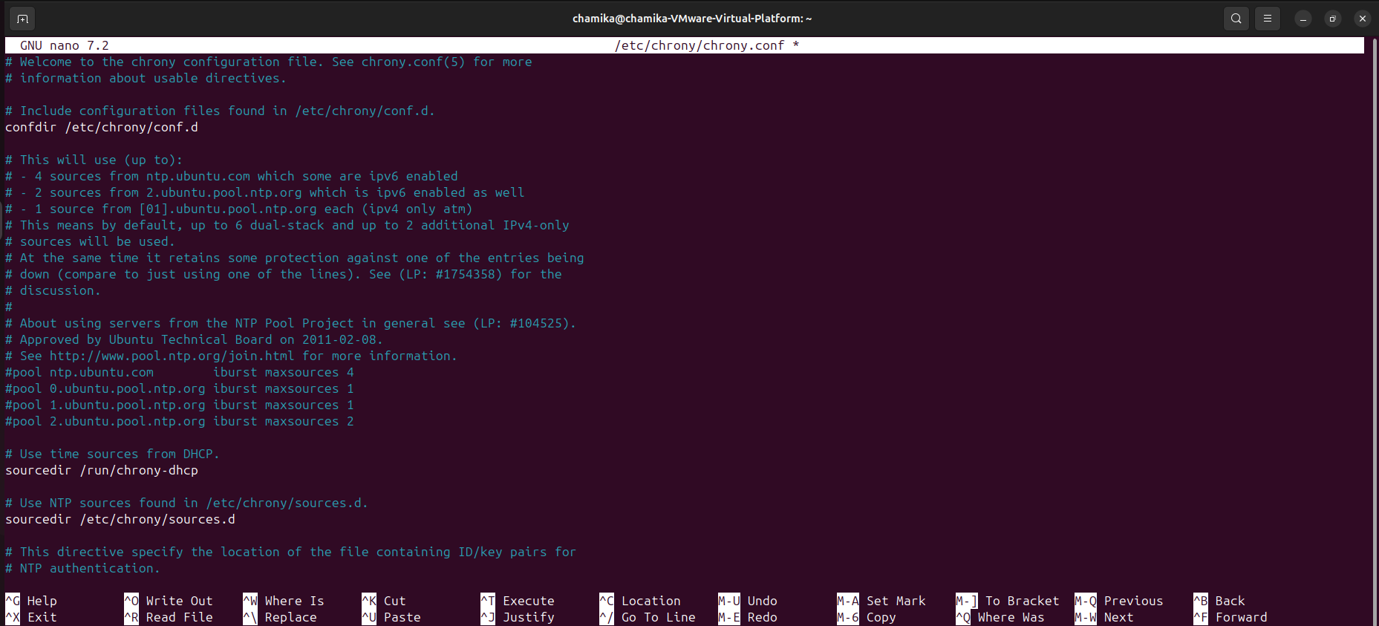

4.add ip address of NTP server in the end of the file.

Use→**server 192.168.111.128 iburst**

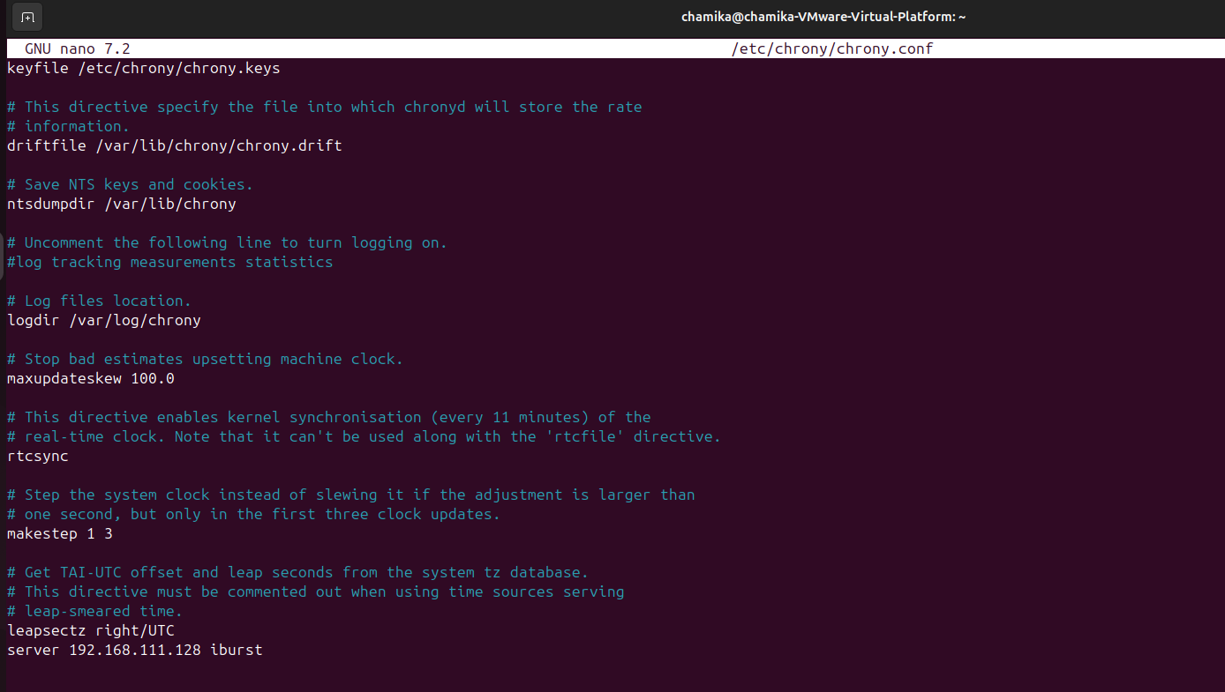

5.restart the chrony service.

Use→**sudo systemctl restart chrony**



1. Then enable configuration to ensure that NTP server starts automatically whenever the system is booted.

Use**→sudo systemctl enable chrony**

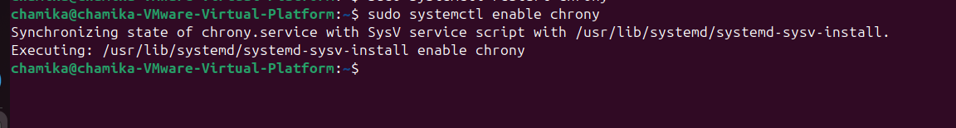

7.check the status of the configuration if it is running correctly

In this case it should be active

Use**→sudo systemctl status chrony**

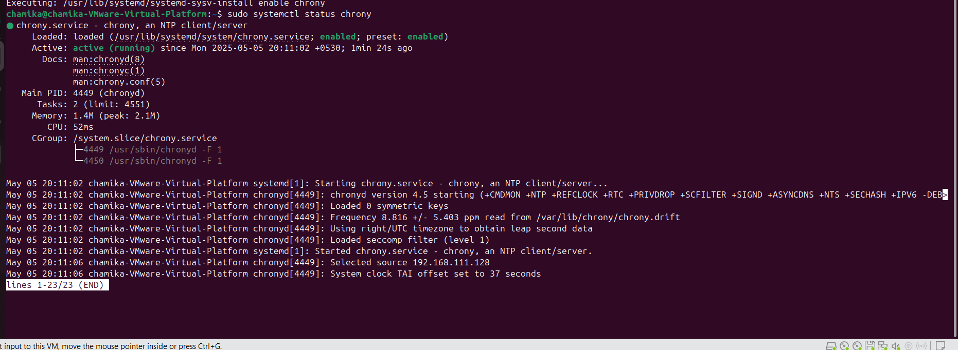

Verification (In the client side)

1.check NTP sources whether the NTP client is synchronizing correctly with the NTP servers and if there are any issues with the time sources.

**Use→chronyc sources**

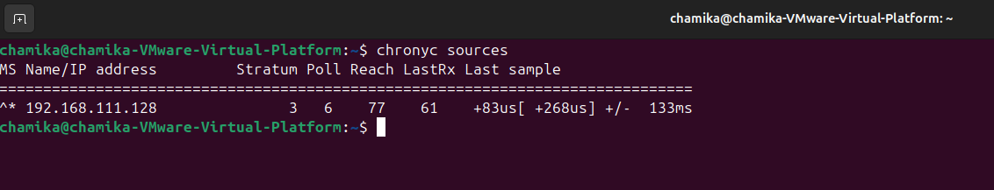

2.check detailed synchronized status including time and accuracy

Use→**chronyc tracking**

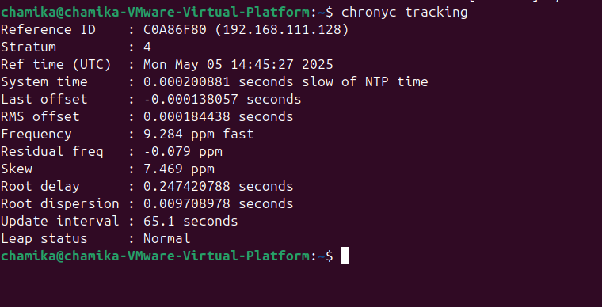

**(In the server side)**

3.display a list of NTP clients that are currently being served or are connected to that NTP server

Use→**sudo chronyc clients**

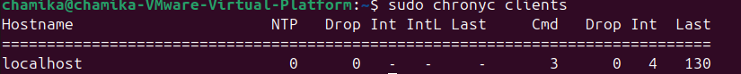

4. then check if the time of server machine synchronized to client machine

**Use→timedatectl**

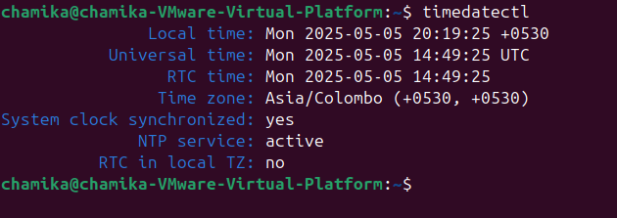

**3. Security and other servers**

**Shell Scripting**

## ****PART 1**** ****: Log Cleanup Script****

### **Step 1: Create the Script File**

The command `**sudo nano /usr/local/bin/log_cleanup.sh`** creates or edits a **log cleanup script** in a system-wide executable directory.

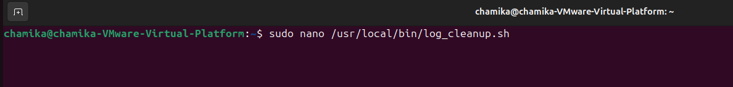

### **Step 2: Write the script**

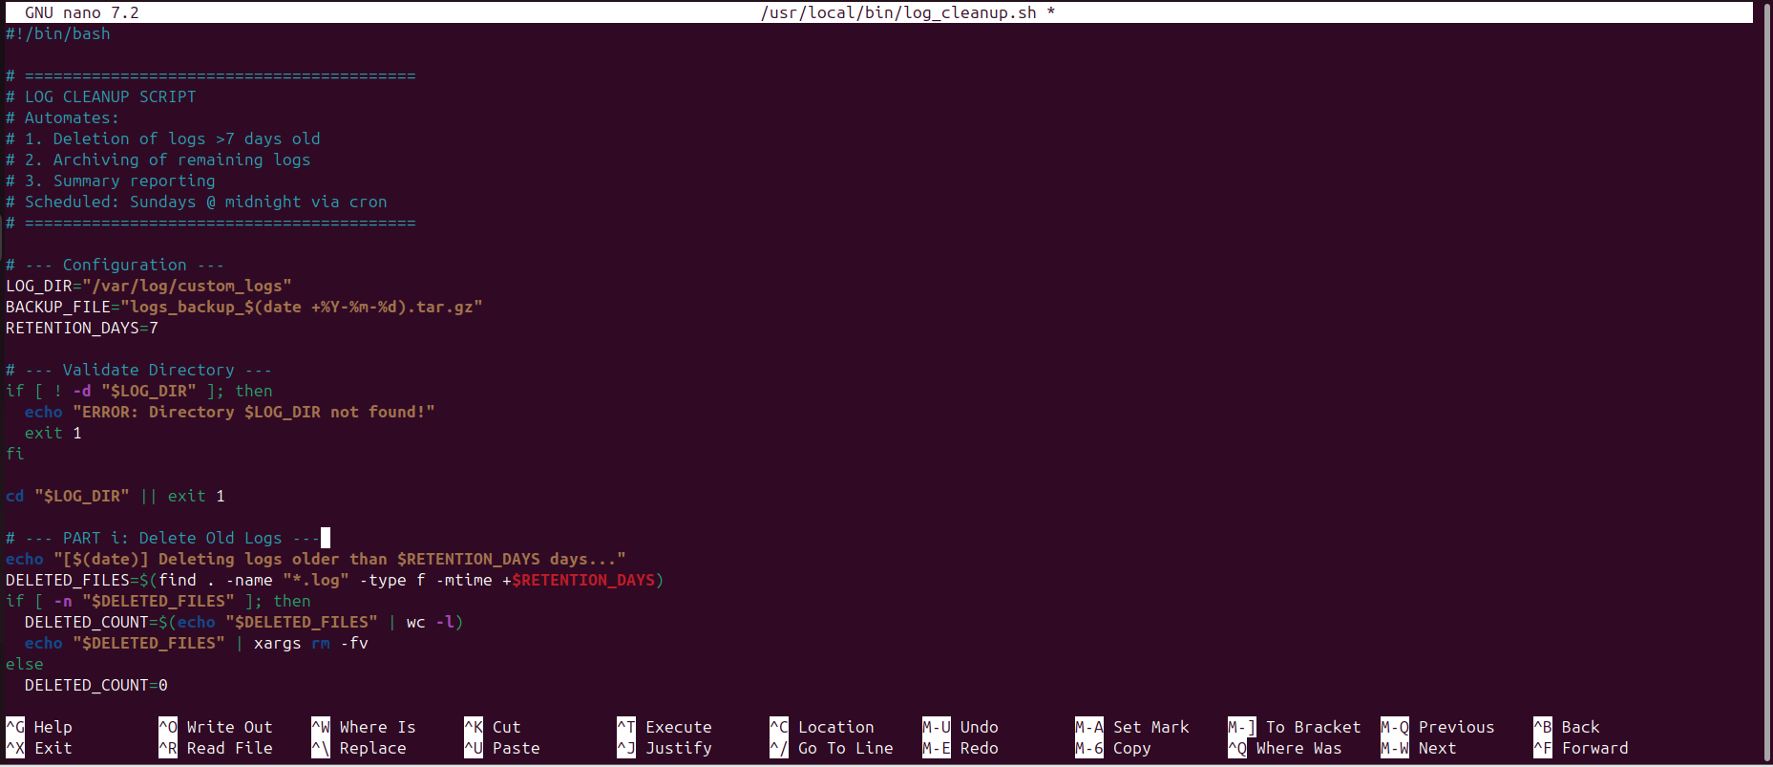

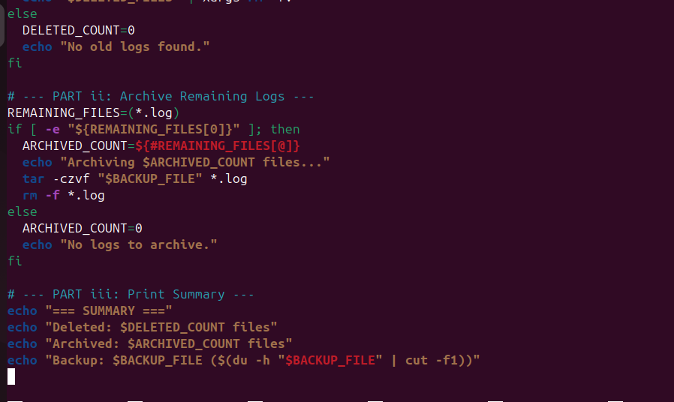

**Save -> ctrl+o**

**Enter**

**Ctrl+x**

**Script**

#!/bin/bash

# =========================================

# LOG CLEANUP SCRIPT

# Automates:

# 1. Deletion of logs >7 days old

# 2. Archiving of remaining logs

# 3. Summary reporting

# Scheduled: Sundays @ midnight via cron

# =========================================

# --- Configuration ---

LOG_DIR="/var/log/custom_logs"

BACKUP_FILE="logs_backup_$(date +%Y-%m-%d).tar.gz"

RETENTION_DAYS=7

# --- Validate Directory ---

if [ ! -d "$LOG_DIR" ]; then

echo "ERROR: Directory $LOG_DIR not found!"

exit 1

fi

cd "$LOG_DIR" || exit 1

# --- PART i: Delete Old Logs ---

echo "[$(date)] Deleting logs older than $RETENTION_DAYS days..."

DELETED_FILES=$(find . -name "*.log" -type f -mtime +$RETENTION_DAYS)

if [ -n "$DELETED_FILES" ]; then

DELETED_COUNT=$(echo "$DELETED_FILES" | wc -l)

echo "$DELETED_FILES" | xargs rm -fv

else

DELETED_COUNT=0

echo "No old logs found."

fi

# --- PART ii: Archive Remaining Logs ---

REMAINING_FILES=(*.log)

if [ -e "${REMAINING_FILES[0]}" ]; then

ARCHIVED_COUNT=${#REMAINING_FILES[@]}

echo "Archiving $ARCHIVED_COUNT files..."

tar -czvf "$BACKUP_FILE" *.log

rm -f *.log

else

ARCHIVED_COUNT=0

echo "No logs to archive."

fi

# --- PART iii: Print Summary ---

echo "=== SUMMARY ==="

echo "Deleted: $DELETED_COUNT files"

echo "Archived: $ARCHIVED_COUNT files"

echo "Backup: $BACKUP_FILE ($(du -h "$BACKUP_FILE" | cut -f1))"

### **Step 3: Make Executable**

The command **sudo chmod +x /usr/local/bin/log_cleanup.sh**makes the script **executable**, allowing it to run as a program.



### **Step 4: Test the Script**

1. **Create Test Logs:**

**sudo mkdir -p /var/log/custom_logs**→ Creates a `custom_logs` directory for testing.

**sudo touch /var/log/custom_logs/{recent1.log,recent2.log}** → Makes two recent log files.

**sudo touch -d "8 days ago" /var/log/custom_logs/old1.log** → Creates an old log (8 days old) for testing deletion.

2. **Run the Script:**

**sudo /usr/local/bin/log_cleanup.sh** → Executes your cleanup script to delete old logs (like old1.log).

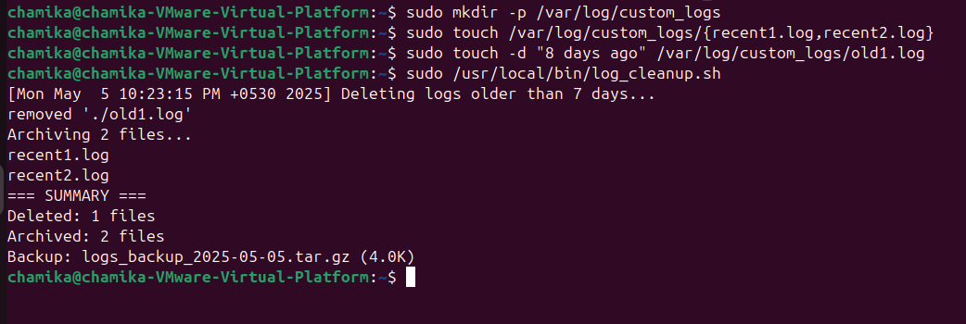

### **Step 5: Schedule with Cron**

The command sudo crontab -e allows you to **edit the root user's cron jobs** (scheduled tasks).

* sudo: Runs with admin privileges (needed for system-wide tasks like log cleanup).
* crontab -e: Opens the cron configuration file in your default text editor (e.g., nano).

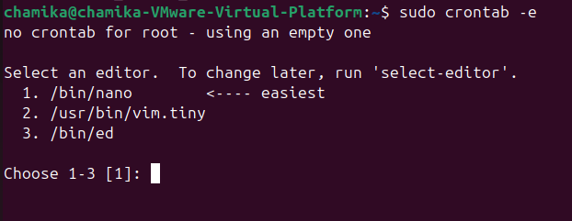

**Press 1**

Add this line (runs Sundays at midnight):

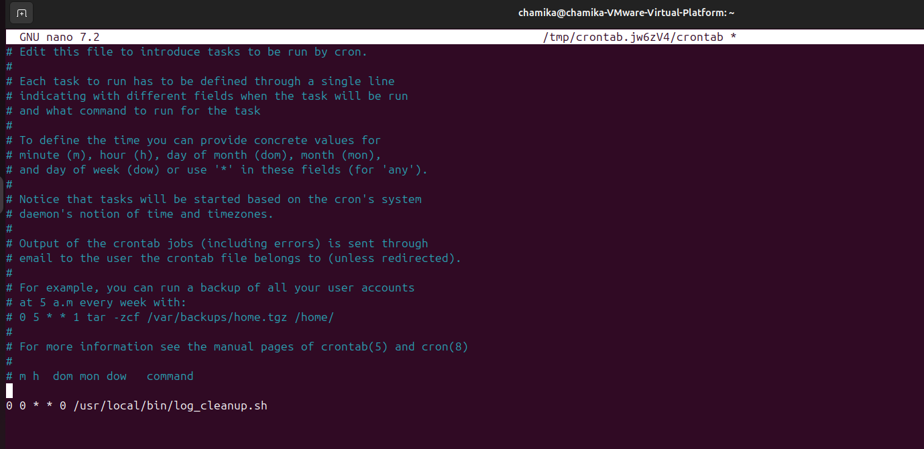

**Save -> ctrl+o**

**Enter**

**Ctrl+x**

**Step 6:** check the status of the cron service. Status should be active

Use→systemctl status cron

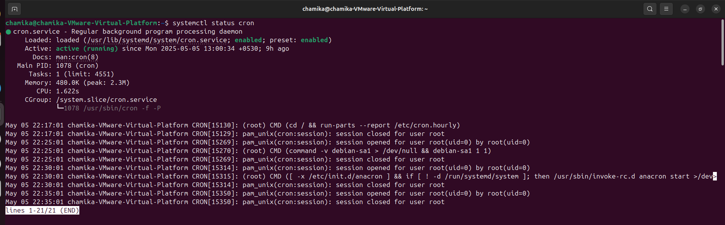

## ****PART 2: System Monitoring Script****

### **Step 1: Create the Script**

The command **sudo nano /usr/local/bin/system_monitor.sh** creates or edits a **system monitoring script** with root privileges.

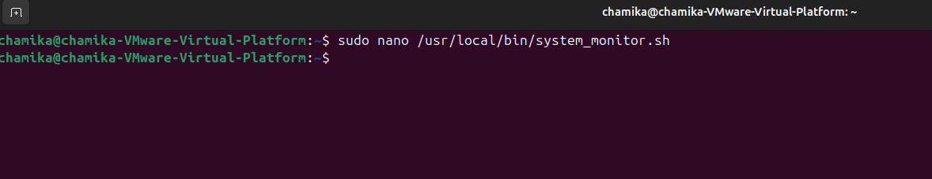

### **Step 2: Write script**

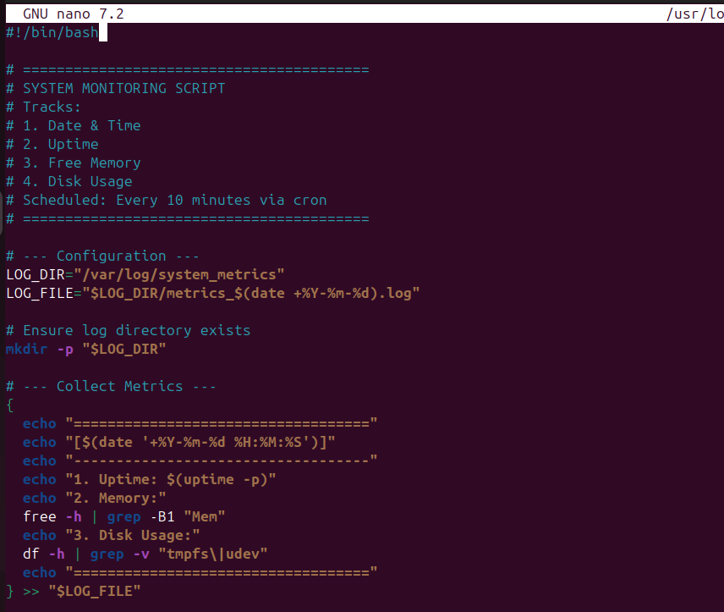

**Save -> ctrl+o**

**Enter**

**Ctrl+x**

**Script**

GNU nano 7.2 /usr/local/bin/system_monitor.sh

#!/bin/bash

# =========================================

# SYSTEM MONITORING SCRIPT

# Tracks:

# 1. Date & Time

# 2. Uptime

# 3. Free Memory

# 4. Disk Usage

# Scheduled: Every 10 minutes via cron

# =========================================

# --- Configuration ---

LOG_DIR="/var/log/system_metrics"

LOG_FILE="$LOG_DIR/metrics_$(date +%Y-%m-%d).log"

# Ensure log directory exists

mkdir -p "$LOG_DIR"

# --- Collect Metrics ---

{

echo "==================================="

echo "[$(date '+%Y-%m-%d %H:%M:%S')]"

echo "-----------------------------------"

echo "1. Uptime: $(uptime -p)"

echo "2. Memory:"

free -h | grep -B1 "Mem"

echo "3. Disk Usage:"

df -h | grep -v "tmpfs\|udev"

echo "==================================="

} >> "$LOG_FILE"

### **Step 3: Make Executable**

The command **sudo chmod +x /usr/local/bin/system_monitor.sh** makes the script **executable** (runnable like a program).



### **Step 4: Test the Script**

1. **sudo /usr/local/bin/system_monitor.sh**
   * Executes the system monitoring script with root privileges
   * This runs the script you created to collect system metrics
   * The script likely saves its output to log files in /var/log/system_metrics/
2. **cat /var/log/system_metrics/metrics_*.log**
   * Displays the contents of all metric log files
   * The * wildcard shows all files matching the pattern metrics_*.log
   * Lets you view the system performance data your script collected

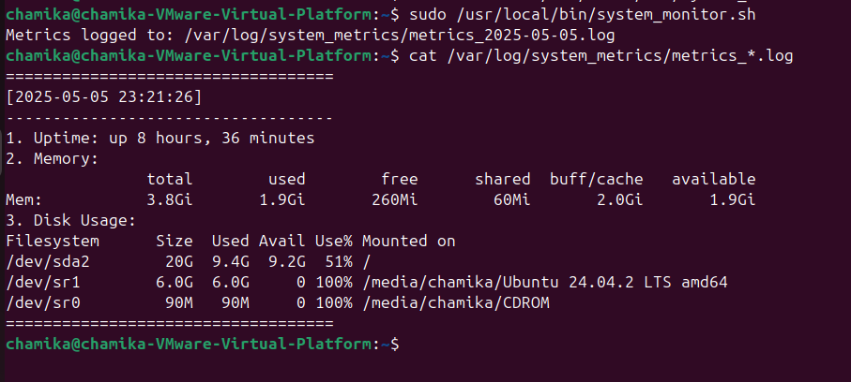

### **Step 5: Schedule with Cron**

sudo crontab -e

* Opens the root user's cron job scheduler for editing
* sudo: Runs with admin privileges (needed for system tasks)
* crontab -e: Launches your default text editor to:
  + Add new scheduled tasks
  + Modify existing ones
  + Delete old jobs

Common use: To automate scripts (like your system_monitor.sh) to run at specific times.



## Add this line (runs every 10 minutes):

## */10 * * * * /usr/local/bin/system_monitor.sh

## 

**Verify:**

### **sudo crontab -l**

* **Purpose**: Lists all scheduled cron jobs for the **root user**.
* **Breakdown**:
  + sudo: Runs with admin privileges (required for root’s cron jobs).
  + crontab -l: **L**ists the current cron jobs (tasks scheduled to run automatically).

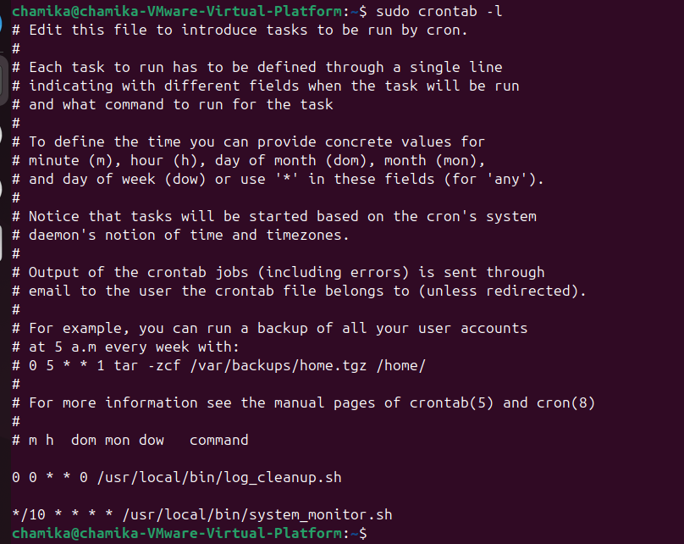

**SSH (Secure Shell)**

For this SSH configuration I used one ubuntu instance as server and windows instance as client 1.update the package list

Use**→sudo apt update**

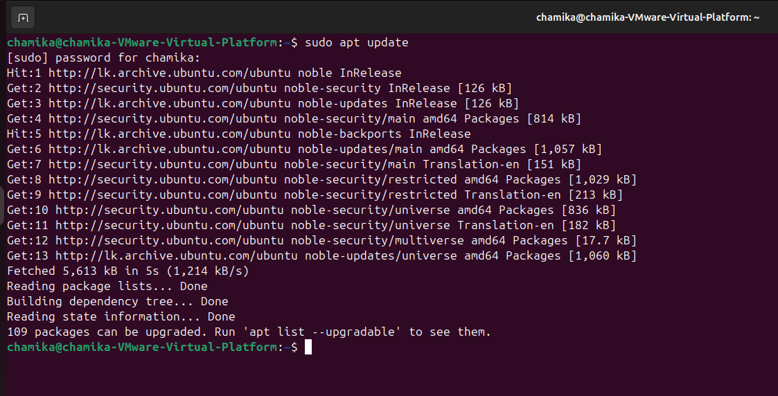

2.install the OpenSSH Server

Use**→sudo apt install openssh-server**

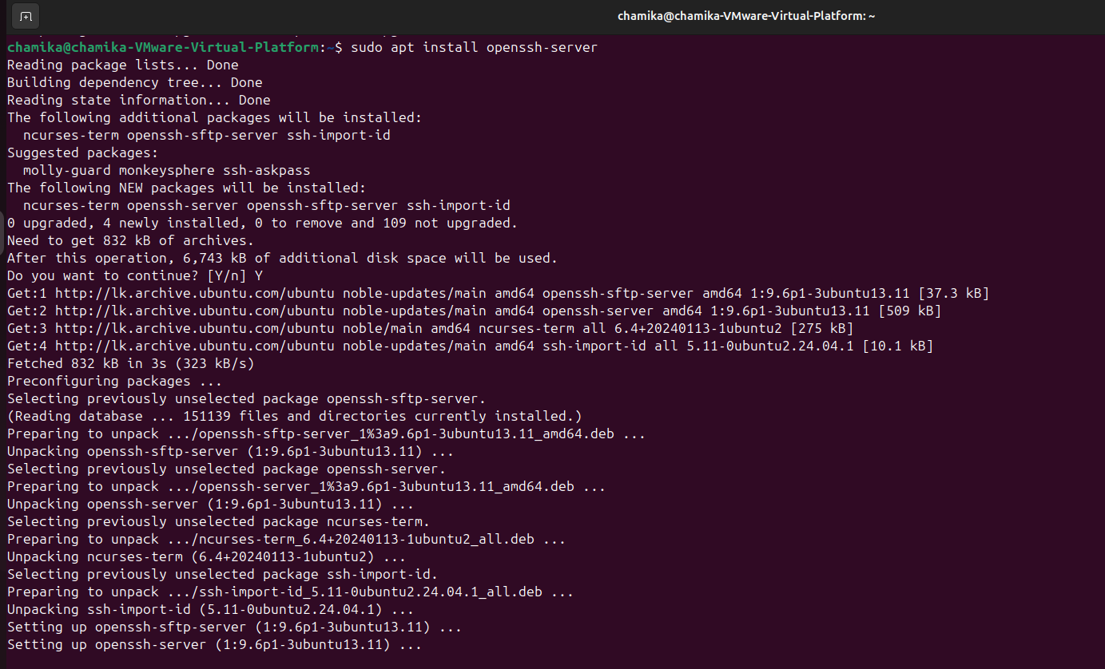

3.start the SSH server

Use**→sudo systemctl start ssh**

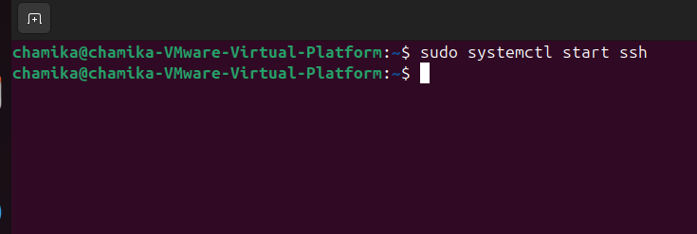

4.Then enable configuration to ensure that SSH server starts automatically whenever the system is booted

Use**→ sudo systemctl enable ssh**

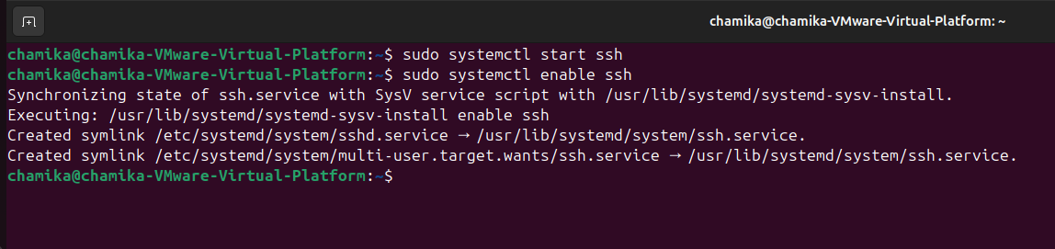

5.check the status if it is running, status should be active

Use**→ sudo systemctl status ssh**

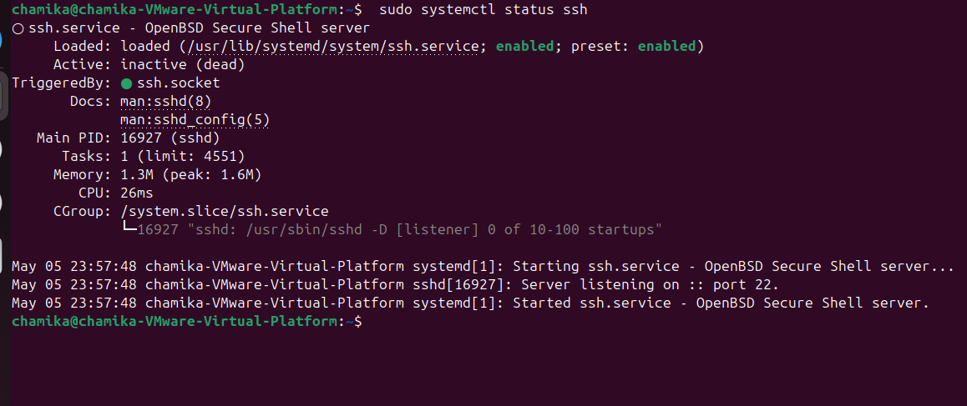

6.allow ssh server to access through firewall.

Use**→sudo ufw allow ssh**

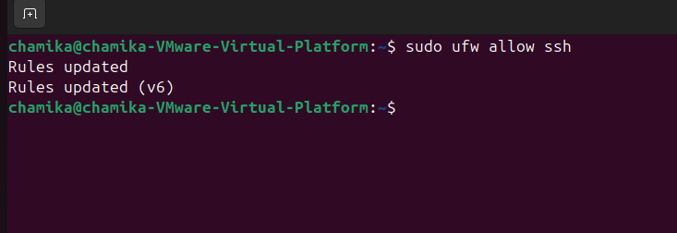

7.check the ip address of the SSH server

Use**→ ip a**

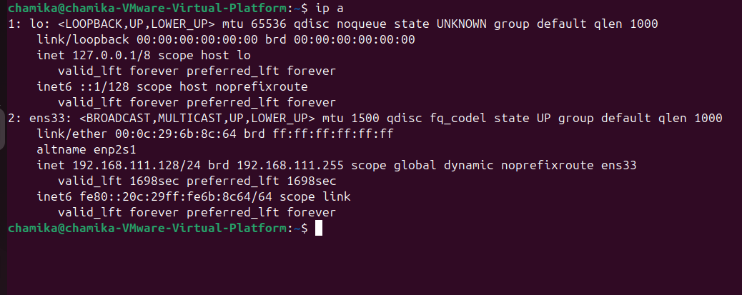

**Verification**

1.in the windows PowerShell check if remote logging is enable

Syntax ssh [username]@[ipaddress]

Use→ssh [chamika@192.168.111.128](mailto:chamika@192.168.111.128)

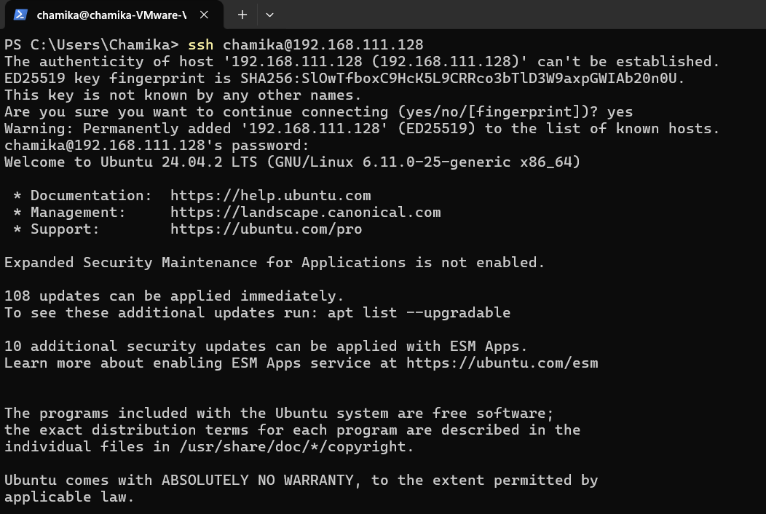

If this is first time connecting, you will be prompted to confirm the fingerprint of the server. Type yes to continue.

Enter Password: Enter the password of the user account on the server machine to log in successfully.

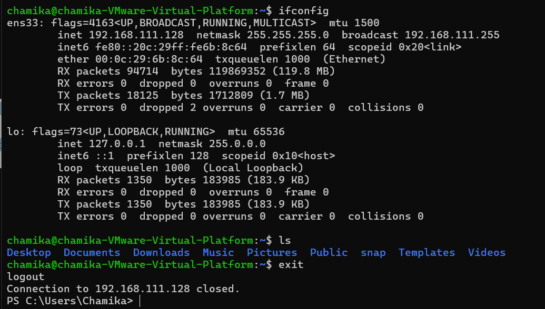

**iptables and ACLs**

## Setup (Important)

Before you begin, **install iptables** (if not installed):

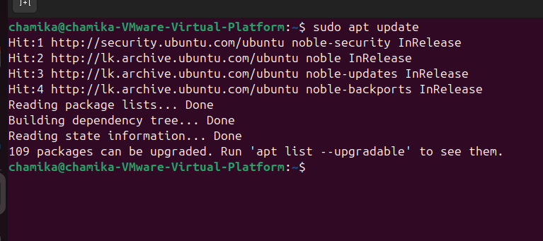

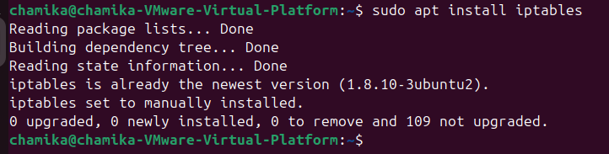

**Check current rules:**

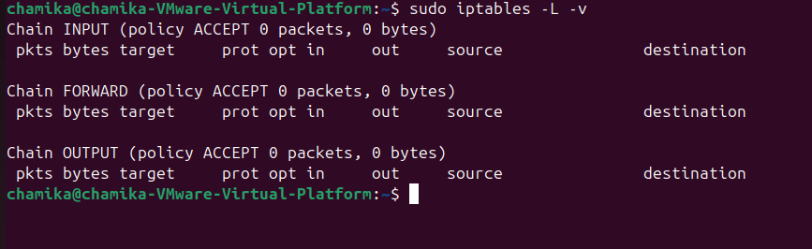

## 5 iptables Rules with Explanation

### **Rule 1: Allow incoming SSH (port 22)**

**Why**: This allows you to access the system remotely using SSH.



**Rule 2: Allow incoming HTTPS (port 443)**

**Why**: Secure web browsing for users.

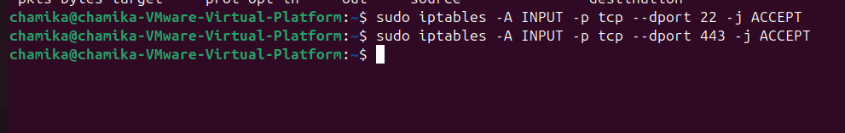

**Rule 3: Block incoming HTTP (port 80)**

**Why**: Prevents access to unencrypted websites.

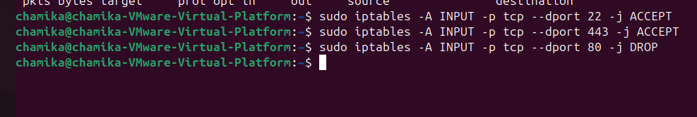

**Rule 4: Allow ICMP ping traffic**

**Why**: Lets you ping the server for connectivity checks.

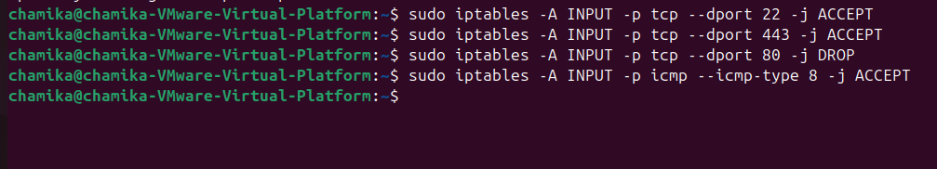

**Rule 5: Block all other incoming traffic**

**Why**: Ensures a default deny policy to increase security.

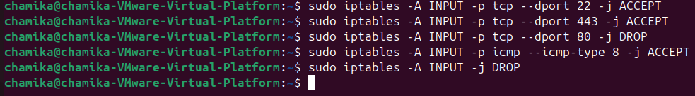

## Block Social Media Sites (Facebook, Instagram, Twitter)

### i. **Blocking by IP (Quick & Basic Method)**

This method blocks social media by their IP addresses.



### **Block HTTP and Allow Only HTTPS,DNS**

To block all unencrypted web browsing (HTTP):

This ensures only secure websites (HTTPS) can be visited.

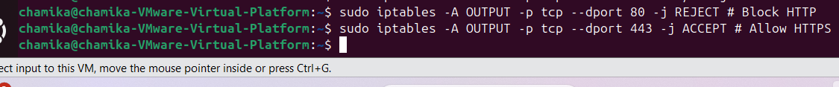

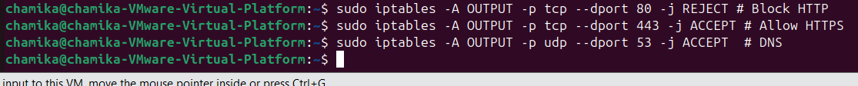

## ****Save Rules Persistently****

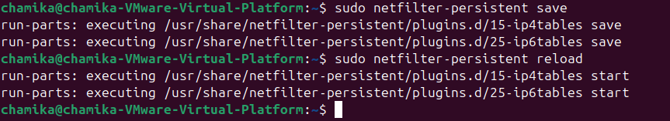

### **4. Verify the Rules**

Check if the rules are applied correctly:

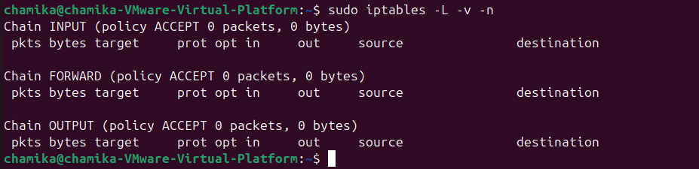

### **5. Test the Rules**

* **Blocked Sites (Should Fail):**



**Allowed Sites (Should Work):**

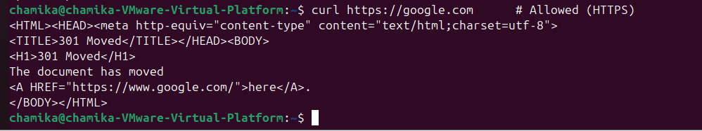

**Web Server (Apache/Nginx)**

**Step 1: Install Apache**

Apache will automatically start after installation.

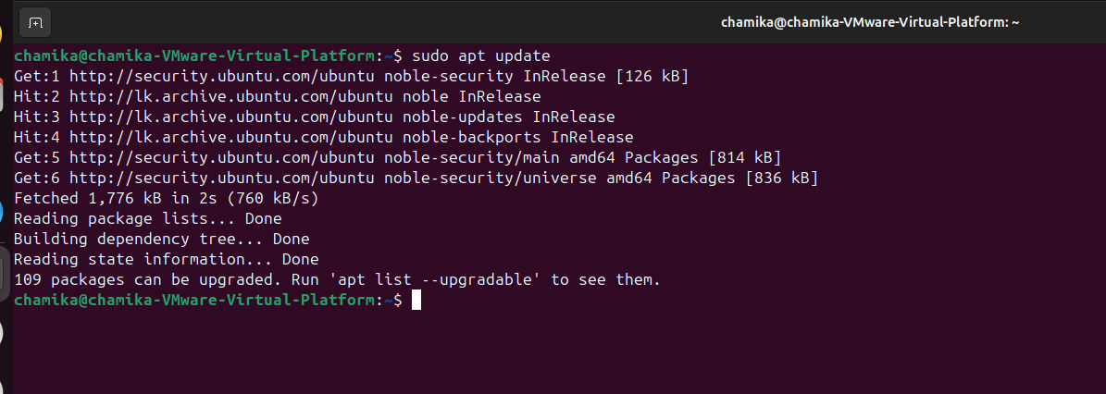

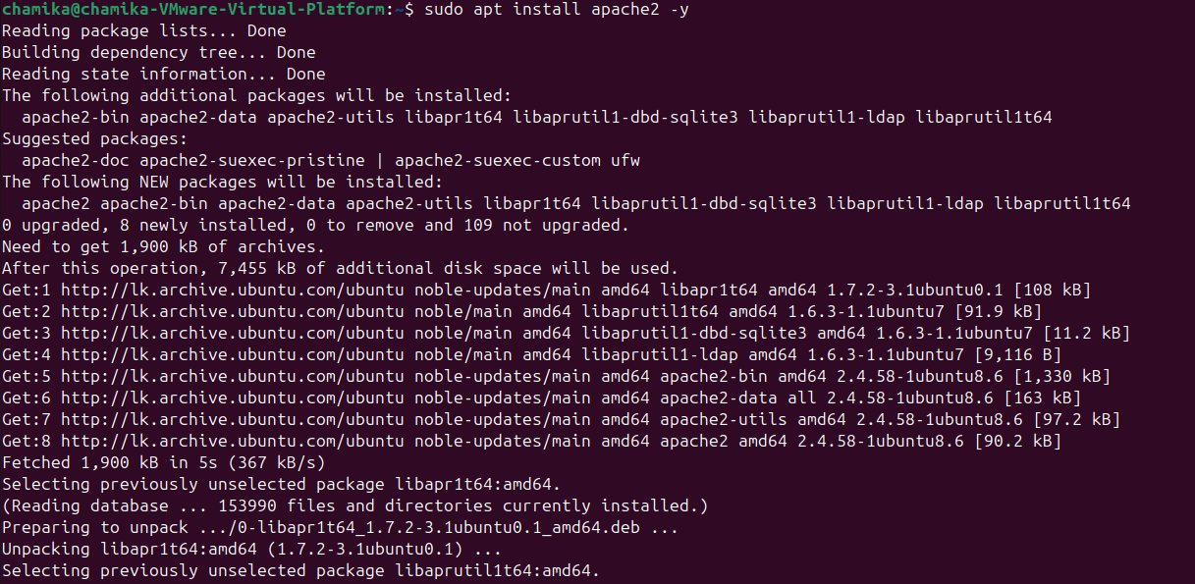

**Step 2: Enable and Start Apache (if not started)**

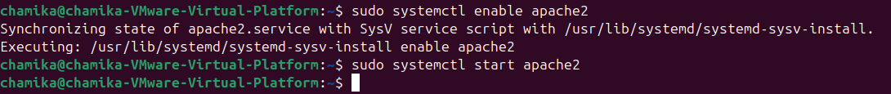

To check its status:

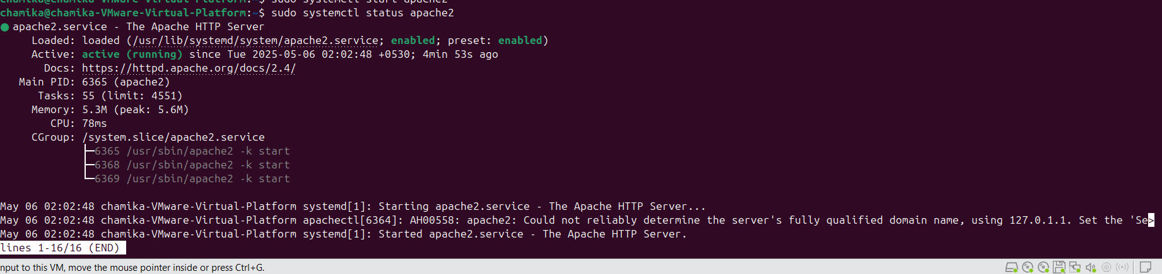

## Step 3: Create a Simple Web Page

Apache serves content from **/var/www/html/** by default. Replace or edit the default file:

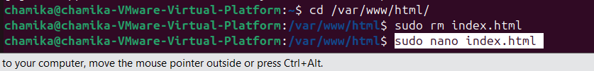

**Add HTML content:**

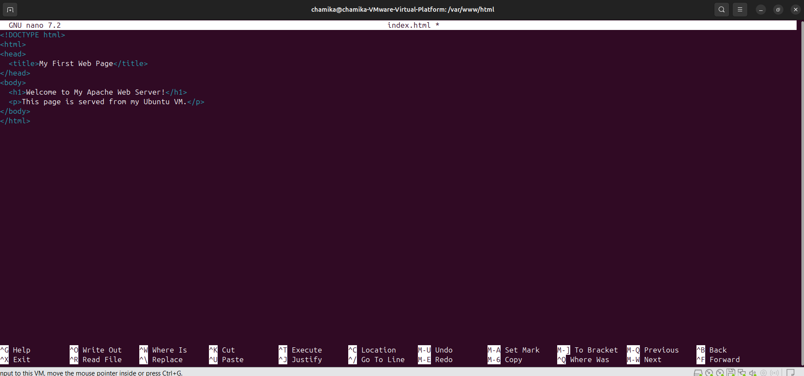

Save with **Ctrl+O**, then **Enter**, and exit with **Ctrl+X.**

## Step 4: Allow HTTP Access Through Firewall

If you're using ufw (Uncomplicated Firewall), allow Apache:

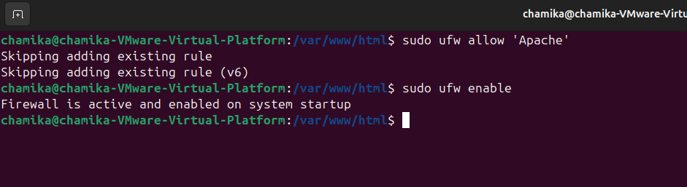

**Check status:**

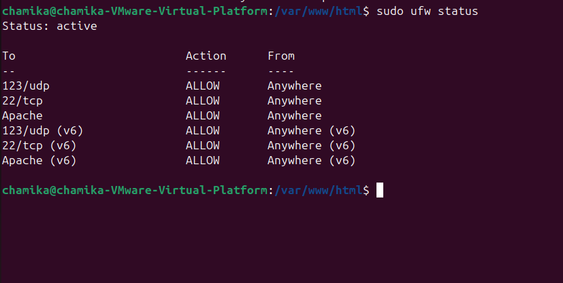

## Step 6: Access the Web Page from Another Machine

On a different machine connected to the **same network**, open a web browser and type:

You should see your custom "Welcome" web page.

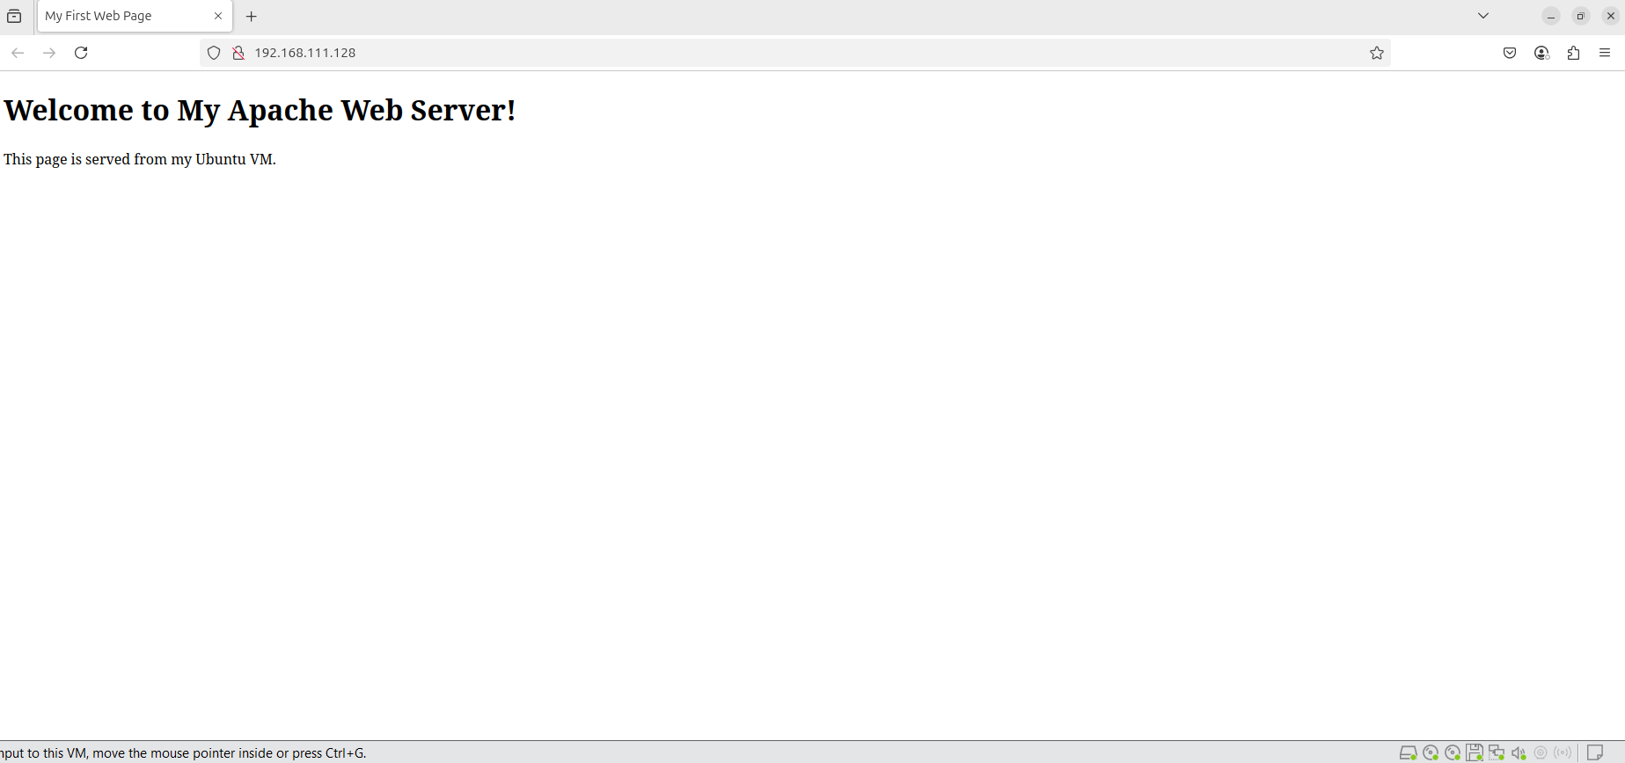

**Email Server (postfix/Exim)**

### **1. Verify Basic Requirements**

**A. Confirm FQDN is Properly Set**

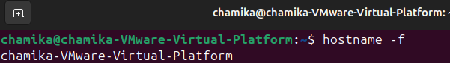

**B. Check DNS Records (Critical!)**

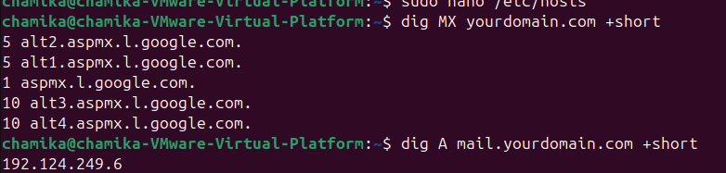

### **2. Reinstall Postfix with Clean Config**

During installation:

* Select **"Internet Site"**
* Set **System mail name**: yourdomain.com

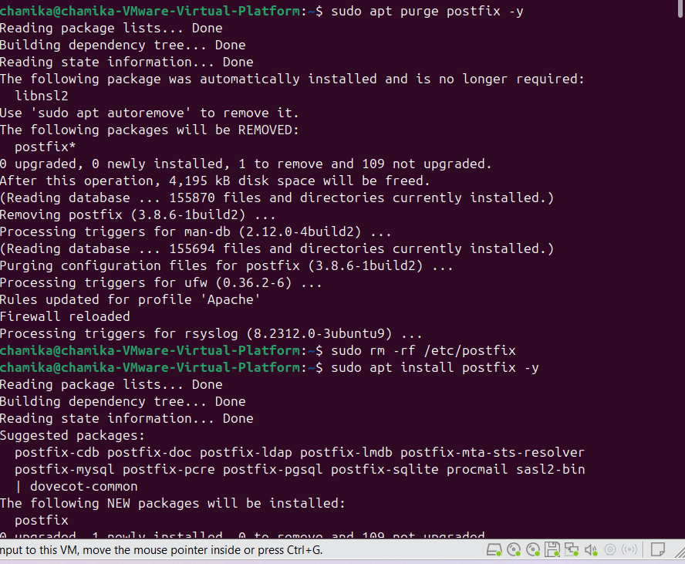

### **3. Minimal Working Config**

Edit /etc/postfix/main.cf:

Script

myhostname = mail.yourdomain.com

mydomain = yourdomain.com

myorigin = $mydomain

inet_interfaces = all

mydestination = $myhostname, localhost.$mydomain, localhost, $mydomain

relayhost =

mynetworks = 127.0.0.0/8 [::ffff:127.0.0.0]/104 [::1]/128

home_mailbox = Maildir/

smtpd_banner = $myhostname ESMTP

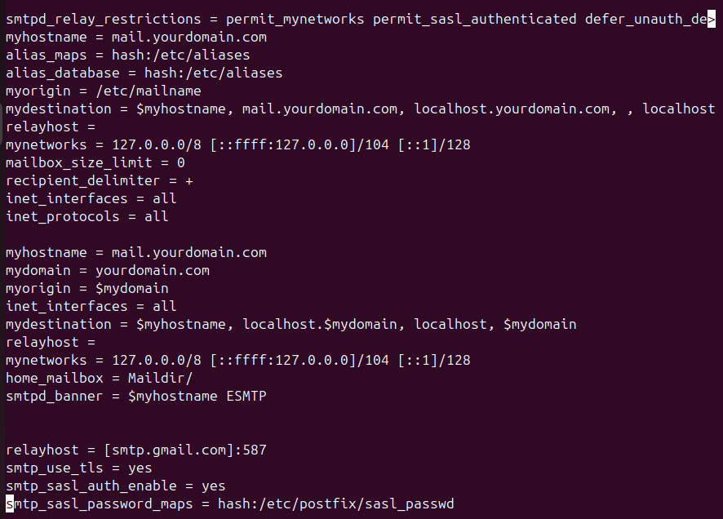

**Then:**



### **4. Test Local Mail First**

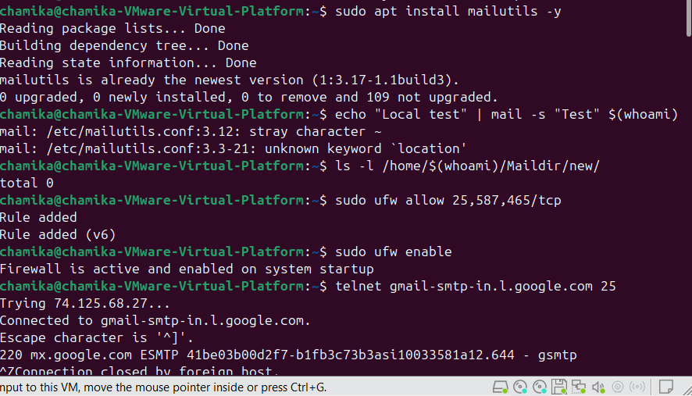

### **5. Fix Outbound Email Issues**

**A. Check Firewall**

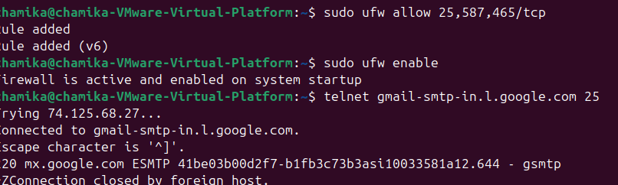

**B. Test SMTP Connectivity**

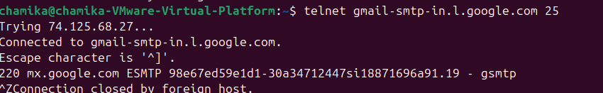

**C. Configure Relay (If Needed)**  
For Gmail relay:

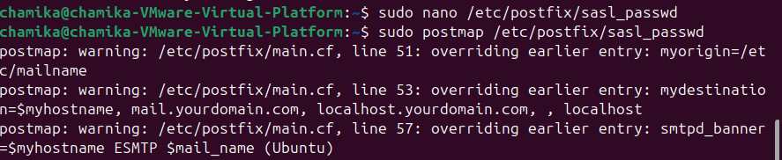

**Add:**

**sudo nano /etc/postfix/sasl_passwd add nano file below one**

**[smtp.gmail.com]:587** [**your@gmail.com:app-password**](mailto:your@gmail.com:app-password)

**Test Email with Full Verbose Output**

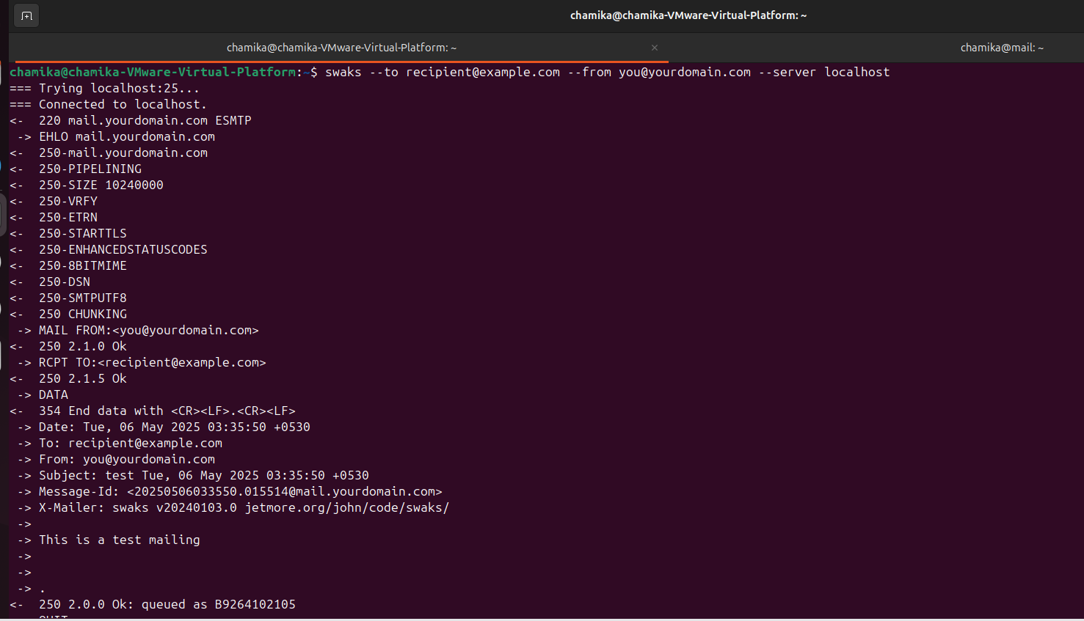

**GDB**

### **Step 1: Check Your System Architecture**

Run the following command in your terminal to determine your system type:

Possible outputs and what they mean:

* x86_64 → Your system is 64-bit (most modern Linux systems). Choose the **x86_64 executable**.
* arm or aarch64 → Your system is ARM-based (e.g., Raspberry Pi, newer Macs with Apple Silicon). Choose the **ARM executable**.
* i686 → Your system is 32-bit (older systems). Choose the **32-bit executable**.



### **Step 2: Navigate to the Extracted Folder**

**1.Go into the extracted folder:**

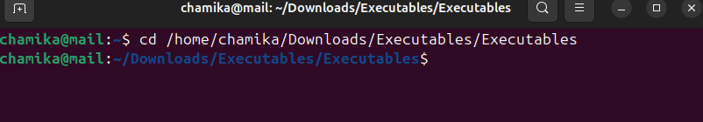

**2.List the files to find your x86_64 executable**:

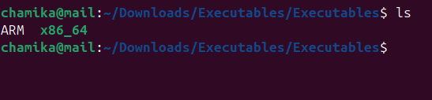

## ****Step 3: Initial Execution****



**1.Run the executable**:

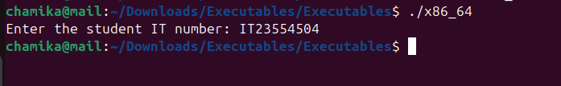

**2.** **Verify the generated file**:

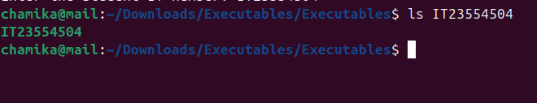

## ****Step 4: Secondary Execution****

**1.Run the generated executable**:

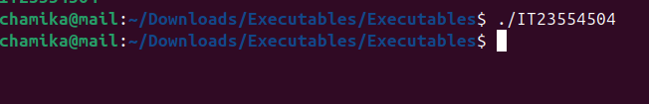

**2.Check generated files**:

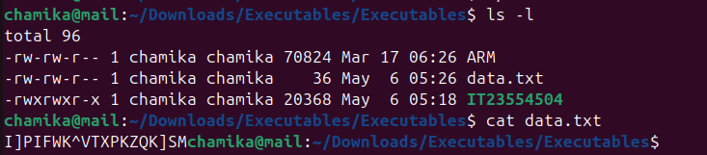

#### **5. GDB Debugging**

### **Launch GDB with Executable**

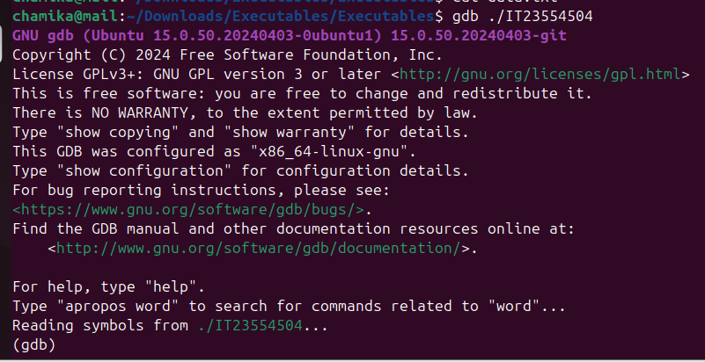

### **Basic Debugging Workflow**

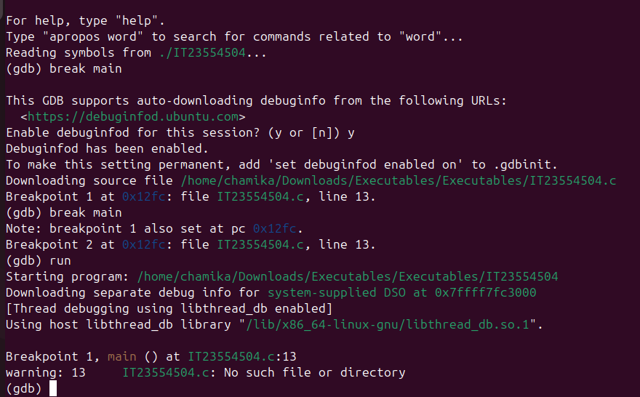

#### **Execute Next Line (Step Over)**

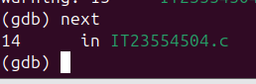

### **Inspecting Registers & Memory**

#### **View All Registers**

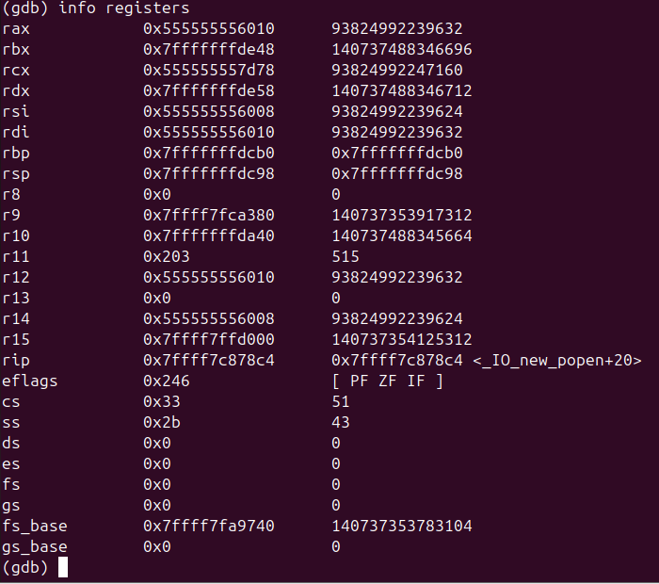

#### **Examine Stack Memory**

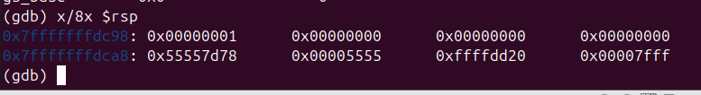

#### **Watch a Variable**

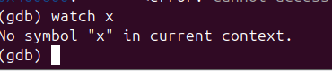

#### **Disassemble a Function**

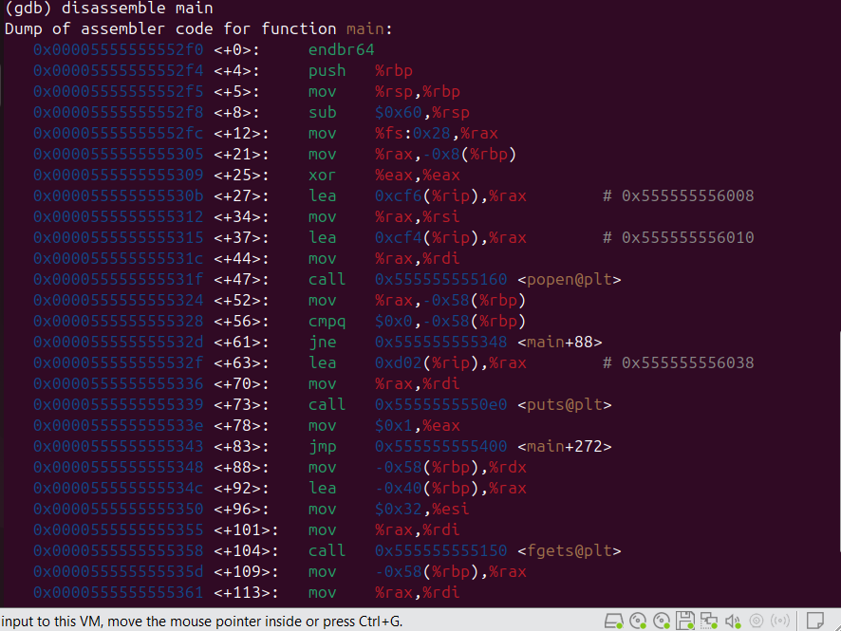

**Debug a file write operation**

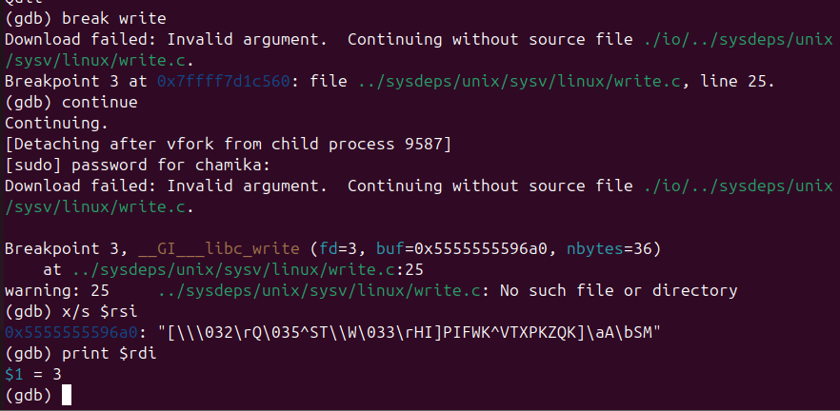

### **File System Monitoring**

### 

**Determine the Contents of “data.txt”**

#### **1. Initial Inspection**



#### **Check for Encoding/Encryption**

**A. Hex View (Reveals Binary Patterns)**

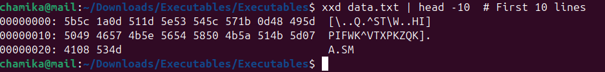

**B. Common Encoding Tests**

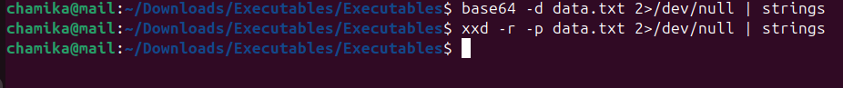

**C. Entropy Check (Encryption Indicator)**

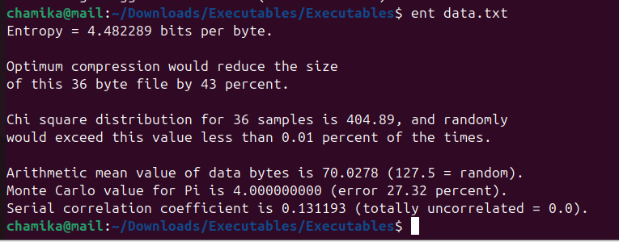

#### **Search for Hidden Data**

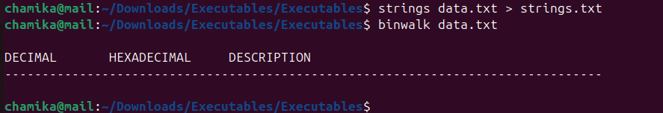

**Strace Logs**



#### **Cross-Reference with Executable**



